# A Beginner's Guide to Eigenvectors, Eigenvalues, PCA, Covariance and Entropy Contents

This post introduces eigenvectors and their relationship to matrices in plain language and without a great deal of math. It builds on those ideas to explain covariance, principal component analysis, and information entropy.

The eigen in eigenvector comes from German, and it means something like “very own.” For example, in German, “mein eigenes Auto” means “my very own car.” So eigen denotes a special relationship between two things. Something particular, characteristic and definitive. This car, or this vector, is mine and not someone else’s.

in linear algebra, Matrices are simply rectangular arrays of numbers, a collection of scalar values between brackets, like a spreadsheet. All square matrices (e.g. 2 x 2 or 3 x 3) have eigenvectors, and they have a very special relationship with them, a bit like Germans have with their cars.

## 

## **Linear Transformations**

We’ll define that relationship after a brief detour into what matrices do, and how they relate to other numbers.

Matrices are useful because you can do things with them like add and multiply. If you multiply a vector v by a matrix A, you get another vector b, and you could say that the matrix performed a linear transformation on the input vector.

**Av = b**

It [maps](https://en.wikipedia.org/wiki/Linear_map) one vector v to another, b.

We’ll illustrate with a concrete example. (You can see how this type of matrix multiply, called a dot product, is performed [here](https://math.stackexchange.com/a/24469).)

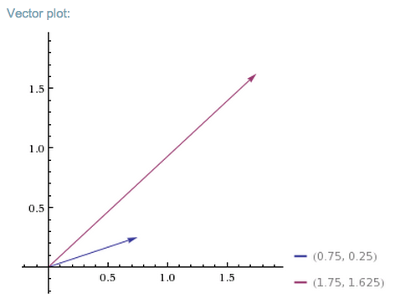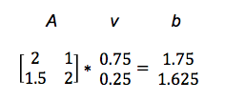

So A turned v into b. In the graph below, we see how the matrix mapped the short, low line v, to the long, high one, b.

You could feed one positive vector after another into matrix A, and each would be projected onto a new space that stretches higher and farther to the right.

Imagine that all the input vectors v live in a normal grid, like this:



And the matrix projects them all into a new space like the one below, which holds the output vectors b:

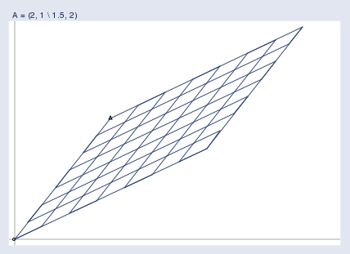

Here you can see the two spaces juxtaposed:

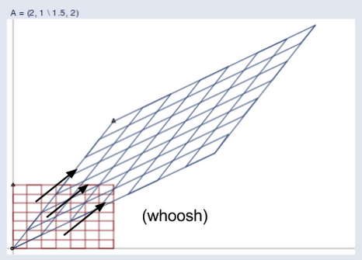

(Credit: William Gould, Stata Blog)

And here’s an animation that shows the matrix’s work transforming one space to another:

The blue lines are eigenvectors.

You can imagine a matrix like a gust of wind, an invisible force that produces a visible result. And a gust of wind must blow in a certain direction. The eigenvector tells you the direction the matrix is blowing in.



So out of all the vectors affected by a matrix blowing through one space, which one is the eigenvector? It’s the one that changes length but not direction; that is, the eigenvector is already pointing in the same direction that the matrix is pushing all vectors toward. An eigenvector is like a weathervane. An eigenvane, as it were.

The definition of an eigenvector, therefore, is a vector that responds to a matrix as though that matrix were a scalar coefficient. In this equation, A is the matrix, x the vector, and lambda the scalar coefficient, a number like 5 or 37 or pi.

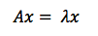

You might also say that eigenvectors are axes along which linear transformation acts, stretching or compressing input vectors. They are the lines of change that represent the action of the larger matrix, the very “line” in linear transformation.

Notice we’re using the plural – axes and lines. Just as a German may have a Volkswagen for grocery shopping, a Mercedes for business travel, and a Porsche for joy rides (each serving a distinct purpose), square matrices can have as many eigenvectors as they have dimensions; i.e. a 2 x 2 matrix could have two eigenvectors, a 3 x 3 matrix three, and an n x n matrix could have n eigenvectors, each one representing its line of action in one dimension.[1](https://pathmind.com/wiki/eigenvector#ref)

Because eigenvectors distill the axes of principal force that a matrix moves input along, they are useful in matrix decomposition; i.e. [the diagonalization of a matrix along its eigenvectors](http://mathworld.wolfram.com/MatrixDiagonalization.html). Because those eigenvectors are representative of the matrix, they perform the same task as the autoencoders employed by deep neural networks.

To quote Yoshua Bengio:

Many mathematical objects can be understood better by breaking them into constituent parts, or ﬁnding some properties of them that are universal, not caused by the way we choose to represent them.

For example, integers can be decomposed into prime factors. The way we represent the number 12 will change depending on whether we write it in base ten or in binary, but it will always be true that 12 = 2 × 2 × 3.

From this representation we can conclude useful properties, such as that 12 is not divisible by 5, or that any integer multiple of 12 will be divisible by 3.

Much as we can discover something about the true nature of an integer by decomposing it into prime factors, we can also decompose matrices in ways that show us information about their functional properties that is not obvious from the representation of the matrix as an array of elements.

One of the most widely used kinds of matrix decomposition is called eigen-decomposition, in which we decompose a matrix into a set of eigenvectors and eigenvalues.

## Principal Component Analysis (PCA)

PCA is a tool for finding patterns in high-dimensional data such as images. Machine-learning practitioners sometimes use PCA to preprocess data for their neural networks. By centering, rotating and scaling data, PCA prioritizes dimensionality (allowing you to drop some low-variance dimensions) and can improve the neural network’s convergence speed and the overall quality of results.

To get to PCA, we’re going to quickly define some basic statistical ideas – mean, standard deviation, variance and covariance – so we can weave them together later. Their equations are closely related.

Mean is simply the average value of all x’s in the set X, which is found by dividing the sum of all data points by the number of data points, n.

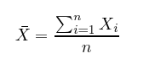

Standard deviation, as fun as that sounds, is simply the square root of the average square distance of data points to the mean. In the equation below, the numerator contains the sum of the differences between each datapoint and the mean, and the denominator is simply the number of data points (minus one), producing the average distance.

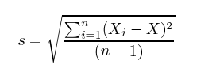

Variance is the measure of the data’s spread. If I take a team of [Dutch basketball players](https://www.theguardian.com/world/2015/apr/08/scientists-try-to-answer-why-dutch-people-are-so-tall) and measure their height, those measurements won’t have a lot of variance. They’ll all be grouped above six feet.

But if I throw the Dutch basketball team into a classroom of psychotic kindergartners, then the combined group’s height measurements will have a lot of variance. Variance is the spread, or the amount of difference that data expresses.

Variance is simply standard deviation squared, and is often expressed as s^2.

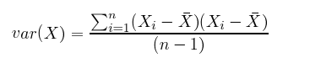

For both variance and standard deviation, squaring the differences between data points and the mean makes them positive, so that values above and below the mean don’t cancel each other out.

Let’s assume you plotted the age (x axis) and height (y axis) of those individuals (setting the mean to zero) and came up with an oblong scatterplot:

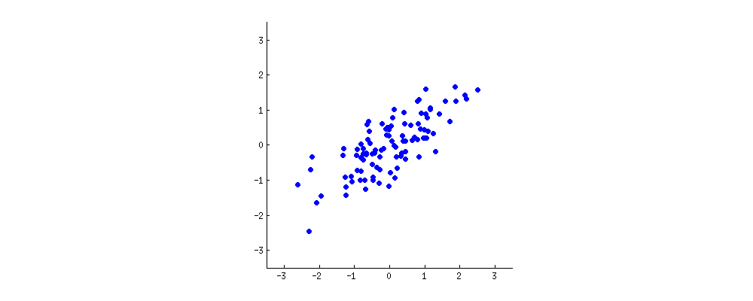

PCA attempts to draw straight, explanatory lines through data, like linear regression.

Each straight line represents a “principal component,” or a relationship between an independent and dependent variable. While there are as many principal components as there are dimensions in the data, PCA’s role is to prioritize them.

The first principal component bisects a scatterplot with a straight line in a way that explains the most variance; that is, it follows the longest dimension of the data. (This happens to coincide with the least error, as expressed by the red lines…) In the graph below, it slices down the length of the “baguette.”

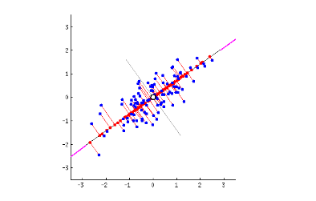

The second principal component cuts through the data perpendicular to the first, fitting the errors produced by the first. There are only two principal components in the graph above, but if it were three-dimensional, the third component would fit the errors from the first and second principal components, and so forth.

## Covariance Matrix

While we introduced matrices as something that transformed one set of vectors into another, another way to think about them is as a description of data that captures the forces at work upon it, the forces by which two variables might relate to each other as expressed by their variance and covariance.

Imagine that we compose a square matrix of numbers that describe the variance of the data, and the covariance among variables. This is the covariance matrix. It is an empirical description of data we observe.

Finding the eigenvectors and eigenvalues of the covariance matrix is the equivalent of fitting those straight, principal-component lines to the variance of the data. Why? Because eigenvectors trace the principal lines of force, and the axes of greatest variance and covariance illustrate where the data is most susceptible to change.

Think of it like this: If a variable changes, it is being acted upon by a force known or unknown. If two variables change together, in all likelihood that is either because one is acting upon the other, or they are both subject to the same hidden and unnamed force.

When a matrix performs a linear transformation, eigenvectors trace the lines of force it applies to input; when a matrix is populated with the variance and covariance of the data, eigenvectors reflect the forces that have been applied to the given. One applies force and the other reflects it.

Eigenvalues are simply the coefficients attached to eigenvectors, which give the axes magnitude. In this case, they are the measure of the data’s covariance. By ranking your eigenvectors in order of their eigenvalues, highest to lowest, you get the principal components in order of significance.

For a 2 x 2 matrix, a covariance matrix might look like this:

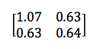

The numbers on the upper left and lower right represent the variance of the x and y variables, respectively, while the identical numbers on the lower left and upper right represent the covariance between x and y. Because of that identity, such matrices are known as symmetrical. As you can see, the covariance is positive, since the graph near the top of the PCA section points up and to the right.

If two variables increase and decrease together (a line going up and to the right), they have a positive covariance, and if one decreases while the other increases, they have a negative covariance (a line going down and to the right).

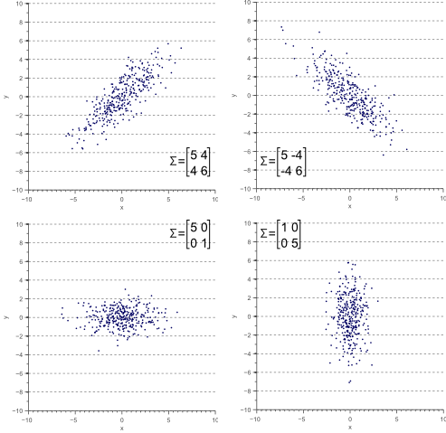

(Credit: Vincent Spruyt)

Notice that when one variable or the other doesn’t move at all, and the graph shows no diagonal motion, there is no covariance whatsoever. Covariance answers the question: do these two variables dance together? If one remains null while the other moves, the answer is no.

Also, in the equation below, you’ll notice that there is only a small difference between covariance and variance.

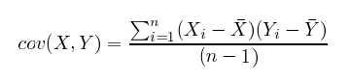

vs.



The great thing about calculating covariance is that, in a high-dimensional space where you can’t eyeball intervariable relationships, you can know how two variables move together by the positive, negative or non-existent character of their covariance. (Correlation is a kind of normalized covariance, with a value between -1 and 1.)

To sum up, the covariance matrix defines the shape of the data. Diagonal spread along eigenvectors is expressed by the covariance, while x-and-y-axis-aligned spread is expressed by the variance.

Causality has a bad name in statistics, so take this with a grain of salt:

While not entirely accurate, it may help to think of each component as a causal force in the Dutch basketball player example above, with the first principal component being age; the second possibly gender; the third nationality (implying nations’ differing healthcare systems), and each of those occupying its own dimension in relation to height. Each acts on height to different degrees. You can read covariance as traces of possible cause.

### **Change of Basis**

Because the eigenvectors of the covariance matrix are orthogonal to each other, they can be used to reorient the data from the x and y axes to the axes represented by the principal components. You [re-base the coordinate system](https://en.wikipedia.org/wiki/Change_of_basis) for the dataset in a new space defined by its lines of greatest variance.

The x and y axes we’ve shown above are what’s called the basis of a matrix; that is, they provide the points of the matrix with x, y coordinates. But it is possible to recast a matrix along other axes; for example, the eigenvectors of a matrix can serve as the foundation of a new set of coordinates for the same matrix. Matrices and vectors are animals in themselves, independent of the numbers linked to a specific coordinate system like x and y.

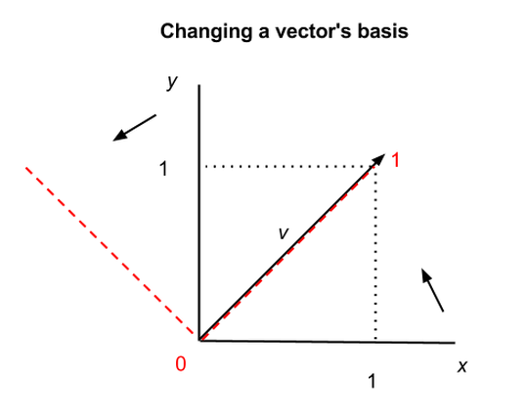

In the graph above, we show how the same vector v can be situated differently in two coordinate systems, the x-y axes in black, and the two other axes shown by the red dashes. In the first coordinate system, v = (1,1), and in the second, v = (1,0), but v itself has not changed. Vectors and matrices can therefore be abstracted from the numbers that appear inside the brackets.

This has profound and almost spiritual implications, one of which is that there exists no natural coordinate system, and mathematical objects in n-dimensional space are subject to multiple descriptions. (Changing matrices’ bases also makes them easier to manipulate.)

A change of basis for vectors is roughly analogous to changing the base for numbers; i.e. the quantity nine can be described as 9 in base ten, as 1001 in binary, and as 100 in base three (i.e. 1, 2, 10, 11, 12, 20, 21, 22, 100 <– that is “nine”). Same quantity, different symbols; same vector, different coordinates.

## **Entropy & Information Gain**

In information theory, the term entropy refers to information we don’t have (normally people define “information” as what they know, and jargon has triumphed once again in turning plain language on its head to the detriment of the uninitiated). The information we don’t have about a system, its entropy, is related to its unpredictability: how much it can surprise us.

If you know that a certain coin has heads embossed on both sides, then flipping the coin gives you absolutely no information, because it will be heads every time. You don’t have to flip it to know. We would say that two-headed coin contains no information, because it has no way to surprise you.

A balanced, two-sided coin does contain an element of surprise with each coin toss. And a six-sided die, by the same argument, contains even more surprise with each roll, which could produce any one of six results with equal frequency. Both those objects contain information in the technical sense.

Now let’s imagine the die is loaded, it comes up “three” on five out of six rolls, and we figure out the game is rigged. Suddenly the amount of surprise produced with each roll by this die is greatly reduced. We understand a trend in the die’s behavior that gives us greater predictive capacity.

Understanding the die is loaded is analogous to finding a principal component in a dataset. You simply identify an underlying pattern.

That transfer of information, from what we don’t know about the system to what we know, represents a change in entropy. Insight decreases the entropy of the system. Get information, reduce entropy. This is information gain. And yes, this type of entropy is subjective, in that it depends on what we know about the system at hand. (Fwiw, [information gain](https://en.wikipedia.org/wiki/Information_gain_in_decision_trees) is synonymous with Kullback-Leibler divergence, which we explored briefly in this tutorial on [restricted Boltzmann machines](https://pathmind.com/wiki/restricted-boltzmann-machine).)

So each principal component cutting through the scatterplot represents a decrease in the system’s entropy, in its unpredictability.

It so happens that explaining the shape of the data one principal component at a time, beginning with the component that accounts for the most variance, is similar to walking data through a decision tree. The first component of PCA, like the first if-then-else split in a properly formed decision tree, will be along the dimension that reduces unpredictability the most.

1) In some cases, matrices may not have a full set of eigenvectors; they can have at most as many linearly independent eigenvectors as their respective order, or number of dimensions.

**Eigenvalues and eigenvectors**

Eigenvalues and eigenvectors are one of those things that pop up in a million places because they’re so useful, but to recognize where they may be useful you need intuition as to what they’re doing.

The eigenvectors are the “axes” of the transformation represented by the matrix. Consider spinning a globe (the universe of vectors): every location faces a new direction, except the poles. The eigenvalue is the amount the eigenvector is scaled up or down when going through the matrix.

Eigenvalues are special numbers associated with a matrix and eigenvectors are special vectors.

A matrix ‘A’ acts on vectors v like a function does, with input v and output Av. Eigenvectors are vectors for which Av is parallel to v. In other words:

**Av = λv.**

In this equation, v is an eigenvector of A and λ is an eigenvalue of A.

If you can draw a line through the three points (0,0), v and Av then Av is just v multiplied by a number λ; that is, Av=λv

In this case, we call λ an **eigenvalue** and v an **eigenvector**. For example, here (1,2) is an eigvector and 5 an eigenvalue.

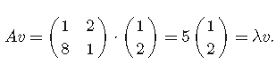

Let us see a demo to understand visually what are the **eigenvalue** and **eigenvector**.

<http://ammozon.co.in/gif/eigenvector.gif>

**eigenspaces:** change the columns of A and drag v to be an eigenvector. Note three facts: First, every point on the same line as an eigenvector is an eigenvector. Those lines are **eigenspaces**, and each has an associated eigenvalue. Second, if you place v on an eigenspace (either s1 or s2) with associated eigenvalue λ<1, then Av is closer to (0,0) than v; but when λ>1, it’s farther. Third, both eigenspaces depend on both columns of A: it is not as though a1 only affects s1.

<http://ammozon.co.in/gif/eigenspaces.gif>

**What are eigenvalues/vectors good for?**

If you keep multiplying v by A, you get a sequence v,Av,A²v ^2v, etc. Eigenspaces attract that sequence and eigenvalues tell you whether it ends up at (0,0) or far away. Therefore, eigenvectors/values tell us about systems that evolve step-by-step.

**Machine Learning & Linear Algebra — Eigenvalue and eigenvector**

Eigenvalue and eigenvector are probably one of the most important concepts in linear algebra. Who can expect a simple equation like Av = λv is so significant? From machine learning to quantum computing, many problems can be solved by finding the eigenvalue and eigenvectors of a matrix. In this article, we will discover why it is so important and how we can apply it. We will also take a look into the Google PageRank, a core part of the Google search engine, to see how it is related to eigenvectors.

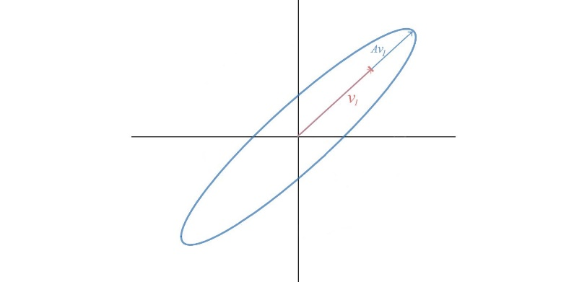By definition, scalar λ and vector v are the eigenvalue and eigenvector of A if



Visually, Av lies along the same line as the eigenvector v.

Ax does not usually equal to λx. Only some exceptional vectors satisfy the condition. Here are some eigenvector examples.

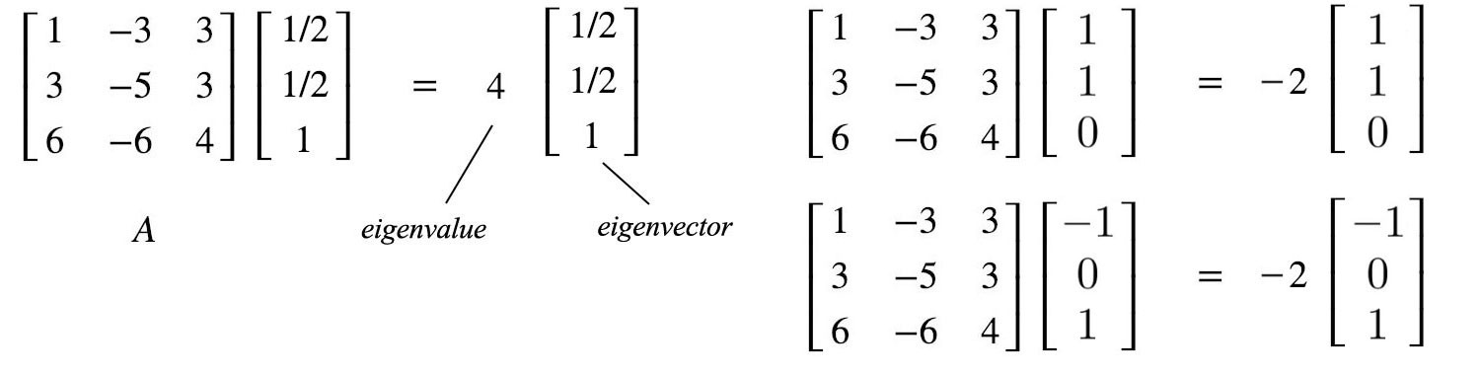

If the eigenvalue is greater than one, the corresponding Avᵢ will expand. If it is smaller than one, it will shrink.

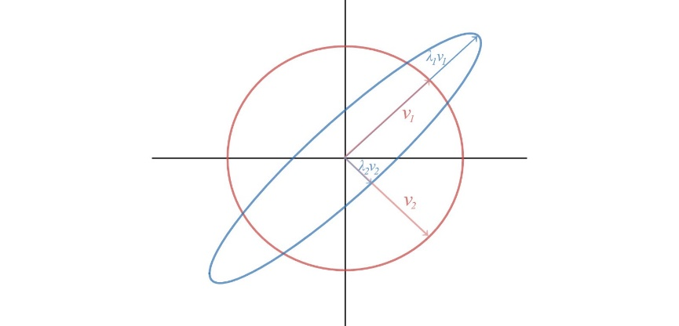

**Application**

But before getting into details, let’s pause and appreciate the beauty of such an abstract concept first. In specific, many problems can be modeled with linear algebra with solutions derived from eigenvalues and eigenvectors.

Let’s start with an abstract example first before getting into a real billion-dollar idea — Google’s PageRank. In many systems, we can express its states in a vector with their rates of change linearly depend on the current states (e.g. the population growth rate is linearly depending on the current population and GDP.). The general equation is



where u composes of n properties. So let’s take a guess on the solution for u(t) that satisfies the equation above. Since the derivative of an exponential function equals itself, we can start the guess with an exponential function of t and multiply it with a vector x. The output will also be a vector and we will compute the value of x and λ next.

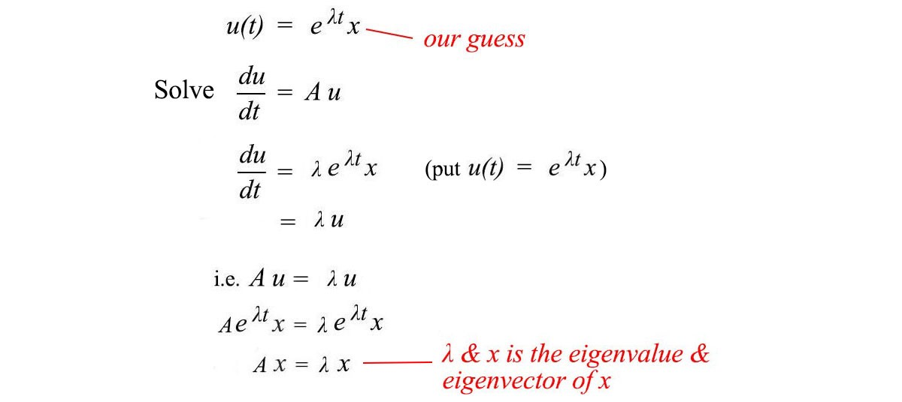

From the calculation above, our guess will satisfy du/dt = Au if x and λare the eigenvectors and eigenvalues of A. i.e.



*In my systems, the problem can be rephrased and solved by eigenvalues and eigenvectors.*

Next, let’s find its complete solution. Our first order derivative equation is a linear function.

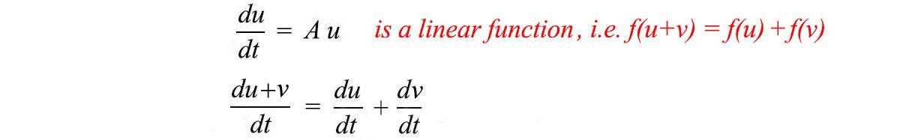

For linear functions, the complete solution is the linear combination of particular solutions. If u and v are the solutions, C₁u + C₂v is also the solution. From our previous example with eigenvalues λ = 4, -2 and -2, the complete solution will be

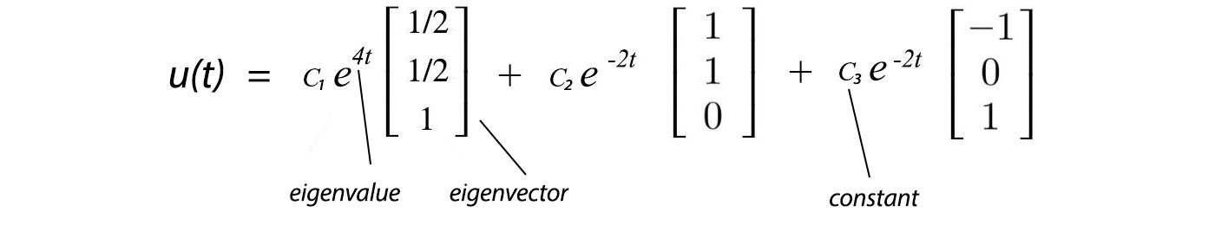

If a system will reach a stable state, then all eigenvalues have to be negative. Otherwise, the non-negative term will change continuously. At time t=0, we can measure the initial state u(0), say [u₀₁, u₀₂, u₀₃]ᵀ, and solve the constant C₁, C₂, and C₃.



Let’s illustrate the idea with a harmonic oscillator. We pick this example because the harmonic oscillator and its close cousin, the quantum harmonic oscillator, are fundamental in studying particle physics, quantum mechanics, string theory or physics in general. Let’s start with the famous F=ma equation and use eigenvalues and eigenvectors to solve the second-order derivative. Since we do have the freedom to pick the unit for mass, physicists often set m=1 to simplify the discussion, i.e.



We reformulate the harmonic oscillator problem into the matrix form in the bottom right below.

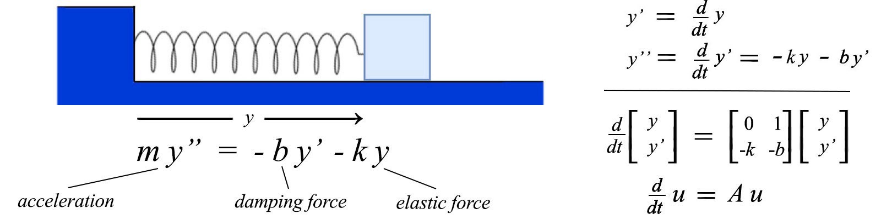

damping harmonic oscillator

This has the same form as our last example and therefore, we can use the eigenvalues and eigenvectors of A to form the complete solution.

This is not an isolated example in demonstrating the power of eigenvalues. Nature seems to have an eigenvector cookbook when making its design. The famous time-independent Schrödinger equation is expressed with eigenvalues and eigenvectors. All observed properties are modeled by eigenvalues in quantum mechanics. They are many other examples including machine learning. One of the biggest eigenvector computed is Google PageRank which is the core part of the Google search.

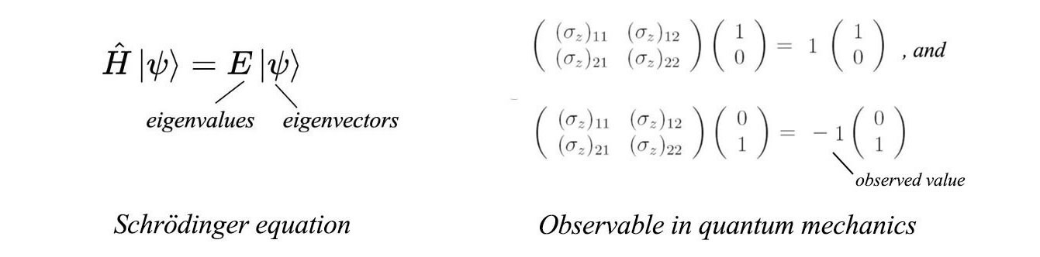

Fundamentally, many systems can be modeled as

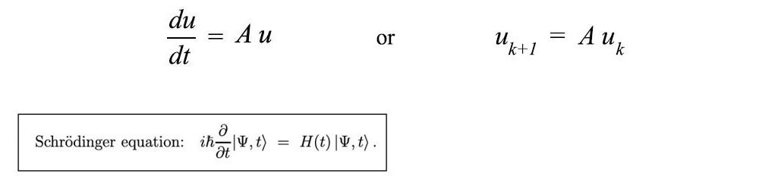

Let’s study the time sequence model below for the purpose of machine learning.



First, we assume the initial state u₀ to be an eigenvector of A. Therefore, its future states can be computed as



This equation can be simplified by replacing the power of a matrix (Aᵏ) with the power of a scalar that is much easy to compute. Next, let’s generalize the problem to include any initial state. Consider A has n linearly independent eigenvectors that form a basis of Rⁿ. We can decompose any vector of Rⁿ into this basis. Again, we can simplify the time sequence calculation by computing the power of the eigenvalue again.

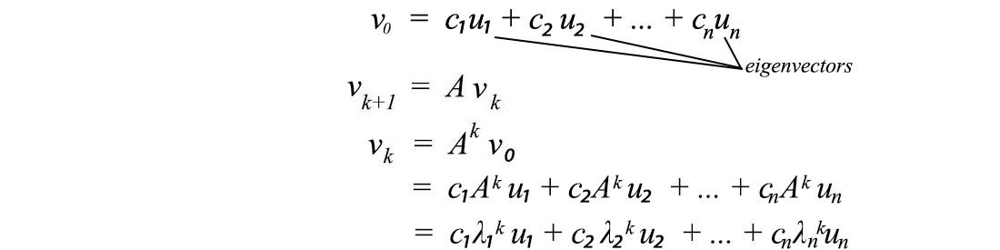

If a system will reach a stable state, we should again expect λᵢ to be smaller or equal to 1. In addition, to compute this stable state, we can ignore terms with λᵢᵏ smaller than 1. As time goes by, these terms diminish to 0. Hence, to find a stable state, we can just focus on eigenvectors associated with λᵢ = 1.

Let’s discuss a real multi-billion idea to realize its full potential. Let’s simplify our discussion and assumes the whole internet contains only three web pages. The element A**ᵢ**ⱼ of a matrix A is the probability of a user going to page i when the user is on page j.





Given a specific page, if we sum over all the possibilities of the next page, it equals 1. i.e., all columns of A sum up to 1.0 and this kind of matrix is called the **stochastic matrix**, **transition matrix** or **Markov matrix**.



Markov matrix has some important properties. The result of Ax or Aᵏx always sums up to one with its columns. The right-hand term is the chance of being on pages 1, 2 and 3 respectively after each click. So it is obvious that it should sum up to one.





Any Markov matrix A has an eigenvalue of 1 and the absolute value of other non-one eigenvalues to be smaller than one. This behavior is very important. In our example,



For a Markov matrix, we can choose the eigenvector for λ=1 to have elements sum up to 1.0. So vectors v0 can be decomposed using the eigenvectors of A with c₁ equals to 1 below.

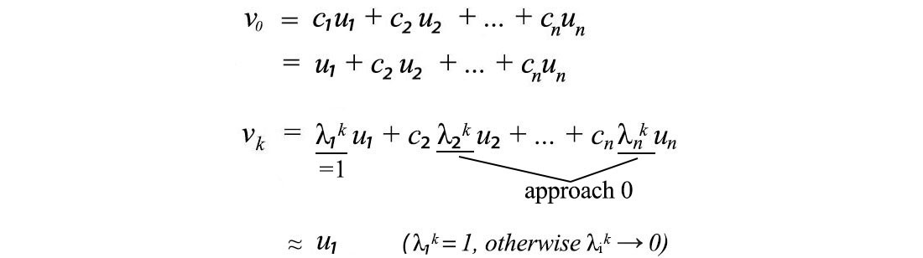

Since u₁, u₂, …, and un are eigenvectors, Aᵏ can be replaced by λᵏ. Except for eigenvalue λ=1, the power of the eigenvalue (λᵏ) for a Markov matrix will diminish. So the system reaches a steady-state that approaches the eigenvector u₁ regardless of the initial state v0. The steady-state will equal the eigenvector u₁ as shown below.

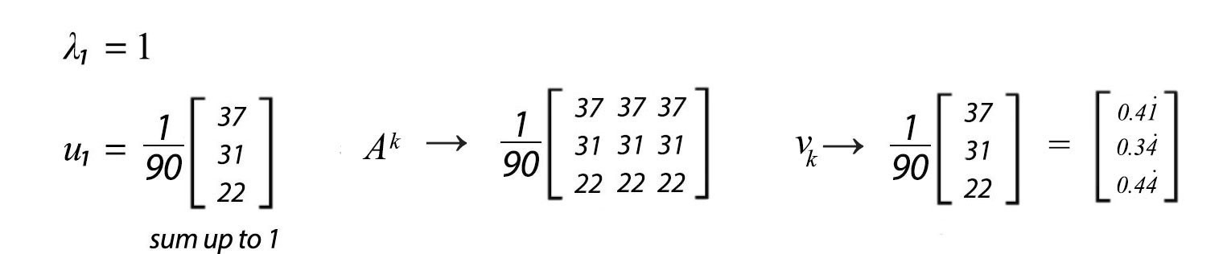

From our example, the chance we land on pages 1, 2 and 3 are about 0.41, 0.34 and 0.44 respectively. This concept has many potential applications. For instance, many problems can be easily modeled with **Markov processes** and a Markov/transition matrix.

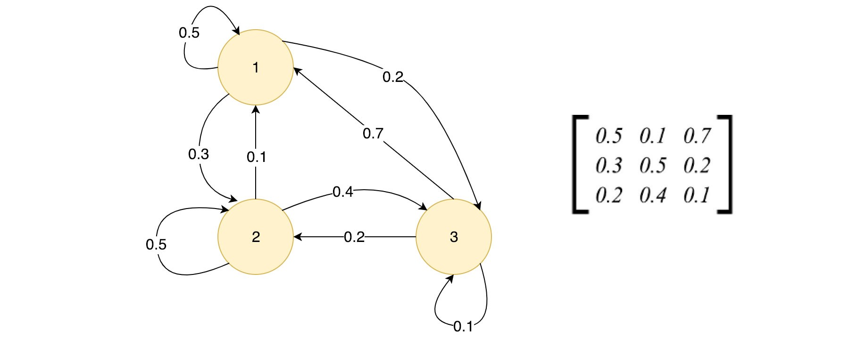

Markov process and the transition matrix

# ****Google PageRank****

I am not exaggerating when I say this is a billion-dollar idea. The PageRank algorithm named after Google co-founder Larry Page is based on a similar concept. It is the first Google search ranking algorithm even it is heavily modified now with added ranking algorithms to improve user experience and to avoid manipulation.

The core idea can be conceptualized as the following. PageRank outputs a probability distribution of pages that you may land on by following links on a web page after many many clicks. This probability will act as the ranking of a Web page. When many pages link to your Web page, Google will rank it higher considering it as a good indicator of popularity.

In our previous example, we have not discussed ways to derive the values in the Markov matrix. For page rank, we compute the values as the sum of other page ranks linked to this page divided by its total number of outbound pages.

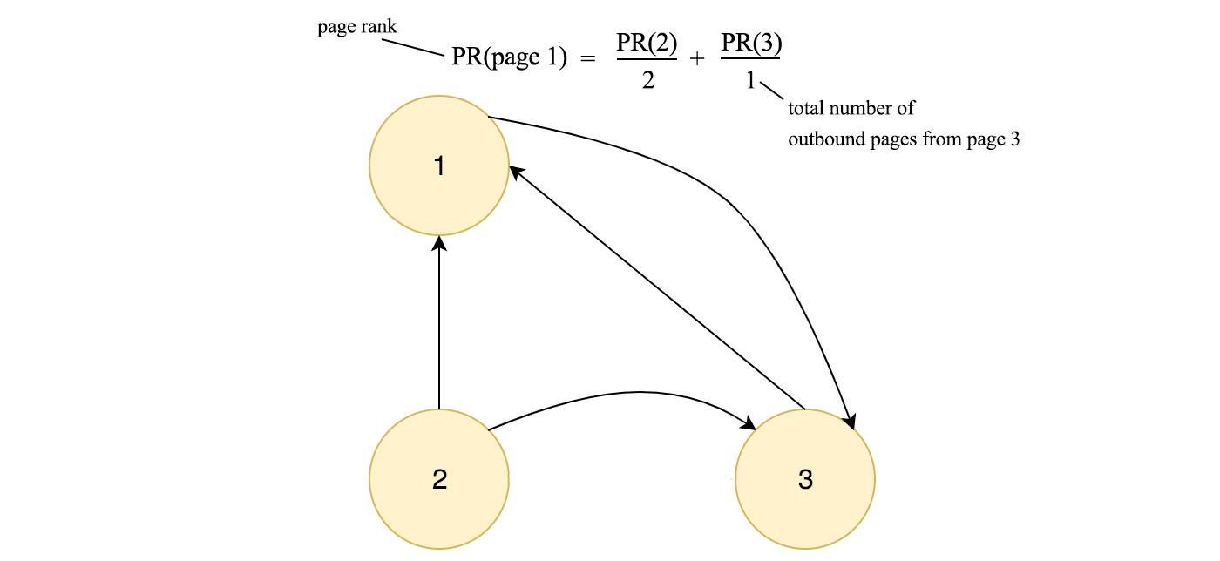

Mathematically, PageRank tries to solve the PageRank vector R (an eigenvector) in the following equation. It initializes R with equal probability at the beginning and performs the calculation iteratively until it reaches a steady-state.

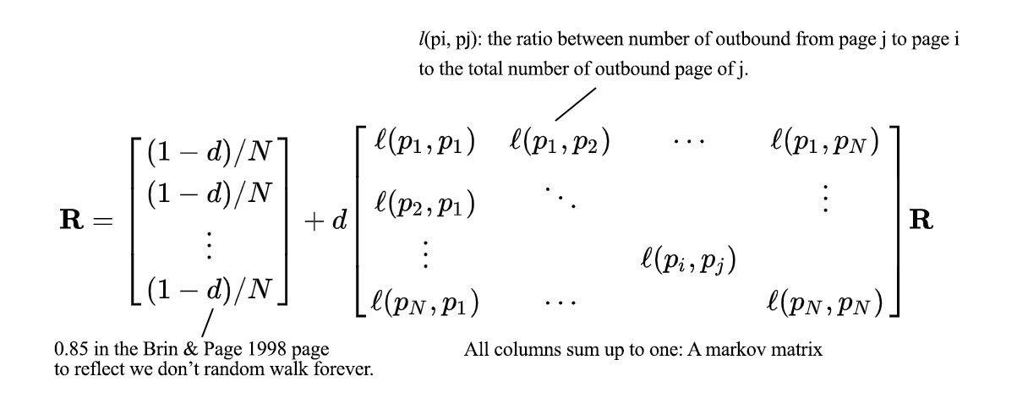

Modified from Wikipedia

The matrix element lᵢⱼ above is the ratio between the number of the outbound page from page j to page i to the total number of the outbound page of j. Each column of l adds up to 1 and it is a Markov matrix. This equation has an enormous similarity with the example we discussed before if we ignore the damping factor d. This factor is introduced because we will not have a random walk to take forever steps.

For Google, they do not compute the eigenvectors directly. In our previous example, the power of A converges very fast which the column of A³ converge to eigenvector u₁ already.

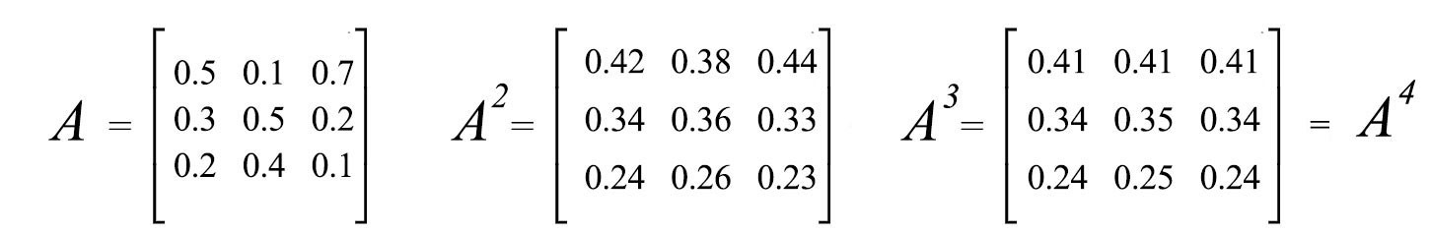

The PageRank paper has demonstrated that with 322 million page links, the solution converges to a tolerable limit in 52 iterations. So the solution scales unexpectedly well.

The Markov matrix leads us to the equation below which the steady-state depends on one principal component.



In machine learning, information is tangled in raw data. Intelligence is based on the ability to extract the principal components of information inside a stack of hay. Mathematically, eigenvalues and eigenvectors provide a way to identify them. Eigenvectors identify the components and eigenvalues quantify its significance. As a preview, the equation below decomposes information in A into components. We can prioritize them based on the square root of eigenvalues and ignore terms with small α values. This reduces the noise and helps us to extract the core information in A. (Details on a later article.)

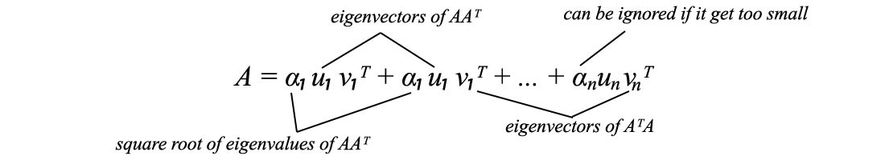

# Solution

I hope you can see the beauty of Ax = λx for now. Let’s see how can we solve it. Eigenvalues and eigenvectors can be calculated by solving (A - λI) v = 0. To have a solution other than v=0 for Ax = λx, the matrix (A - λI) cannot be invertible. i.e. it is singular. Its determinant is zero. det(A - λI) = 0 is called the **characteristic polynomial** and the eigenvalues are the root of this polynomial.

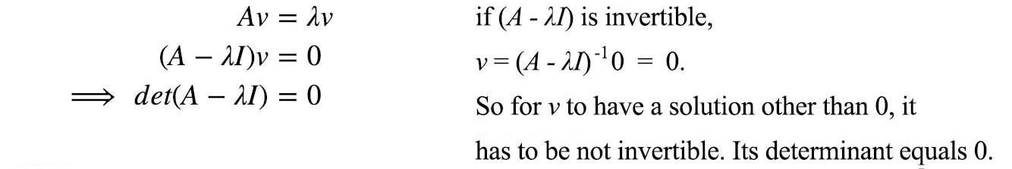

**Example**



The eigenvalues are:

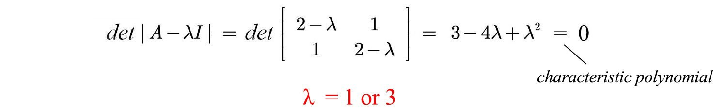

Apply Av = λv, we solve:



Let’s detail the step with a more complicated example,



To find the eigenvalue λ,

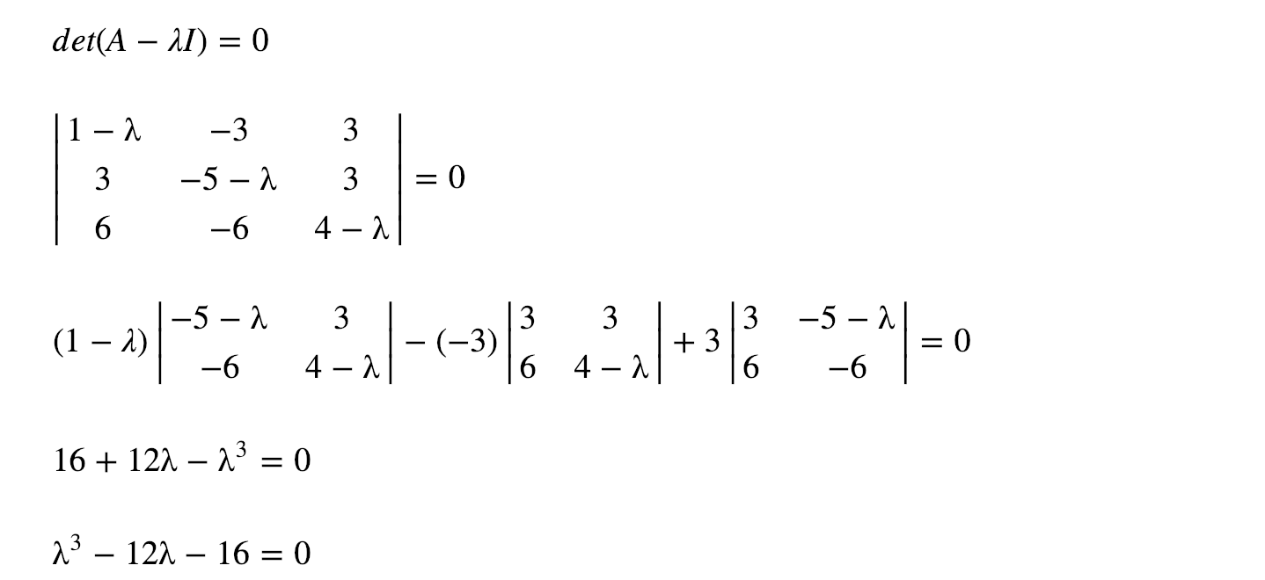

The possible factors for 16 are 1, 2, 4, 8, 16.

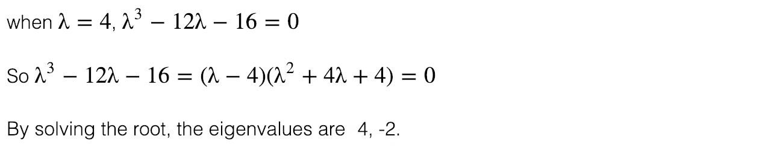

Let’s calculate the eigenvector for eigenvalue λ = 4 through **row reduction**.

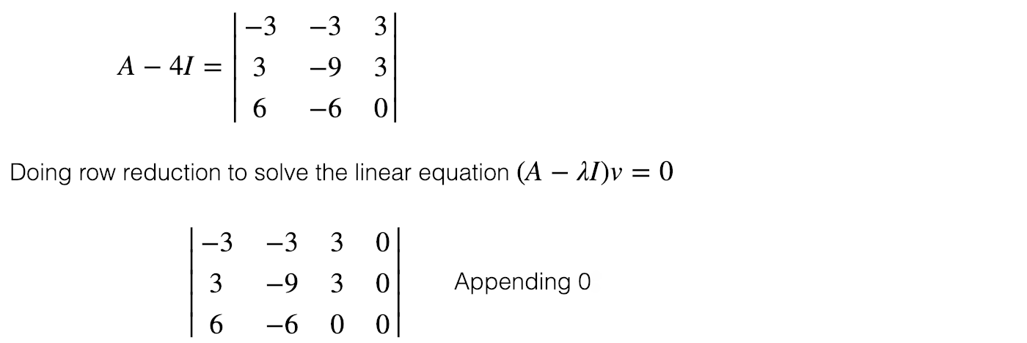

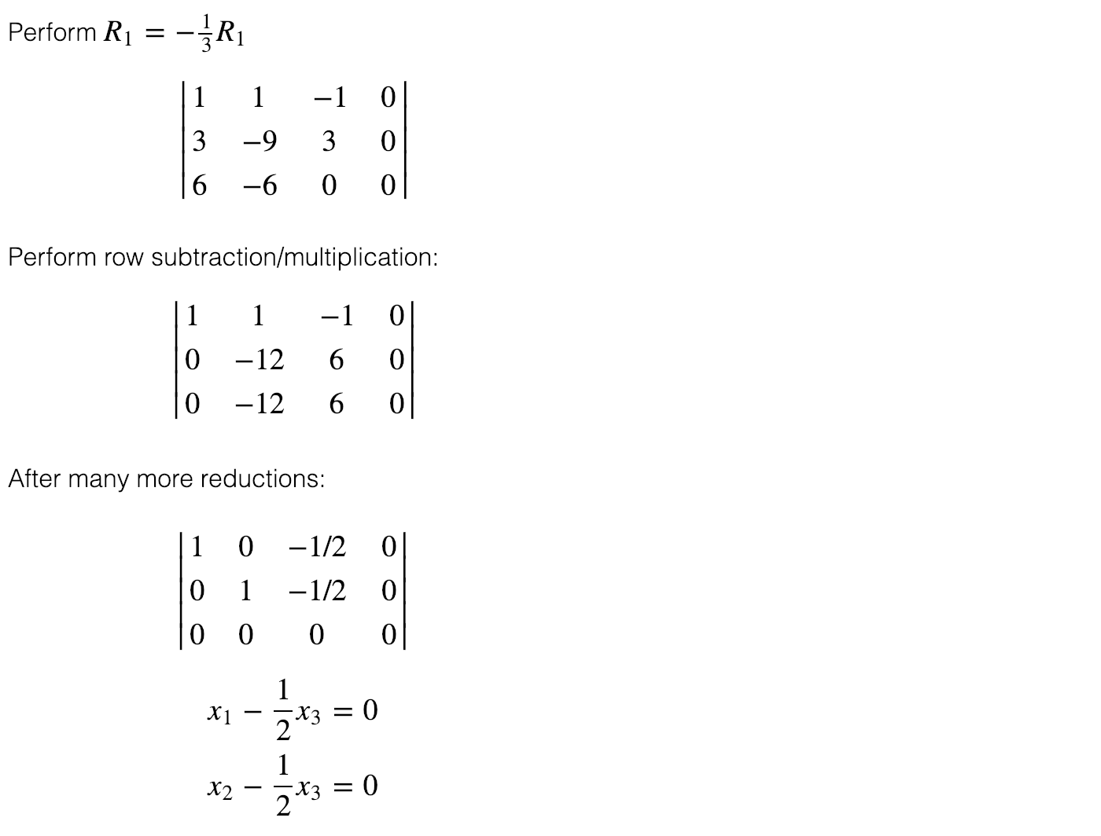

We have three variables with 2 equations. We set x₃ arbitrary to 1 and compute the other two variables. So for λ=4, the eigenvector is:



We repeat the calculation for λ=-2 and get



With 3 variables and 1 equation, we have 2 degrees of freedom in our solution. Let’s set the value to one in one of the degrees of freedom while other(s) to 0. i.e. setting x₂=1, x₃=0, and x₂=0, x₃=1 separately, the calculated eigenvectors will be:



Note that the solution set for eigenvalues and eigenvectors are not unique. we can rescale the eigenvectors. We can also set different values for x₂, x₃ above. Hene, it is possible and desirable to **choose** our eigenvectors to meet certain conditions. For example, for a symmetric matrix, it is always possible to choose the eigenvectors to have unit length and orthogonal to each other.

In our example, we have a repeated eigenvalue “-2”. It generates two different eigenvectors. However, this is not always the case — there are cases where repeated eigenvalues do not have more than one eigenvector.

# Diagonalizable

Let’s assume a matrix A has two eigenvalues and eigenvectors.



We can concatenate them together and rewrite the equations in the matrix form.



We can generalize it into any number of eigenvectors as



since

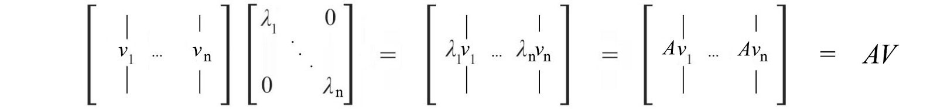

where V concatenates all the eigenvectors and Λ (the capital letter for λ) is the diagonal matrix containing the eigenvalues.

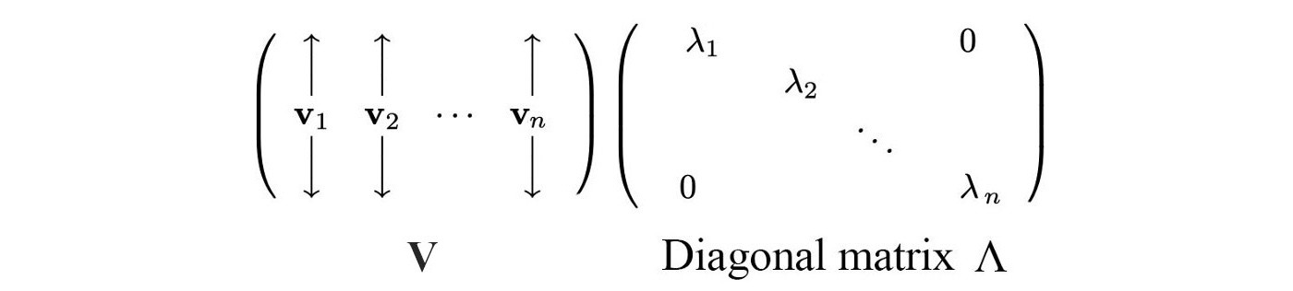

A square matrix **A** is **diagonalizable** if we can convert it into a diagonal matrix, like



i.e.,



An n × n square matrix is diagonalizable if it has n linearly independent eigenvectors. If a matrix is symmetric, it is diagonalizable. If a matrix does not have repeated eigenvalue, it always generates enough linearly independent eigenvectors to diagonalize a vector. If it has repeated eigenvalues, there is no guarantee we have enough eigenvectors. Some will not be diagonalizable.

# Eigendecomposition

If **A** is a square matrix with N linearly independent eigenvectors (v₁, v₂, … & vn and corresponding eigenvalues λ₁, λ₂, … & λn), we can rearrange



into



For example,

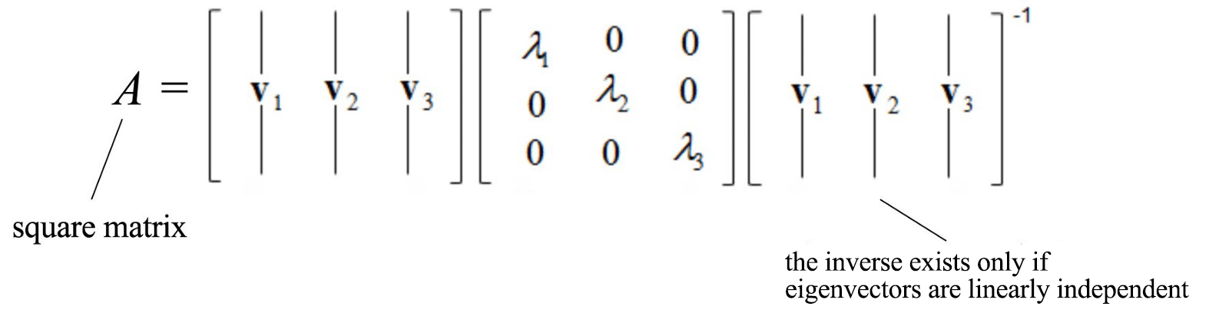

However, there are some serious limitations on eigendecomposition. First, A needs to be a square matrix. Second, V may not be invertible. As a preview, SVD solves both problems and SVD decomposes a matrix into orthogonal matrices which are easier to manipulate. But for matrices like symmetric matrices, this is not a problem. The power of a diagonalizable matrix A is easy to compute.



This demonstrates the power of decomposing a matrix that can be manipulated easily.

*To recap, for states that can be expressed as*



Aᵏ *can be computed with eigenvalues.*

# Properties of eigenvalue & eigenvectors

* Ax lies on the same line as the eigenvector x (same or opposite direction).
* The sum of eigenvalues equals the trace of a matrix (sum of diagonal elements).
* The product of eigenvalues equals the determinant.
* Both conditions above serve as a good insanity check on the calculations of eigenvalues.
* If no eigenvalue is repeated, all eigenvectors are linearly independent. Such an n × n matrix will have n eigenvalues and n linearly independent eigenvectors.
* If eigenvalues are repeated, we may or may not have all n linearly independent eigenvectors to diagonalize a square matrix.
* The number of positive eigenvalues equals the number of positive pivots.
* For Ax = λx,



* If A is singular, it has an eigenvalue of 0. An invertible matrix has all eigenvalues non-zero.
* Eigenvalues and eigenvectors can be complex numbers.
* Projection matrices always have eigenvalues of 1 and 0 only. Reflection matrices have eigenvalues of 1 and -1.

# More thoughts

Eigenvalues quantify the importance of information along the line of eigenvectors. Equipped with this information, we know what part of the information can be ignored and how to compress information (SVD, Dimension reduction & PCA). It also helps us to extract features in developing machine learning models. Sometimes, it makes the model easier to train because of the reduction of tangled information. It also serves the purpose to visualize tangled raw data. Other applications include the recommendation systems or financial risk analysis. For example, we suggest movies based on your personal viewing behavior and others. We can also use eigenvectors to understand the correlations among data. Develop trends of the information and cluster information to find the common factors, like the combination of genes that triggers certain kind of disease. And all of them start from the simple equation:



Matrices are not created equally. It is important to know the properties of some common matrices in machine learning. Next, we will take a look at it.

**Machine Learning & Linear Algebra — Special Matrices**

In literature, we often deal with statements like “since the matrix is symmetric, it has orthonormal eigenvectors”. It sounds like you should know them by heart. In linear algebra, there are special matrices with properties that are easy to analyze and to manipulate. They may have specific eigenvalues or special relationship among their eigenvectors. They obey rules that make operations easy. And there are methods to factorize a matrix into these “easier” matrices.



The reduction in operation complexity improves scalability. However, even these matrices are special, they are no way uncommon. In machine learning and many applications, we deal with them all the time. In this article, we will introduce them so you feel less intimidated when you heard “positive definite matrix has all positive eigenvalues”.

# Diagonal matrix

A diagonal matrix **S** has all non-diagonal elements equal zero.



Many factorization methods have one of the decomposed matrices to be a diagonal matrix. Since the matrix contains diagonal elements only, we sometimes write it in term of a vector.



The inverse of a generic matrix is not easy to calculate. But finding the inverse of a diagonal matrix is easy. We can replace the diagonal element with 1/m.



Also, matrix multiplication is much simpler if one of the matrices is diagonal. But when any diagonal element equals zero or the diagonal matrix is not square, its inverse does not exist. But yet, pseudo inverse (keep the inverse of 0 as 0) can be used as a substitute in some methods.

# Orthogonal matrix

An orthogonal matrix **Q** is a **square** matrix that fulfills the following requirement.



All the columns (v₁, …, vᵢ , …) in Q are orthonormal, i.e. vᵢᵀ vⱼ =0 for i≠j and vᵢ are all unit vectors.



This sounds like a tough requirement but for some matrix, like a symmetric matrix, we can choose our eigenvectors to be orthonormal during factorization.

The following matrix is orthogonal.



And

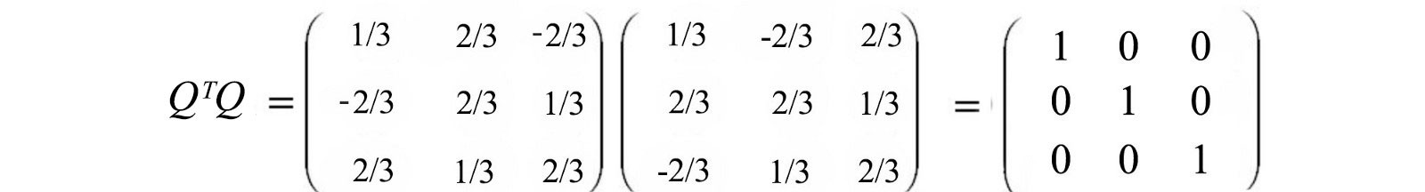

Like a diagonal matrix, its inverse is very easy to compute — the inverse of an orthogonal matrix is its transpose. This is one key reason why orthogonal matrices are so handy.



**Proof:**



If we multiply x with an orthogonal matrix, the errors present in x will not be magnified. This behavior is very desirable for maintaining numerical stability.



The relation QQᵀ=I simplify my relationship. For example, for projection, This property simplifies many computations like [projections](https://medium.com/@jonathan_hui/machine-learning-linear-algebra-a5b1658f0151).



And the projection vector can be simplified as



where qᵢ is column i of Q.

# ****Symmetric matrix****

A matrix is symmetric if its transpose equals itself.



For example,



Symmetric matrices are one of the most important matrices in linear algebra and machine learning. In machine learning (ML), we often use matrices to hold f(vᵢ , vⱼ). Such functions are often symmetrical, f(x, y) = f(y, x), and the corresponding matrix is therefore symmetric. For instance, in machine learning, f can measure the feature distance between data points or calculates the covariance of features.

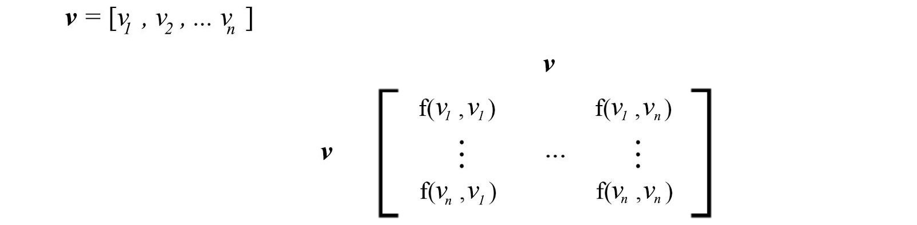

**Symmetric Matrix Properties**

A symmetric matrix **S** is an n × n square matrices.

* Its inverse is also symmetrical.
* All eigenvalues of S are real (not a complex number).
* We can choose n eigenvectors of S to be orthonormal even with repeated eigenvalues.
* A symmetric matrix can be formed by multiplying a matrix **A** with its transpose — **AᵀA** or **AAᵀ** (usually AᵀA ≠ AAᵀ). In machine learning, the covariance matrix with zero-centered data is in this form.



* **AᵀA** isinvertible if columns of A are linearly independent.
* Every symmetric matrix S can be diagonalized (factorized) with Q formed by the orthonormal eigenvectors vᵢ of S and Λ is a diagonal matrix holding all the eigenvalues.



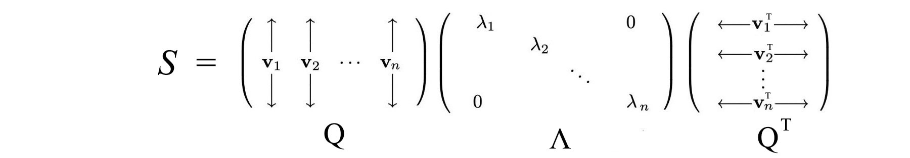

The equation above can be rewritten as



where v are unit vectors. Therefore the eigenvalue term λᵢ dominates the importance of each term above. In fact, if it is too small, we can drop the corresponding term λᵢvᵢvᵢᵀ completely.

This factorization property and “S has n orthogonal eigenvectors” are two important properties for a symmetric matrix.

**Orthonormal eigenvectors**

Eigenvectors are not unique. But often, we can “choose” a set of eigenvectors to meet some specific conditions. As mentioned before, the eigenvectors of a symmetric matrix can be chosen to be orthonormal. If S is a symmetric matrix, its eigenvalue λ and μ fulfill the following condition.

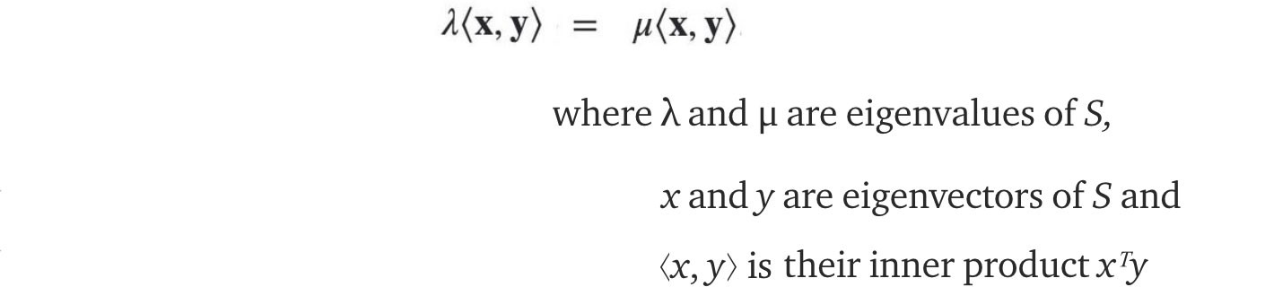

**Proof**

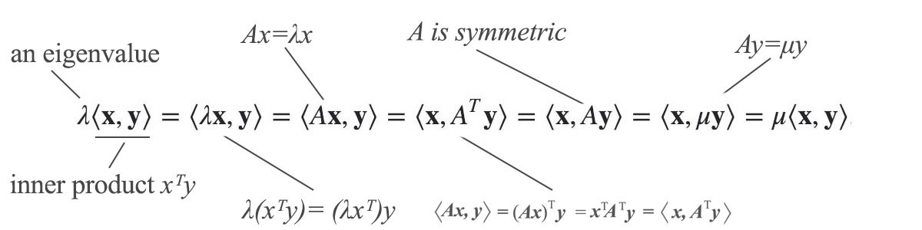

From this condition, if λ and μ have different values, the equivalency force the inner product to be zero. Therefore, x and y are orthogonal and it is easy to normalize them to have unit length — orthonormal. This proves that we can choose eigenvectors of S to be orthogonal if at least their corresponding eigenvalues are different. But even with repeated eigenvalue, this is still true for a symmetric matrix.

**Proof — part 2 (optional)**

For an n × n symmetric matrix, we can always find n independent orthonormal eigenvectors. The largest eigenvalue is



To find the maximum, we set the derivative of r(x) to 0. After some manipulation, it can be shown that



i.e. r(x) achieves the highest ratio if x is an eigenvector with the largest eigenvalues. By induction, we can deduce that we can find the next highest eigenvalue with an eigenvector orthogonal to the previous one. This is only a high-level description of the proof. For details, please refer to section 7.2 in Gilbert Strang’s book (see reference at the end).

**Spectral theorem**

Let’s summarize. Every n × n symmetric matrix **S** has n real eigenvalues λᵢ with n chosen orthonormal eigenvectors vᵢ.



These eigenvalues can form a diagonal matrix Λ as diag(λ). We can also concatenate eigenvectors vᵢ to form V. i.e.,



We rename V as Q. Because Q is orthogonal, it is invertible and Qᵀ = Q⁻ ¹. Therefore, the symmetric matrix **S** can be factorized into



This is the Spectral theorem. Because finding transpose is much easier than the inverse, a symmetric matrix is very desirable in linear algebra.

# ****Positive Definite Matrix****

Positive definite matrix has all positive eigenvalues. It is **symmetric** so it inherits all the nice properties from it. It sounds unusual but many matrices in real-life problems are positive definite. The term below computes the **energy** of a system with state **x**. If **S** is positive definite, it guarantees the energy stays positive unless **x** is zero.



So if energy is positive, the corresponding S should be positive definite.

There are many equivalent conditions to test positive definiteness. A symmetric matrix **S** is positive definite if any of the tests below is true:

1. All eigenvalues > 0,



2. All upper left determinants > 0,



3. All pivots > 0,

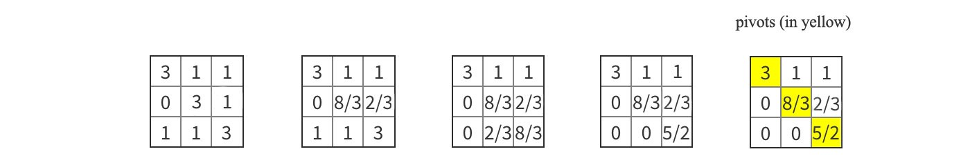

4. Energy > 0 except at **x** = 0,



5. **S** can be constructed by a matrix **A** having independent columns.



Verifying all eigenvalues is positive takes a lot of works. Therefore, condition 2 or 3 are a more common test. For example, positive pivots mean positive eigenvalues (or vice versa). On the other hand, if we prove a matrix is positive definite with one of the tests above, we guarantee that it owns all the properties above.

Beside positive definite, we also have positive semidefinite, negative definite and negative semidefinite. **Positive semidefinite** replace all the “>” conditions above with “≥”. For example, its eigenvalues are greater or equal to 0. **Negative definite** and **negative semidefinite** is the opposite of positive definite and positive semidefinite.

**Proof**

In this section, we will prove some of the property above. If **S** is positive definite, all λ is positive. Therefore, the computed energy of the corresponding state **x** is positive (except x = 0).



If **S** is composed of AᵀA, **S** is positive semi-definite under the energy test.



*AAᵀ and* *AᵀA* are positive semi-definite.

**Minimum**

In calculus, we set the first-order derivative of f to zero to find its critical point. However, such a point can be a maximum, a minimum or a saddle point. Many machine learning model expresses its cost function in the quadratic form xAᵀx. Knowing whether this function is a convex function is important. Since if it is convex, we know that the local minimum serves as the global minimum also. If A is positive definite, the quadratic function is convex.

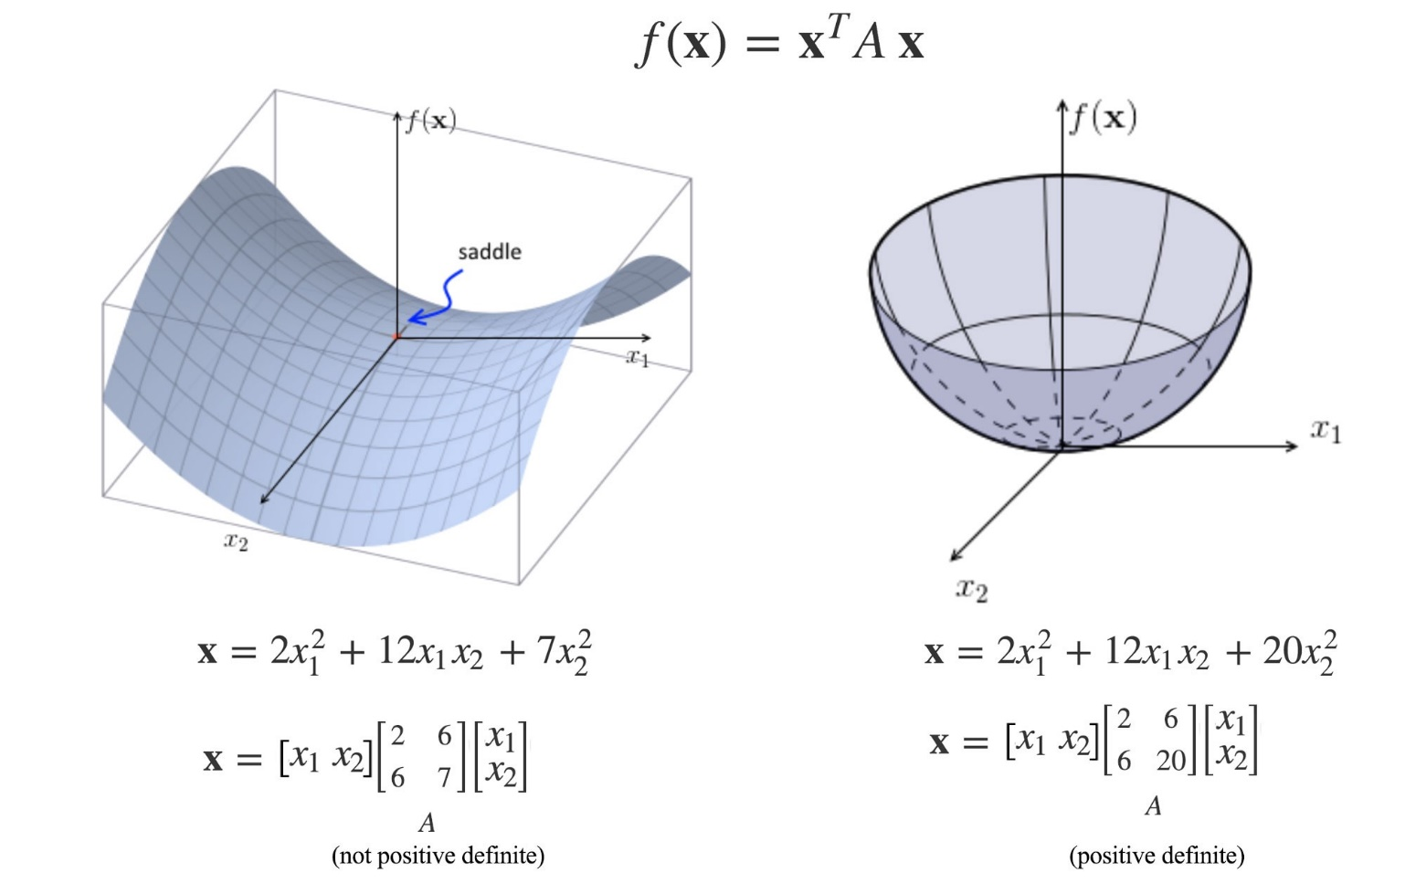

Modified from [source](http://mlwiki.org/index.php/Positive-Definite_Matrices)

For any function f, we compute the Hessian matrix below. If A is positive definite, the corresponding point is a local minimum.

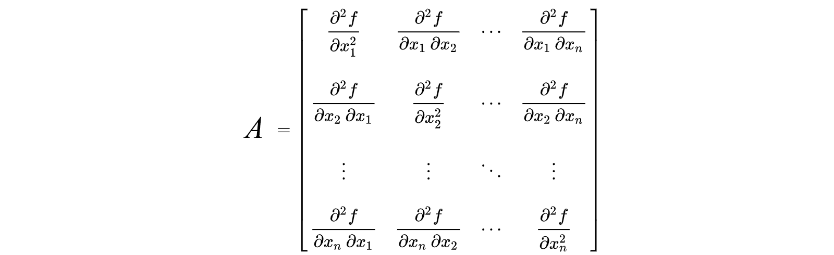

# ****Covariance matrix****

In machine learning, we are very interested in finding the correlation between properties. The figure below demonstrates a positive relationship between the weight and the height.

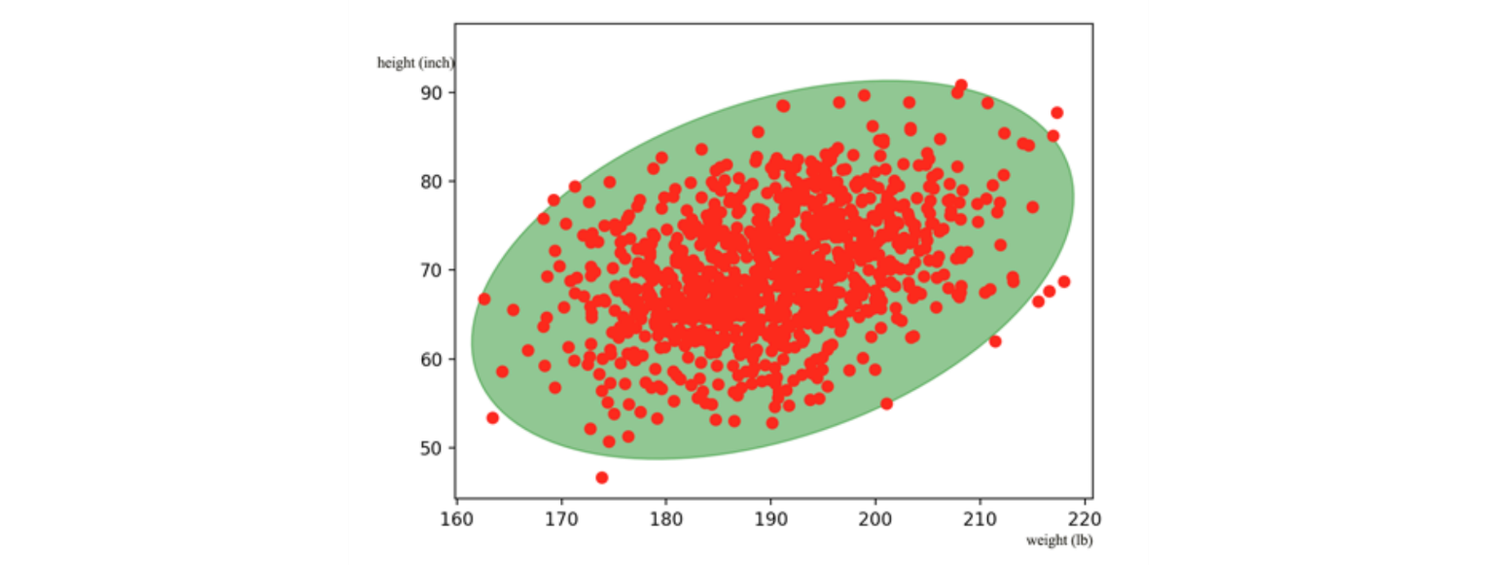

In machine learning, we model the relationship with a covariance matrix Σ.

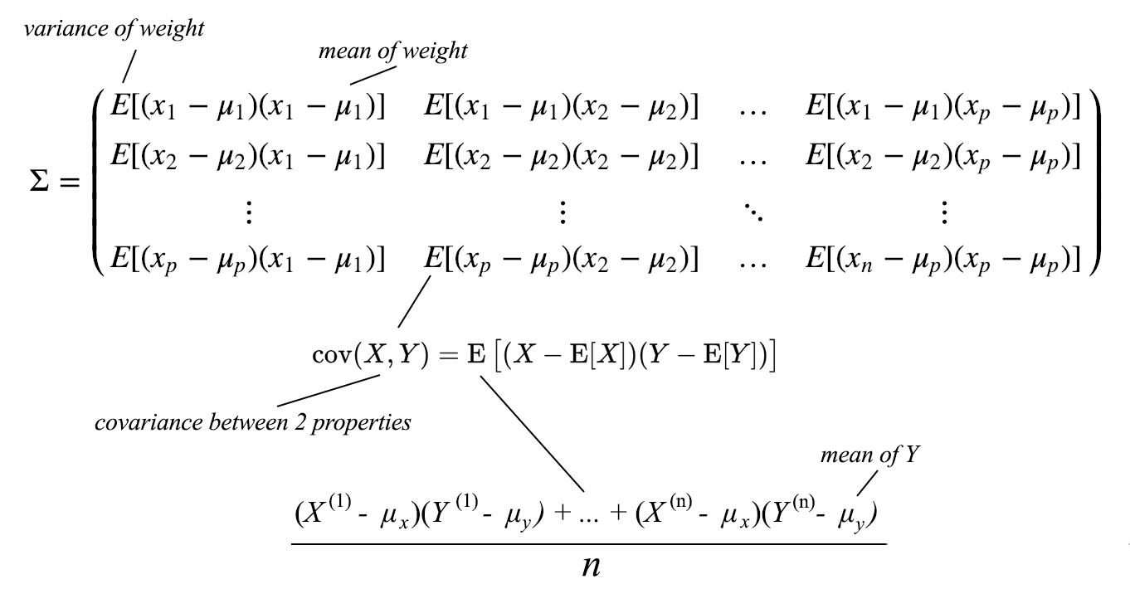

Covariance matrix is positive semidefinite.

**Machine Learning & Linear Algebra**

# Distributive, associative & communicative

Basic matrix behavior:



As shown in the last equation, matrices are **not commutable**.

# Transpose

By convention, a vector **x** is written as a column vector. Here are the transposes of a vector and a matrix.

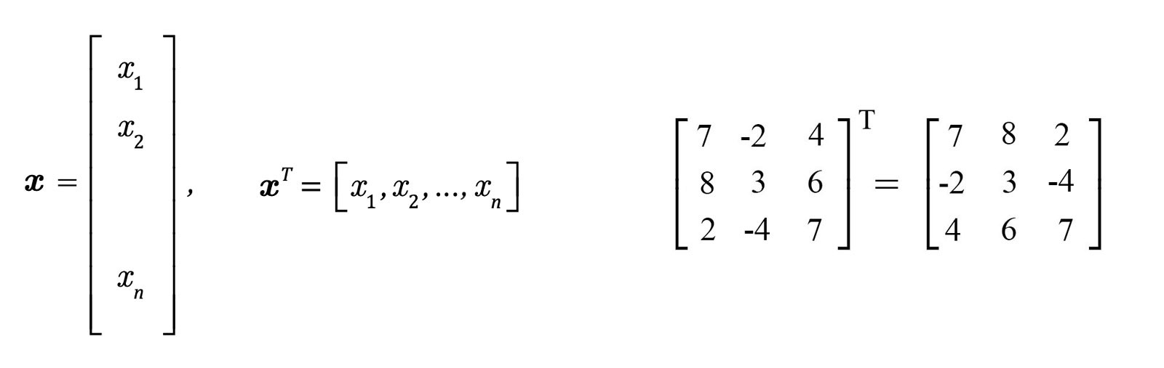

**Properties:**



A matrix is **symmetric** if A = Aᵀ. It is called **antisymmetric** (skew-symmetric) if A = -Aᵀ.

# Inner Product

The **inner product** ⟨a, b⟩ (or a・b) is a scalar function. The inner product for two vectors is defined as:



The transpose of any scalar value equals itself. You will see the following manipulation in many machine learning papers.



A unit vector is a vector with a unit length.



The angle between the two vectors u and v is



Vectors obey the following inequality



**Properties**



The last equation is important. Here is its proof:



# Outer product

Do not treat xᵀy the same as xyᵀ. The inner product xᵀy produces a scalar but the **outer product** xyᵀ produces a matrix.



The multiplication of two matrices is the sum of column i of A with row i of B.

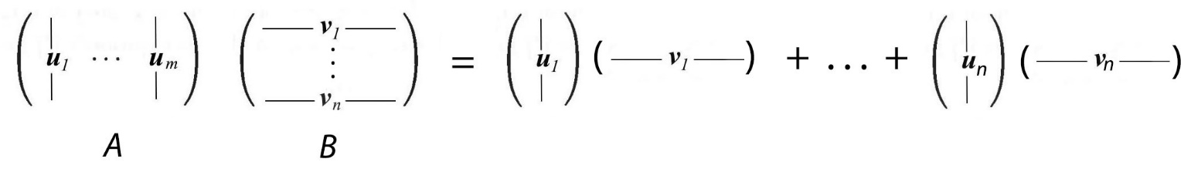

Example



This perspective of matrix multiplication seems odd but becomes very important when we look into matrix factorization.

# Derivative

In ML, we use matrices to store data. Objective functions and errors are expressed with matrices and vectors. To optimize a solution or to minimize an error, we need to know how to differentiate them. Let's define the notation for the derivative of a scalar y (f(**x**)) w.r.t. **x** as

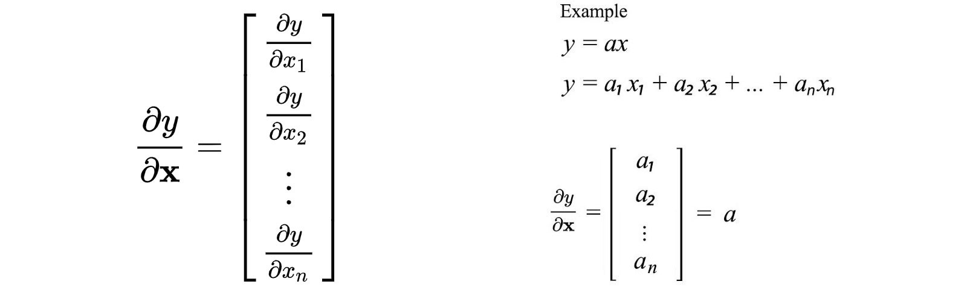

Here is the notation we will use for differentiating a vector **y** w.r.t. **x**.

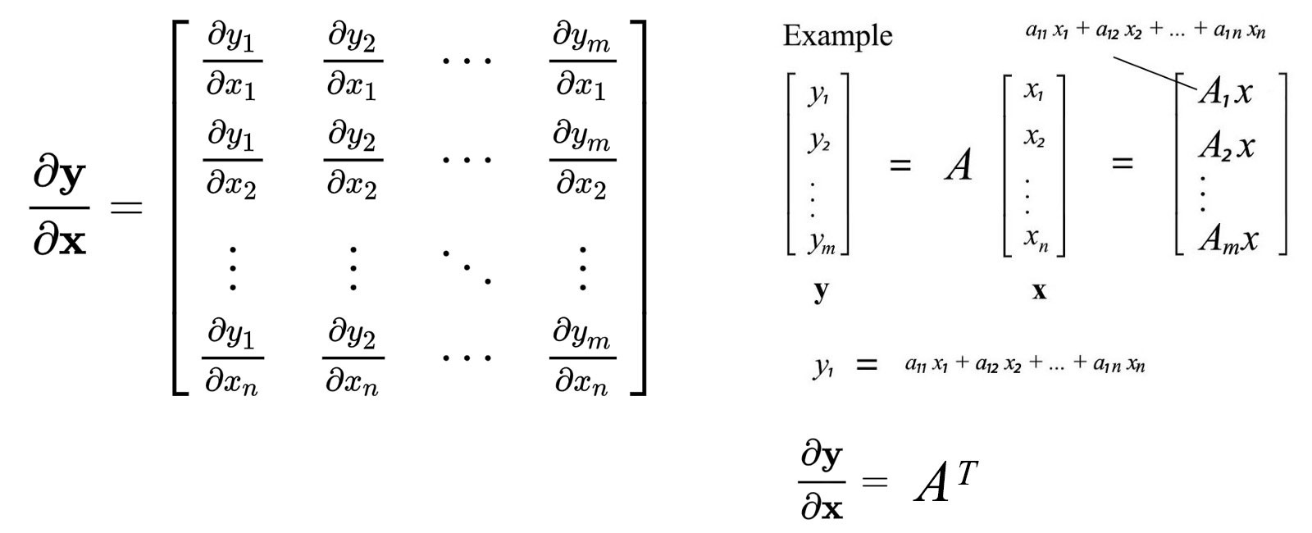

The notation above is called the denominator-layout notation (or Hessian formulation). Let’s calculate the derivative of vectors and matrices.

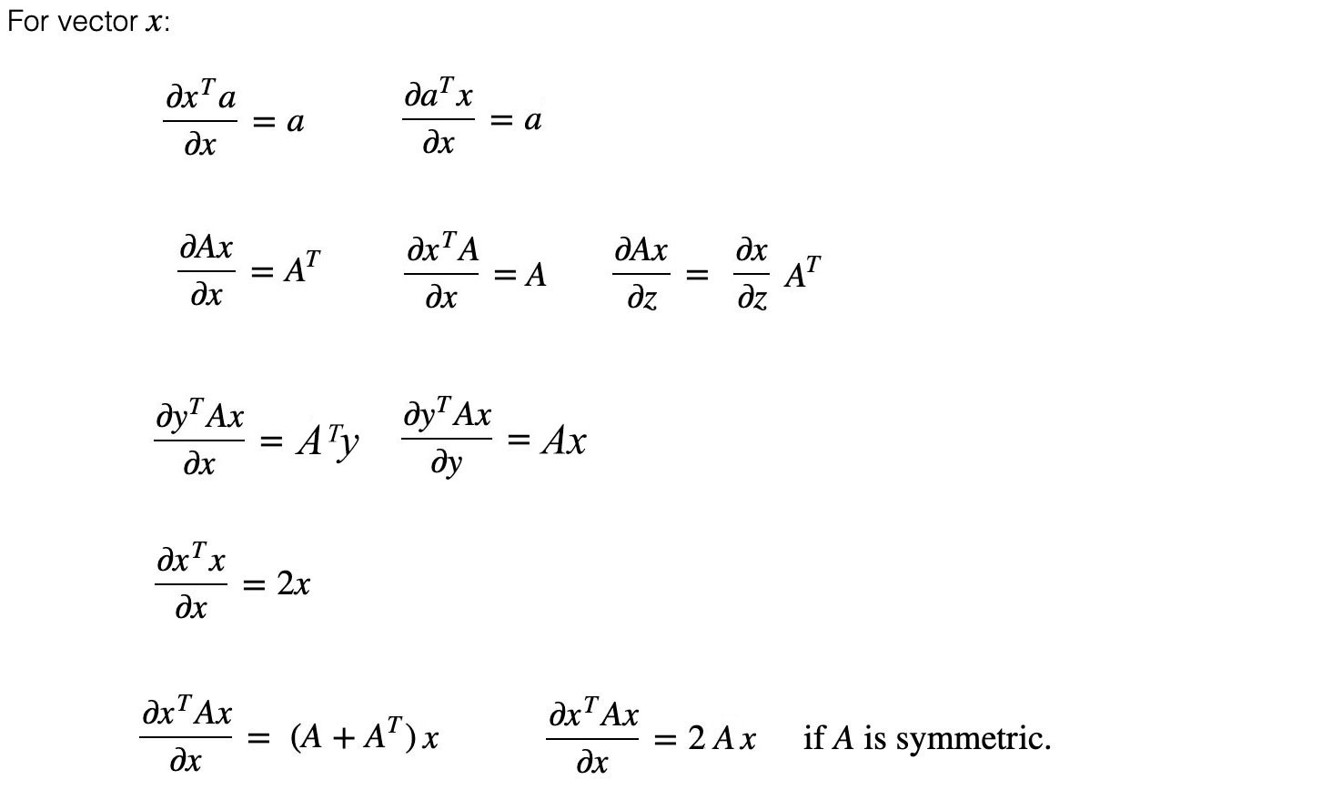

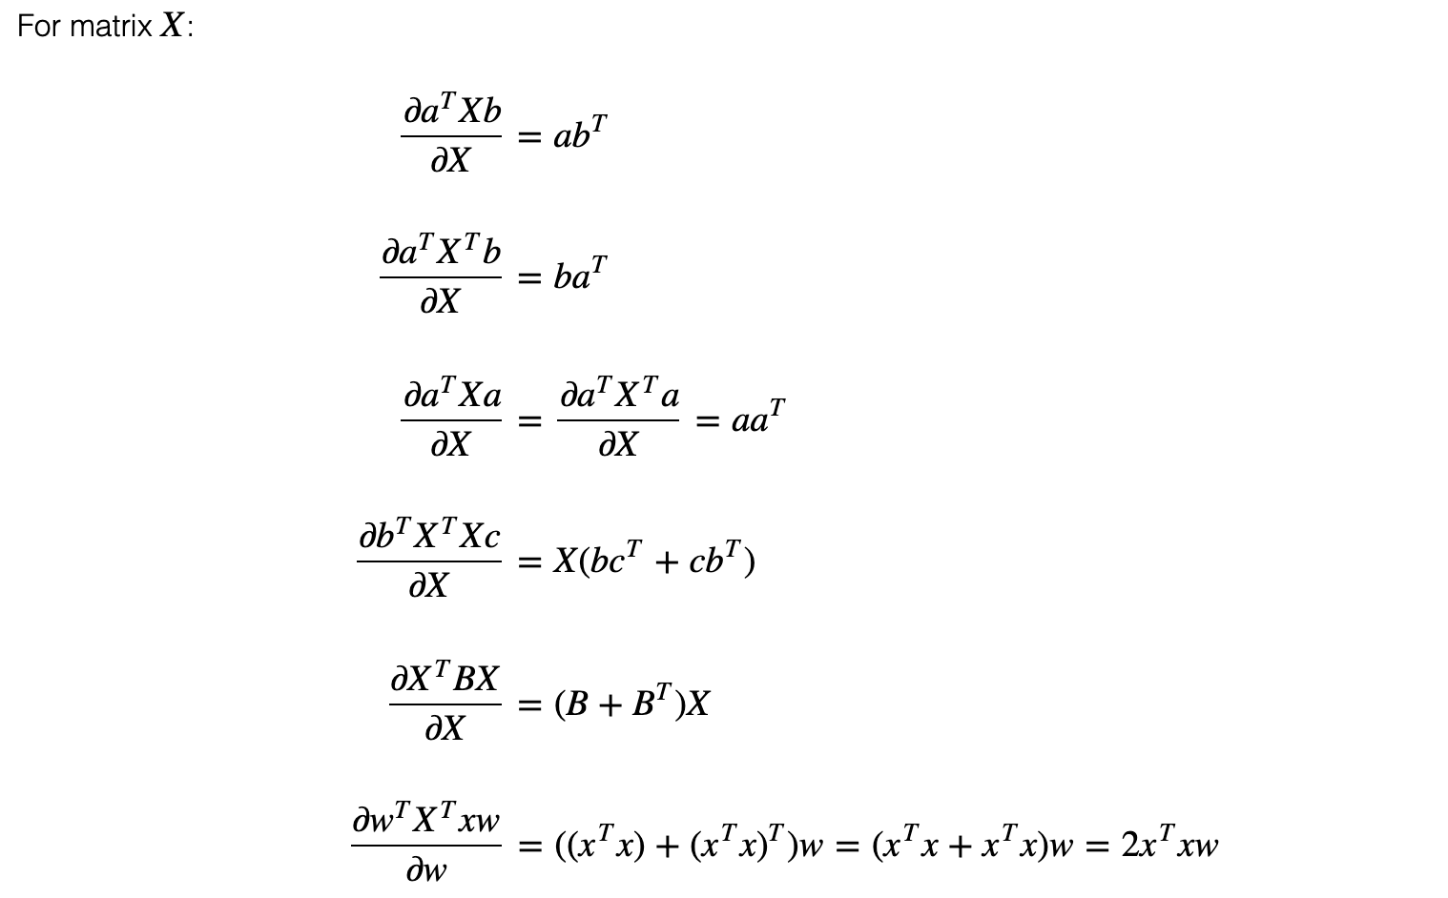

There are other notations. The numerator layout (Jacobian formulation) uses a column vector for the derivative of a scalar.

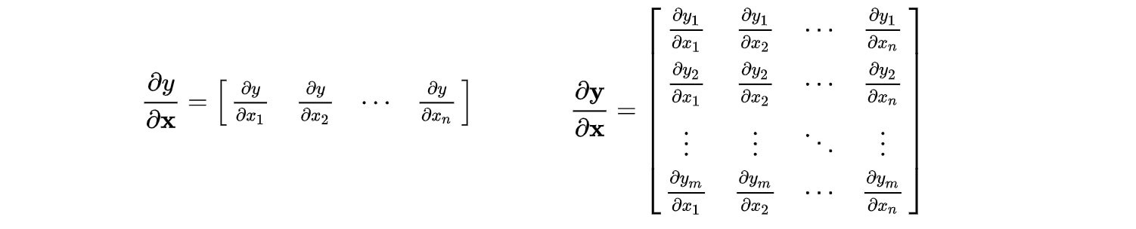

If this notation is used, the results of our previous equations need to be transposed.

Let’s optimizes the mean square error of linear regression and apply what we learn.

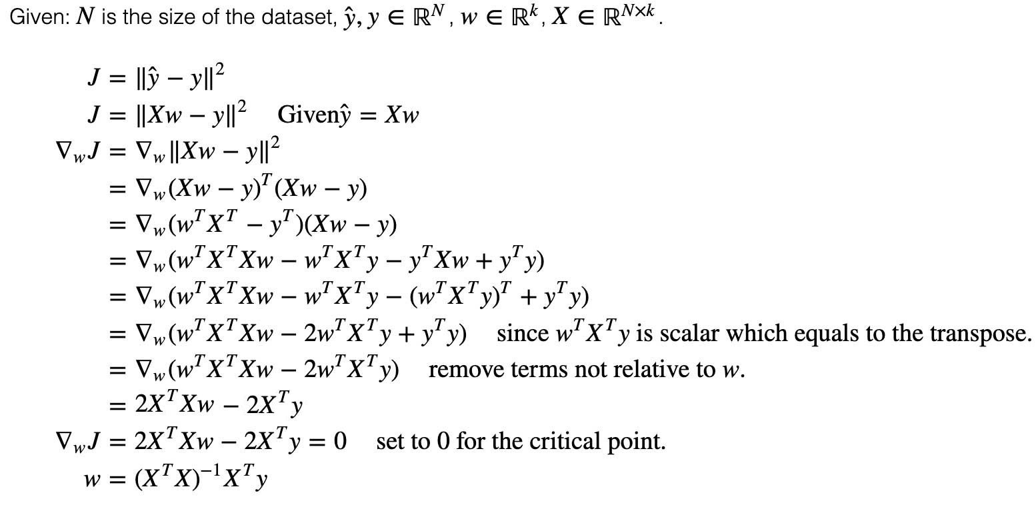

# Inverse

The **matrix inverse** of matrix A is defined as:



**Properties**:



**Note**: The property above is true only if A and B are invertible. It is not true even when A is a non-square matrix. (the matrix inverse assumes A is an n × n square matrix.) To solve a system of linear equations Ax=b, we can multiply the matrix inverse of A with b to solve x.



If A is not invertible, this method fails. We will need some other methods, like Gaussian elimination, to solve it.

We introduce the inverse above on the left side — left inverse. If it is introduced on the right side, it is called the right inverse.



For a square matrix, both are the same and we just call it the inverse. As a side note, because matrices are not commutable, the concepts of “right” and “left” appear frequently in many terms.

However, even inverse seems to be everywhere in literature, we avoid inverting an arbitrary matrix in practice. In machine learning (**ML**), we deal with many **sparse** matrices — a matrix mainly composed of zero-value elements. The inverse of a sparse matrix is dense and less desirable because of space and computational complexity. In addition, inverting a matrix can be **numerically unstable** — a small imprecision or error in the input can trigger a large error.

# Singular matrix

So what matrices are not invertible? A **singular** (**degenerate**) matrix is a square matrix that does not have an inverse. The following equations calculate the inverse of a 3 × 3 matrix.

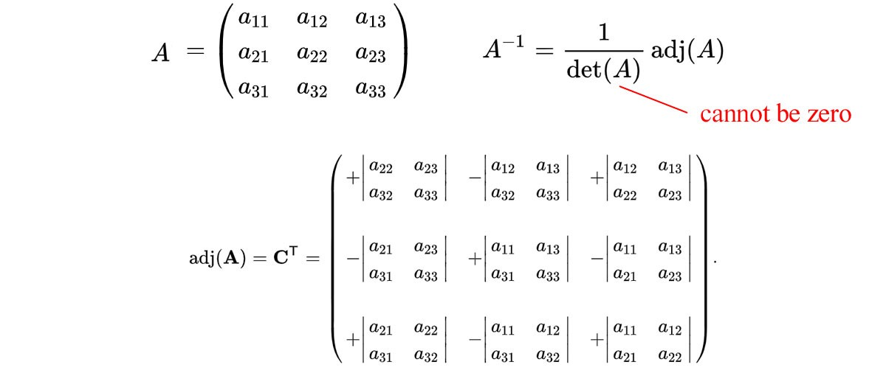

Modified from Wikipedia

For the inverse to exist, the determinant cannot be 0. For example, the matrix below is a singular matrix.



Its determinant equals 0. Therefore, it does not have an inverse.

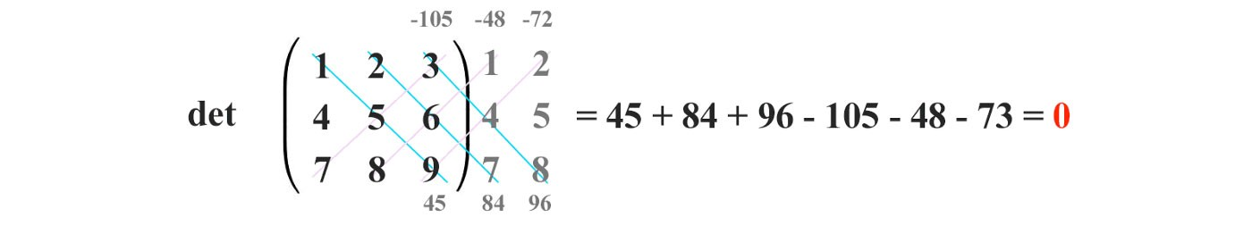

# Row space & column space

Vectors can be grouped to form a vector space. Rⁿ is a vector space containing all the n-dimensional real number vectors. Space can be divided into subspaces for further study. For example, R³ is a 3-D space and a plane is a subspace of R³.

Mathematicians love to create abstract concepts so one stone can kill two birds. By definition, if u and v are in a space, both u + v and cu (where c is a constant) must be in the same space. If not, they don’t form a space. This definition works for the subspaces also.

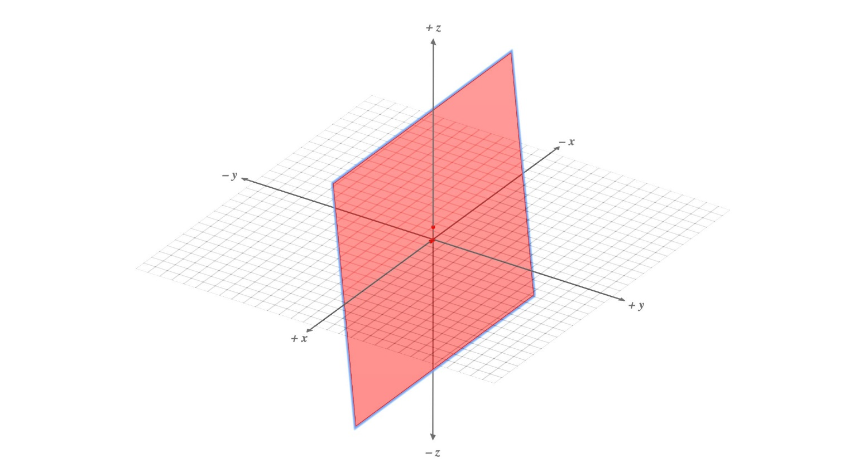

Expand the red plane outwards will create a subspace in R³

This is a very abstract definition. It does not limit itself to vectors. Indeed, many objects including polynomial functions can form a space. For example, polynomial functions of any order form a space. Add two polynomial functions of x together remains to be a polynomial.



The linear combination of columns of a matrix spans a space called the **column space**.

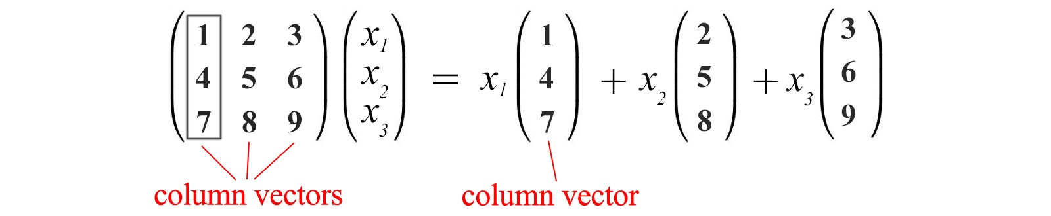

If all the column vectors above are linear independent, the column space spans the whole 3-dimensional space. However, the column vectors above are linear dependent. The third column vector is a linear combination of the first two columns.



We can remove the third column vectors in representing the column space of A. Therefore, the column space of this matrix **span** a plane only.

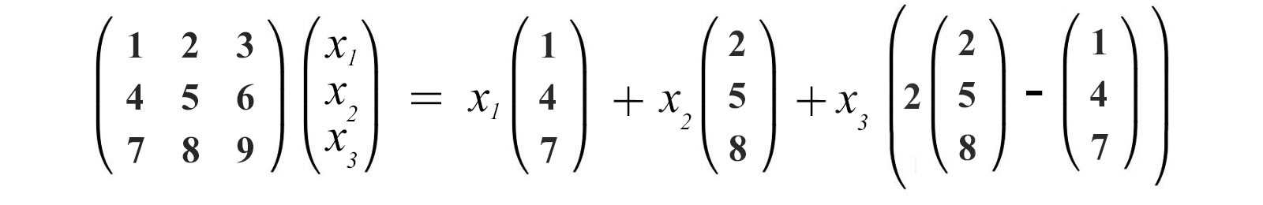

The concept that Ax is a linear combination of the column vectors of A is very fundamental. So, spend a few seconds to get used to this concept.



This equation is also presented in a more familiar form



where a₁ to an span the column space of A (the basis for the column space).

Similar, rows form row vectors in creating a **row space**.



If we use the notation C(A) for the column space of A, we can transpose A and C(Aᵀ) represent the row space of A.

# ****Linear dependency****

An n-dimensional space cannot have more than n linearly independent vectors. In the left diagram below, the vector in the green color can be expressed by the blue and the red vector. Two vector forms a plane in a 3-D space. Any vectors in the same plane, like the yellow vector below, is a linear combination of the red vectors.

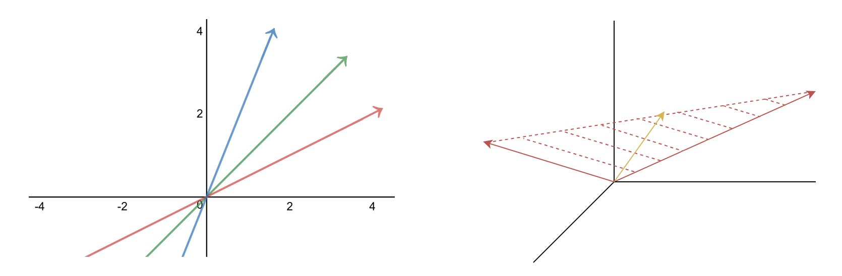

Mathematically, for a set of vectors to be linearly independent, it fulfills



only if all the linear factors cᵢ are 0. In short, any vector cannot be expressed as a linear combination of others. In addition, the columns of A are linearly independent if the only solution for





is



To have a solution other than 0, A needs to be singular. i.e.



Otherwise, we can compute the inverse and v has exactly one solution equals 0.



For *Ax = 0* to have a non-zero solution, *A* is singularand *det(A) = 0.*

This becomes useful when we study the eigenvectors later.

# Rank

Rank measures the linear independence of the columns/rows of A. It is the dimension span by these columns/rows. The **rank** of a matrix equals



For any matrix, the column space and row space have the same dimension (rank). Therefore, the rank of a matrix can be calculated either from rows or columns. The following are the ranks for different matrices.

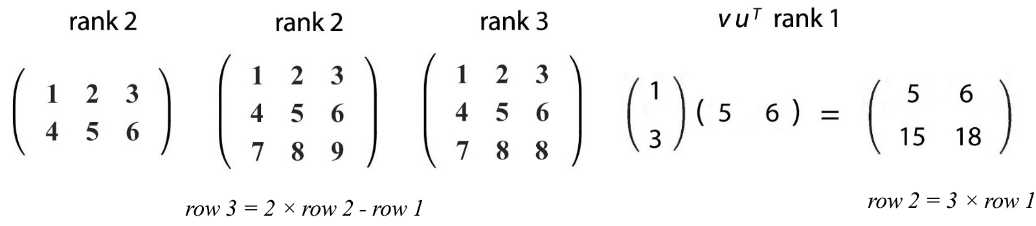

If a matrix is invertible, its inverse is unique. There will be exactly one solution for x=A⁻¹b. However, for a square matrix, if columns/rows are linearly dependent, the matrix is singular and not invertible.

In general, for any matrix, the rank of A determine the linear dependency. From there, we can determine whether we have a unique solution. The figure below demonstrates how we represent a system of linear equations in the matrix form and its number of solution.

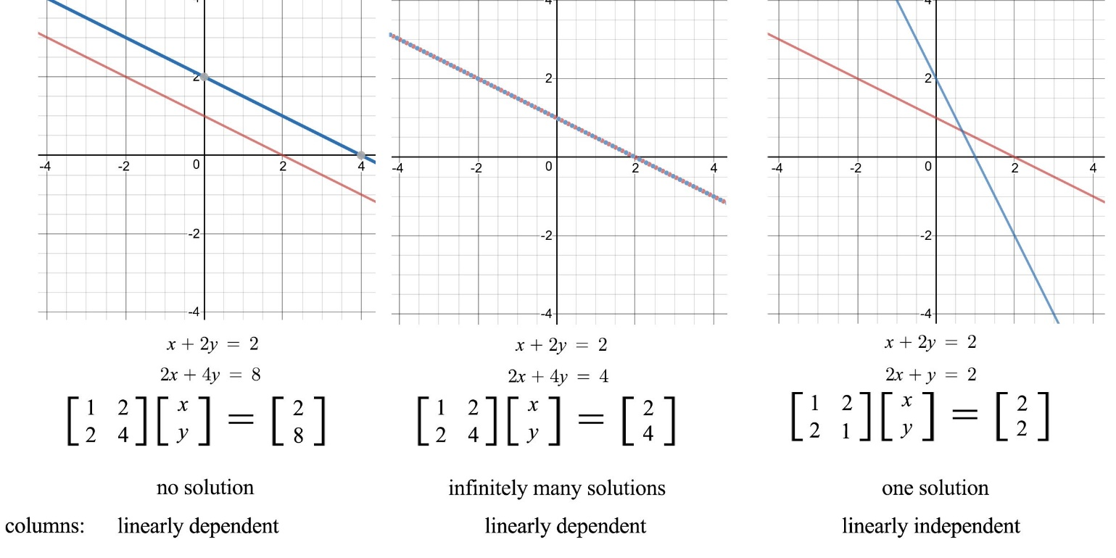

It has zero solution if b is not in the column space of A. i.e. the linear combination of columns in A cannot reach b.

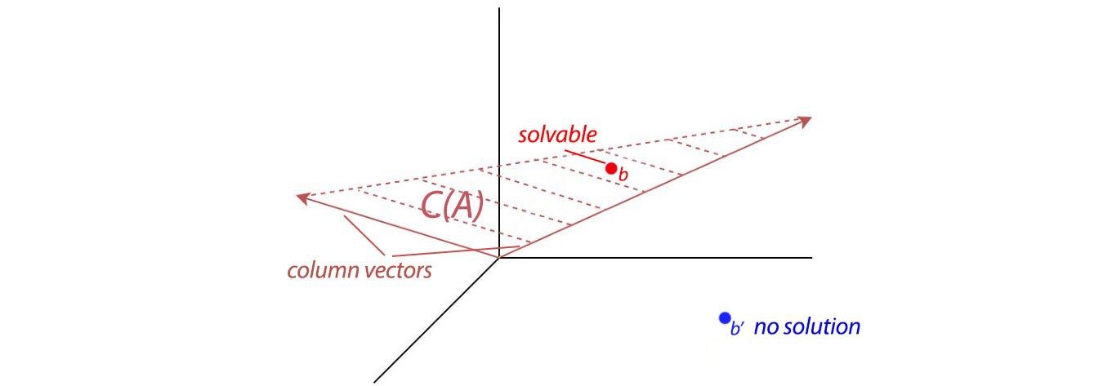

# Gaussian elimination & back substitution

As discussed before, we rarely compute the inverse of A to solve x for Ax=b. One most common method is Gaussian elimination and back substitution. Many people already know how to solve linear equations through this method. So I will go through it quickly and introduce some key terms. To solve,



We apply elimination to create leading zeros for row 2 and row 3 in the x₁ column. Once we are done with the column for x₁, we repeat the process for x₂ and x₃.

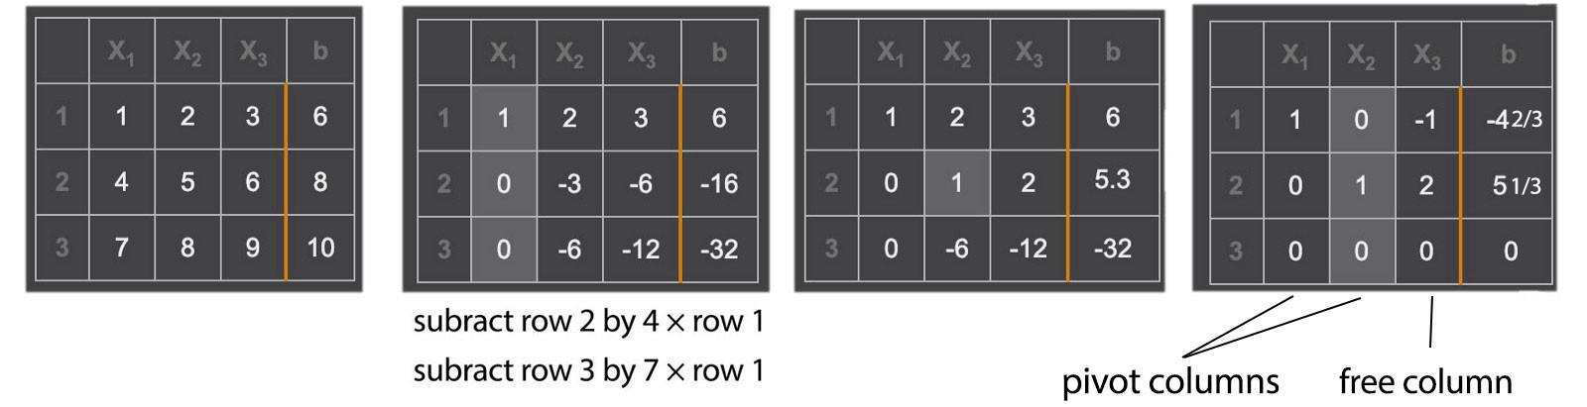

This matrix A can be eliminated into two rows with non-zero leading values. These two non-zero values are called **pivots**.



The rank of a matrix equals the number of pivots. After the elimination, we are left with two meaningful equations only. If an n × n matrix has less than n pivots, the matrix is singular. Excluding column b, the bottom row(s) will have all zeros.

The variables corresponding to a pivot in its column are called the **pivot variables**. The other variables are called free variables which can take infinitely many values. In the example above, we have two pivot variables (x₁, x₂) and one free variable x₃. After the elimination steps, the matrix associated with the variables **x**, forms an **upper triangular matrix**.



To solve Ax=b, we perform back substitution. Start from the bottom row and resolve one variable at a time from the bottom to the top.



If we set the free variable x₃ to 0, one particular solution will be



Let’s solve another example using pivots. After the row elimination, we use the non-zero values in column b to set those pivot variables and then, set all free variables to 0. This becomes the solution for x.

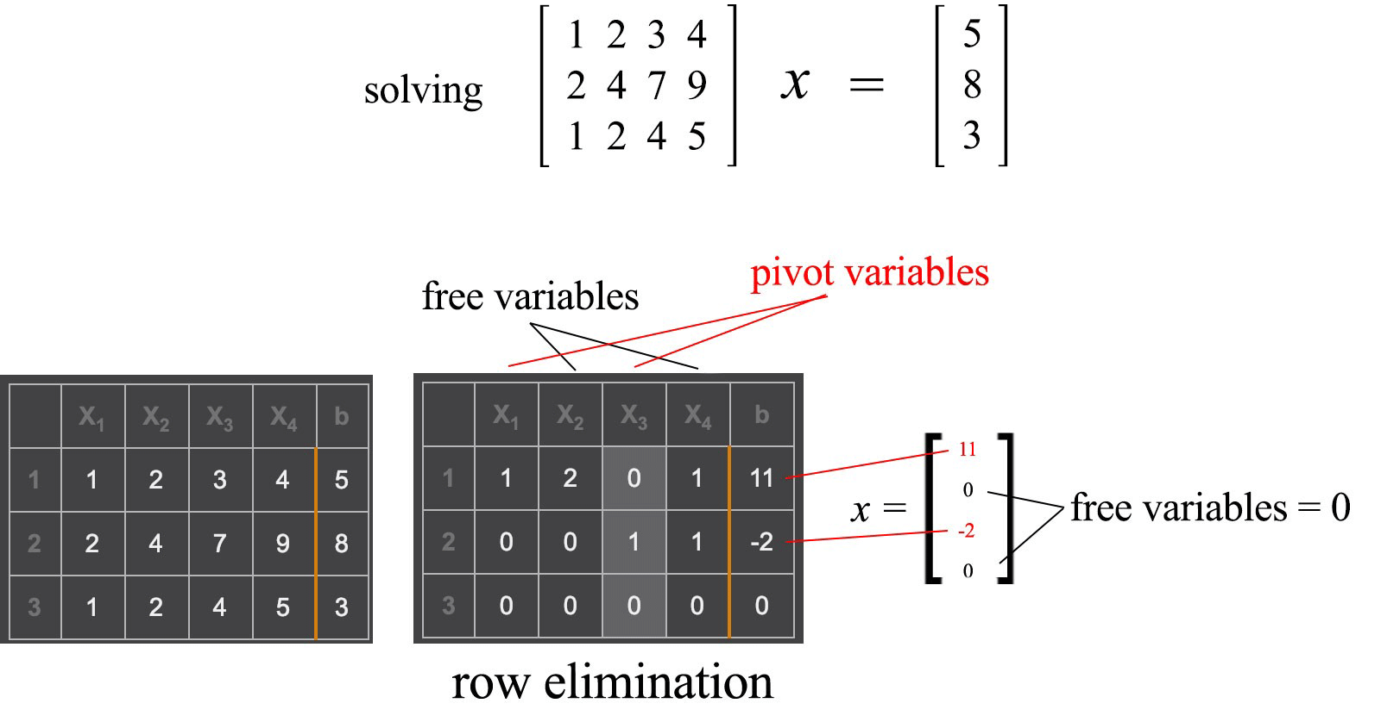

Consider Ax=b where A is an m × n matrix with rank r and x has n components. After row elimination, excluding the column b, the matrix will have m - r all zeros rows.

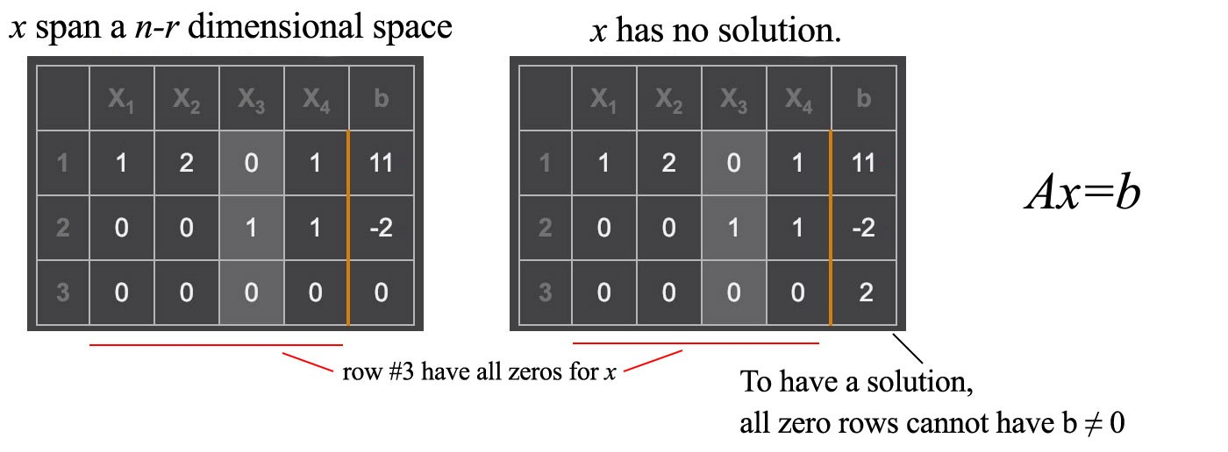

If any all zero rows have b ≠ 0, it has no solution. We cannot conclude 0=2 in the right diagram above. The linear equations are conflicting with each other. If the rank r is less than n, x span n - r dimensions. In other words, if we have r linearly independent equations to solve n variables in x, x will have n - r degrees of freedom as long as there are no conflicts in the equations.

**Gauss-Jordan Elimination**

The method we used is called Gauss-Jordan elimination. Here is an example of a non-singular matrix.

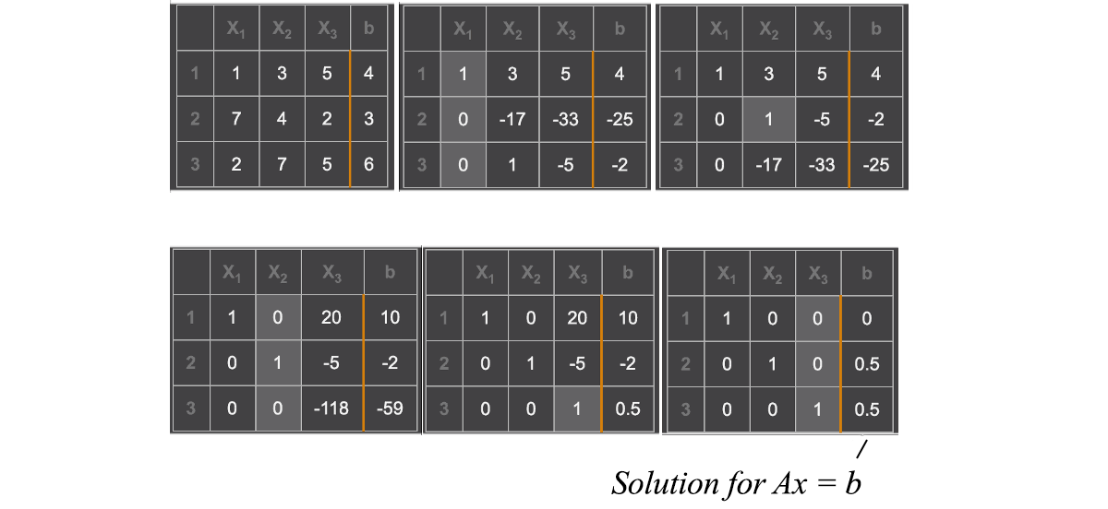

To find the inverse of A, we can replace b with an n × n identity matrix I. After the elimination, the columns holding the original identity matrix hold the inverse of A now.

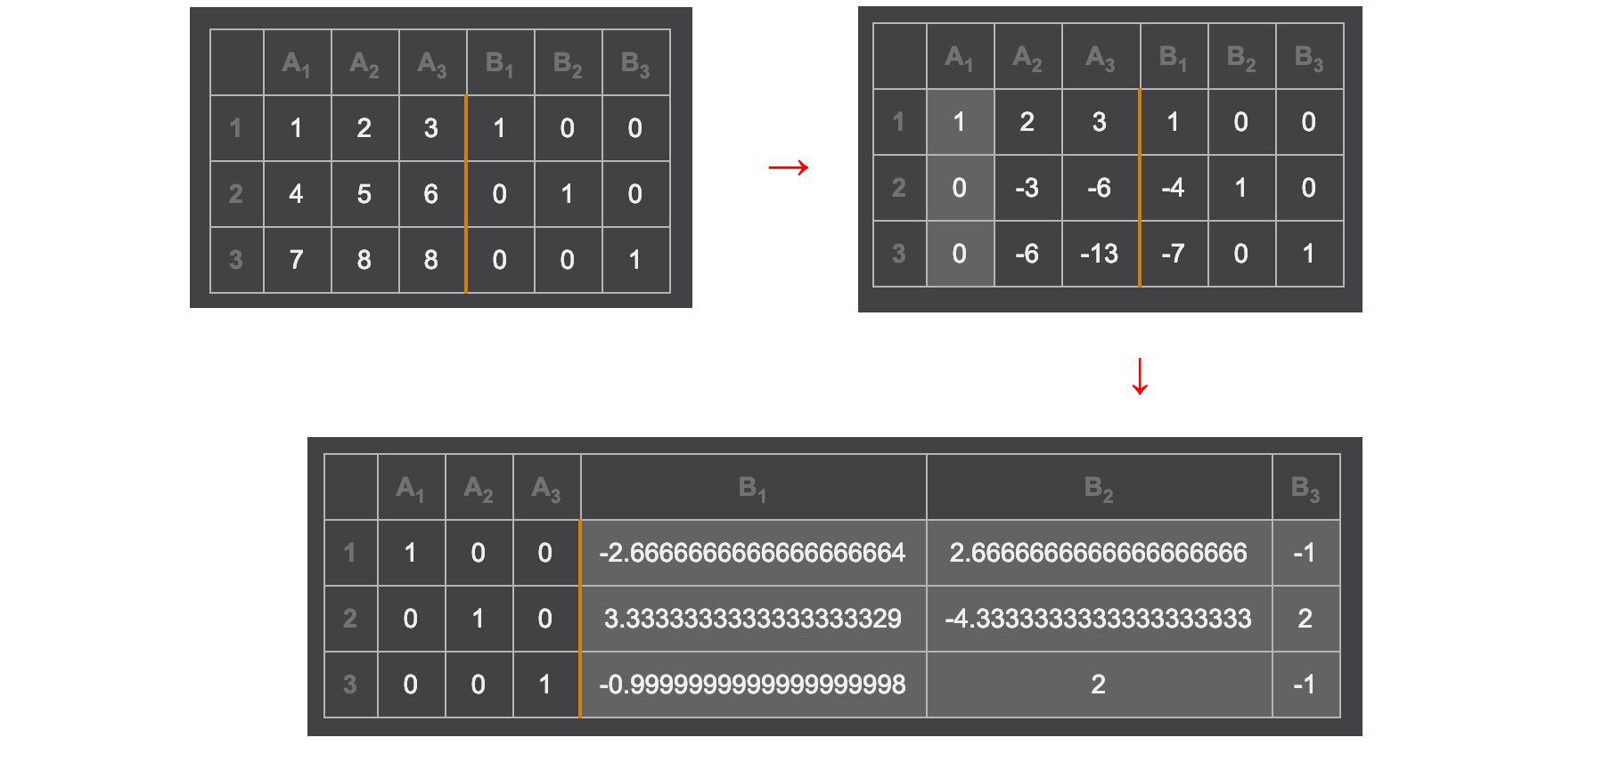

Computation has limited precision. When dealing with linear algebra, this is particularly important. In addition, we want the computation to be fast. We are blessed with libraries that handle the dirty work for us. So we will be brief here.

* Row exchange. With some clever exchange of rows, the row elimination and back substitution will be less vulnerable to rounding errors. Before a row elimination, if there is a huge difference in the scale of coefficients, we swap the top row with the underneath row that has the largest leading value. Without the reordering, the solution can be way off. Sometimes, rescaling a row may help also.

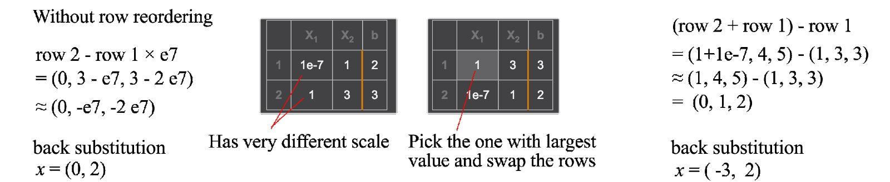

* Promoting & preserving the spareness of a matrix reduces the number of operation because we can ignore multiplying zero with any number. In matrix manipulation, we prefer the non-zero value to be located on a narrow band along the diagonal of a matrix.

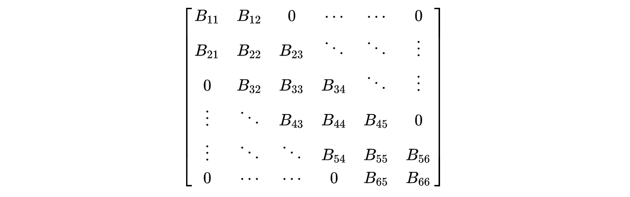

Band matrix (source Wikipedia)

# Nullspace & left nullspace

We have introduced the row space and column space. There are two more subspaces that are important. The space span by x below is called the **nullspace** of A, with notation N(A).



It contains all the solution for Ax=0. It contains at least x=0. Multiplying the row vector of A with x (the inner product) equals 0.



Therefore, any vectors in the row space are perpendicular to the nullspace. i.e.

*The row space of A is orthogonal to the nullspace of A.*

This matrix below has a rank of 2.



The column with the pivot variable is called the **pivot column** and one with the free variable is the **free column**. The number of free columns equals the number of columns minus the rank. As shown below, the corresponding free variables are x₂ and x₄.

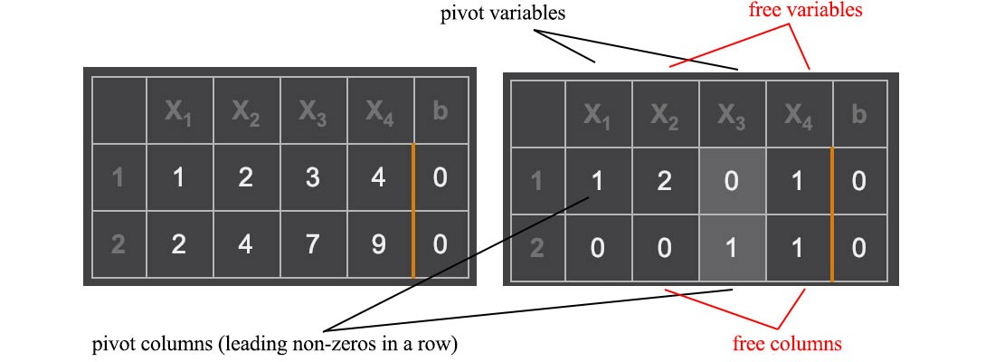

To solve Ax=0, we set each free variable to 1 with other free variables to 0 one at a time. With two free variables, we can derive two particular solutions.



The complete solution for Ax=0 will be any linear combination of the particular solutions which forms the nullspace with a rank of 2. As shown before, if columns in A are linear independent, the nullspace contains vector 0 only. Similarly, there is a **left nullspace** N(Aᵀ) which is orthogonal to the column space, i.e. Aᵀx = 0. Row space, column space, nullspace, and left nullspace form four fundamental subspaces from matrix A.

# Complete solution for linear systems

Previously, we just find one particular solution for **Ax=b**. It can have infinitely many or none if A is singular. Let’s find a complete solution now.

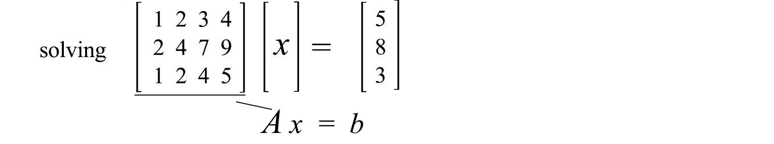

First, find a particular solution first.

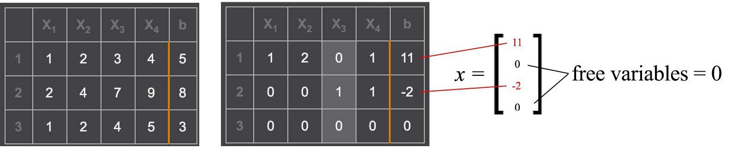

Next, find the solutions for **Ax=0**. A has a rank of two and therefore, we can find 2 (4 – 2=2) independent solutions.

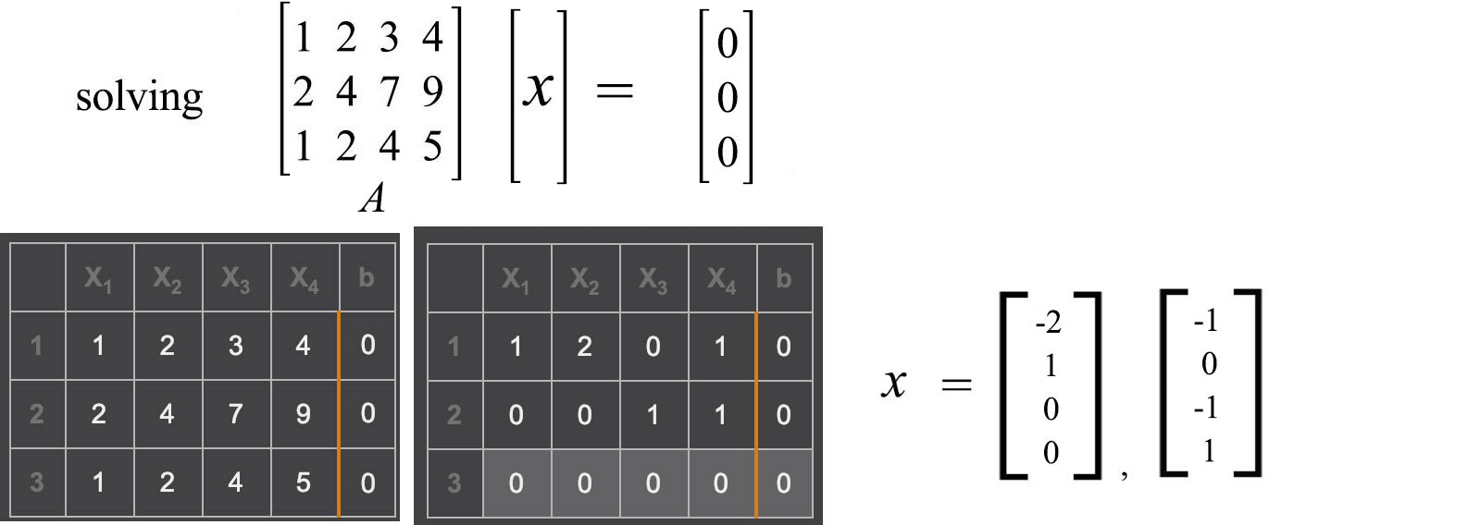

The complete solution is the particular solution pluses any linear combination for the solutions of Ax=0.

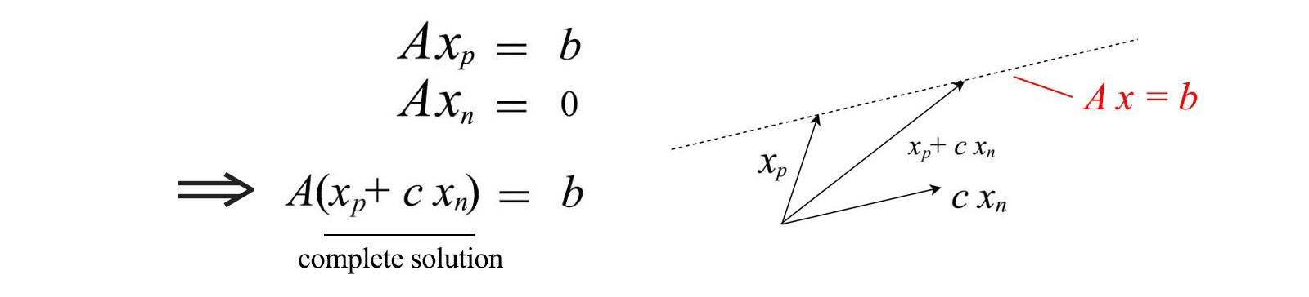

Graphically, this is the dotted line above for a 2-D example. The equation below is the complete solution for our example where cᵢ is constant.

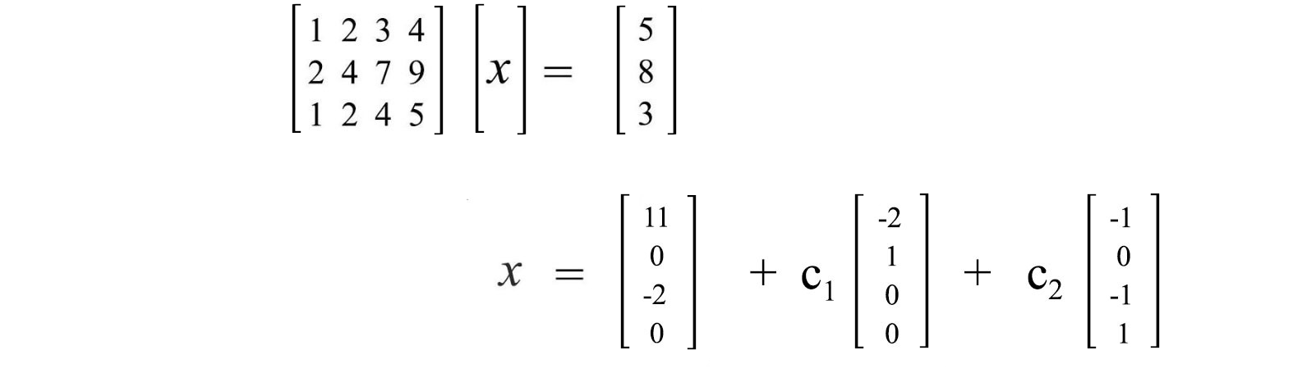

# Orthogonal & Subspaces

Two vectors are **orthogonal** if their inner product ⟨x, y⟩ equals zero.



If they are 2-Dimensional or 3-dimensional vectors, they can be visualized as perpendicular to each other. We love zero in computer science because we can ignore many of its operations. Hence, we like to have vectors to be orthogonal to each other.

If orthogonal vectors have unit lengths, they are called **orthonormal**. Two subspaces are orthogonal to each other if any vectors from each subspace are always orthogonal to each other. In 3-D space, the x-axis and y-axis are two subspaces that are orthogonal to each other. However, not all vectors perpendicular to x-axis belong to the y-axis. It can be any vectors on the yz-plane. One subspace is **orthogonal complement** to another subspace if any vector perpendicular to one subspace must belong to the other subspace. Combining one vector from each subspace reconstruct the Rⁿ space. If one orthogonal complement subspace has a dimension k, the other subspace must have a dimension of n - k.

Column space, row space, nullspace, and left nullspace forms four fundamental subspaces from the m × n matrix A.

* column space: C(A)
* row space: C(Aᵀ)
* nullspace: N(A)
* left nullspace: N(Aᵀ)

The relationship for these subspaces are:

* Column space and row space have the same dimension & rank.
* The rank (r) of A equals the rank of the column space and row space.
* Row space is orthogonal complement (⊥) to nullspace.
* Column space is orthogonal complement (⊥) to left nullspace.
* Row space has r dimension, null space has n - r dimension.
* Column space has r dimension, left nullspace has m - r dimension.



Let’s do a recap. In solving x for Ax=b, it is not solvable if b is not in the column space of A. And the particular solution of Ax=b is in the row space. The solution for Ax=0 is in the nullspace. The complete solution is formed by adding a particular solution and any linear combination of solutions from the nullspace.

# ****Orthogonal matrix****

If all the columns/rows of a square matrix A are orthonormal to each other, A is an **orthogonal matrix** which obeys



It is because if Q composes of columns q₁ to qn which are orthonormal to each other, the inner product ⟨ qᵢ, qⱼ⟩ equals 1 if i = j, otherwise 0. Therefore, QᵀQ = I. The equation Qᵀ = Q⁻¹ is very important. Computing an inverse is usually hard but not for the orthogonal matrix. Therefore, if we can factorize a matrix into orthogonal matrices, that will be great news. For a symmetric matrix, we can guarantee to decompose it into QΛQᵀ where Q is an orthogonal matrix and Λ is a diagonal matrix.

# Properties of singular and non-singular matrix

Let’s review some of the properties of a singular n × n matrix A:

* It is not invertible.
* Its determinant equals zero.
* Columns/rows are linearly dependent.
* It has less than n pivots, i.e. it has at least one all-zero row for its variables after the row elimination.
* It has an eigenvalue equals zero. From the eigenvalue definition, if the eigenvalue λ is zero, det(A) = 0 and therefore, it is singular. (We will discuss eigenvalue later.)





Let’s summarize the difference between a singular and non-singular n × n matrix.

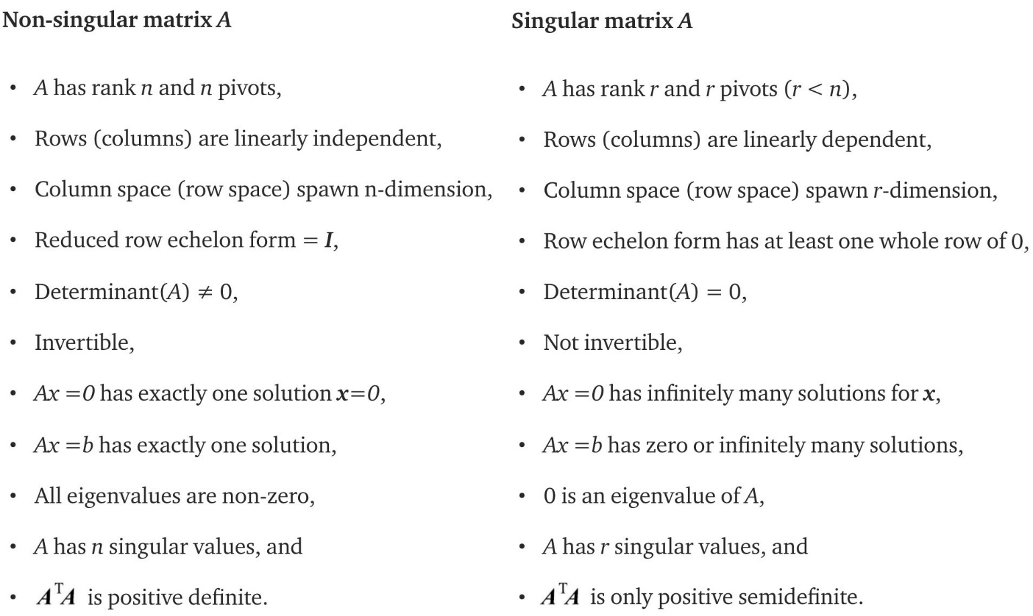

# Basis

A **basis** for a vector space is a series of linearly independent vectors that span this space. Different basis can have different vectors. But all bases have the exact same number of vectors (not too few and not too many). n linearly independent vectors are needed to form a basis for Rⁿ. The dimension of a subspace equals the number of linearly independent vectors that span this subspace. After performing row elimination, all the pivot rows/columns can be used to form a basis for the row/column space of **A**. The n - r special solution for Ax=0 can form a basis for the nullspace N(A).

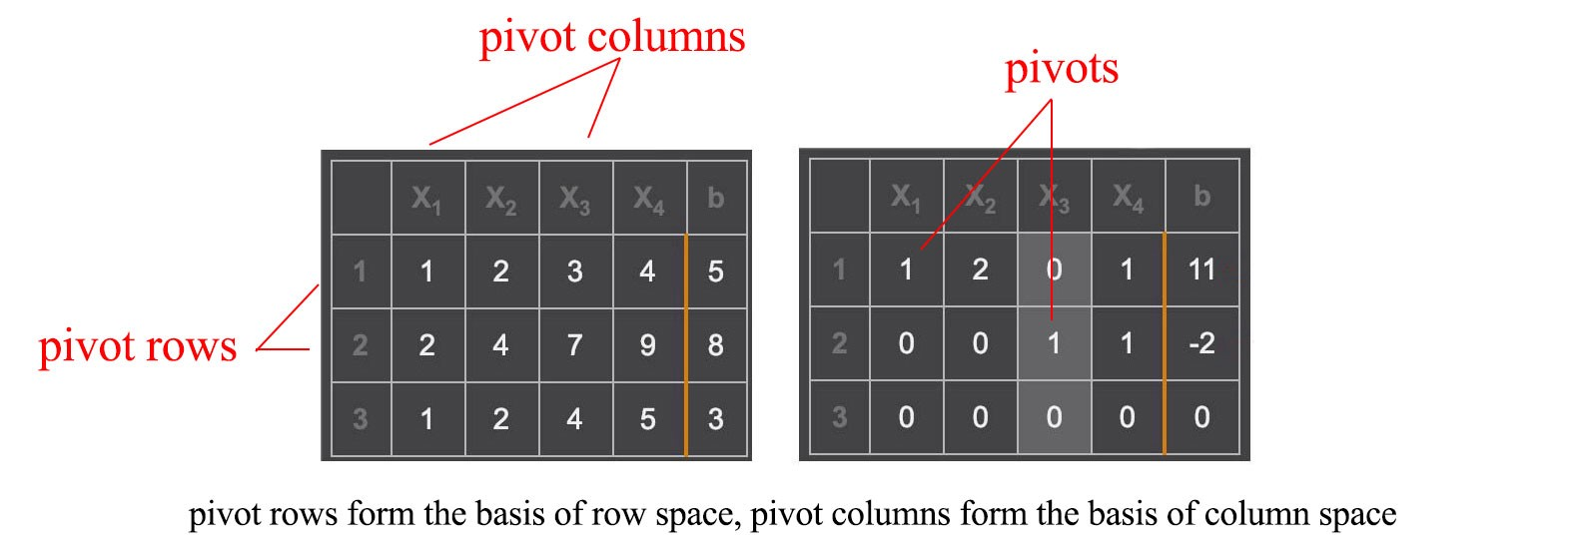

Try not to restrict yourself into numerical space only.



**x** can have a functional basis like (1, x, x², x³) and **y** has a basis of (x, x², x’).



# Matrix multiplication representation

To calculate a matrix multiplication (C=AB), we compute the element Cᵢⱼ as the dot product of the rowᵢ of A and the columnⱼ of B. However, doing this prematurely may easily get us lost in discovering the relationships between rows and columns. Let’s take a border view on matrix multiplication.

The column i of the multiplication result of AB is the multiplication of A with the corresponding column i of B.



Or, the row i of the multiplication result is the multiplication of row i of A with B.



Or, the multiplication result is the sum of the multiplication of column i in A with row i in B using the outer product.



Here is an example and each term on the right below is in rank 1.

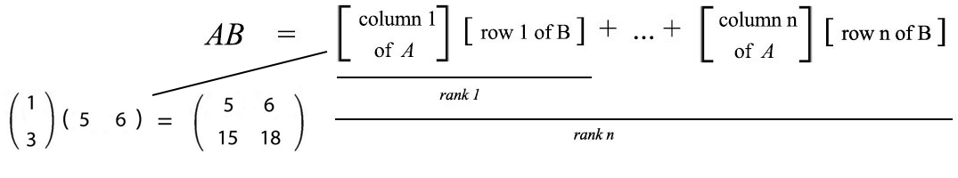

As recalled, we can also view the multiplication of a matrix and a vector as

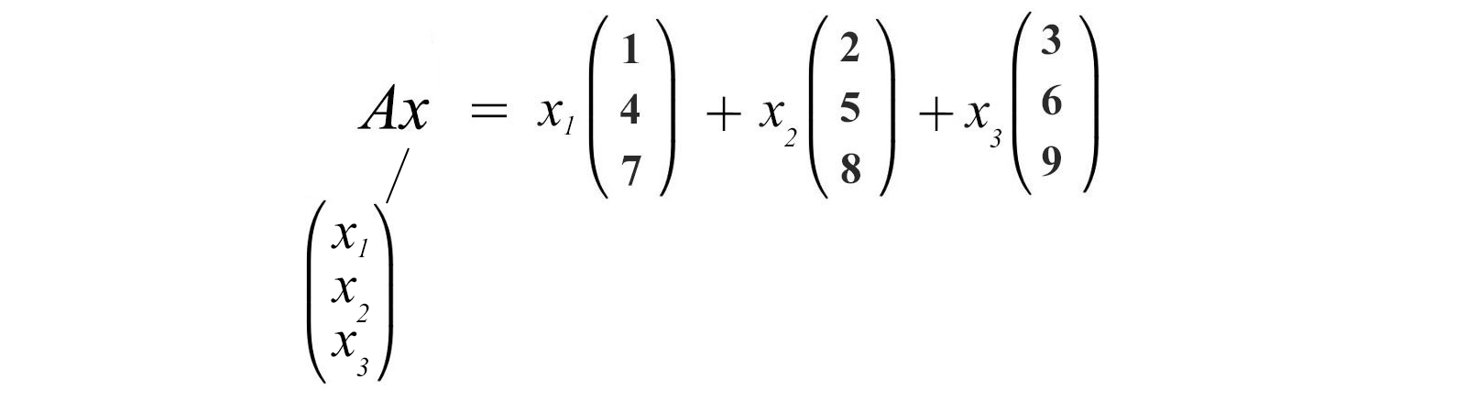

We will not elaborate further from now. But all these perspective are important in many proofs.

# Elimination, permutation, rotation, reflection matrix

In linear algebra, we can use matrix multiplication to define some matrix operations. With the new perspective on matrix multiplication, row elimination can be viewed as multiplying a matrix with an elimination matrix.

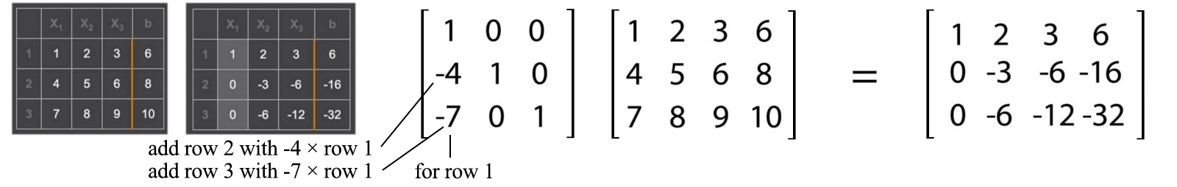

A permutation matrix swaps rows in a matrix. For each row and column, it allows only one element equals 1, others have to be 0.



A rotation matrix has the form of



A reflection matrix has the form of



which creates a reflection along u.

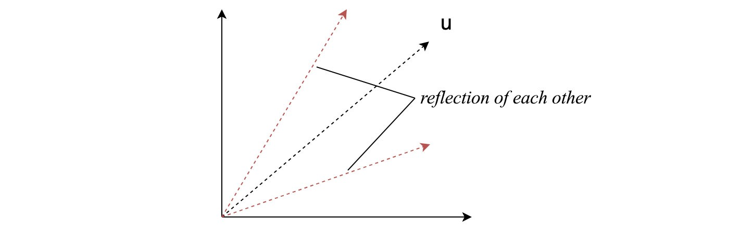

*All permutation, rotation, reflection matrix are orthogonal matrices. Its inverse equals its transpose, P⁻¹ = Pᵀ.*

# ****LU factorization****

As discussed, steps in the Gaussian elimination can be formulated as matrix multiplications. For example, in a 3 × 3 matrix A below, we use a matrix E₂₁ to eliminate the leading element of row 2 using row 1. The final result after all the eliminations becomes U. U is an upper triangular matrix that we use back substitution to compute the solution.



We can combine all Eᵢⱼ to form E. All Eᵢⱼ and E are all lower triangle matrices. We invert E to form L (L = E⁻¹). L is also a lower triangle matrix. The LU factorization is about factorizing A into a lower triangular matrix L and an upper triangular matrix U.

Example,



Or, sometimes we want the diagonal elements of L and U to be all ones.



where D is a diagonal matrix with diagonal elements holding the pivots.

This is our first example of matrix factorization. They play a very important role in linear algebra. There are many other factorizations and we will introduce some of them later.

# ****Projection****

Let’s review something that we may be already familiar with. In the diagram below, we project a vector b onto a. The length x̂ of the projection vector p equals the inner product aᵀb. And p equals

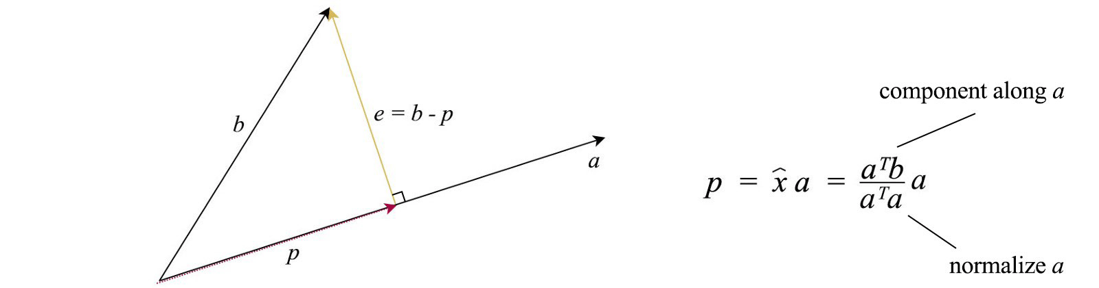

e is perpendicular to p and connects p and b together. In one perspective, projection tries to minimize this vector e that can be viewed as an error vector. Now come to a harder problem. For a multi-dimensional space, how can we project a vector onto the column space of A (space spans by Ax)? Let’s express p with the component x̂ᵢ and the basis of A (aᵢ)



And we will model the projection with a projection matrix P



Below is the solution for P and p which can be calculated from A and b.

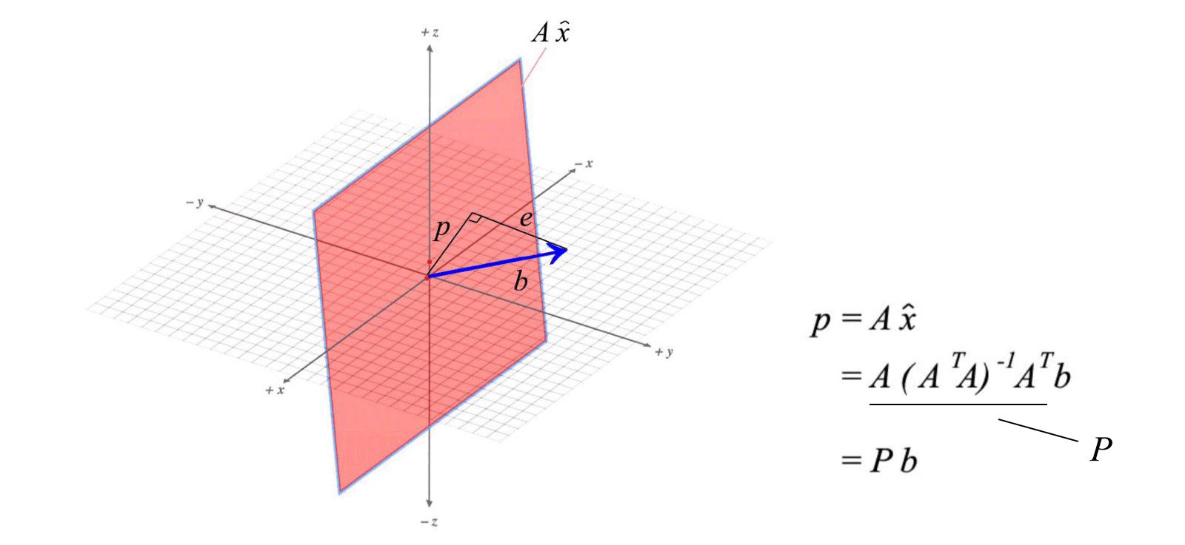

**Proof**

Since p is orthogonal to e, each vector in the basis is perpendicular to e also. We can rewrite these conditions (the left diagram below) into a matrix form.



We can solve this equation and here is the solution.



Note: We may tempt to resolve the inverse (AᵀA)⁻¹ which A(AᵀA)⁻¹Aᵀ becomes AA⁻¹ (Aᵀ)⁻¹Aᵀ and equals I. Therefore, p = b. This is wrong because (AᵀA)⁻¹ equals A⁻¹ (Aᵀ)⁻¹ only if A is invertible. This is not true for many cases. A is not invertible even for a non-square matrix.

In addition, P = P² = Pⁿ — since the projected vector is on the column space already, its projection equals itself.

# Least square error

Often, it is not possible to find an exact solution for Ax=b. In ML, we want to find x with the best fit for the data, For example, we want to minimize the least square error



The equation above has the same objective as our projection. Recall



Our solution for **x̂** will fulfill



Therefore, we can use the equation above to compute **x̂** using b and A. In machine learning, data is noisy. The measured or observed b has noise.



But if we know how b is distributed and how components are related, we can turn this information to make a better estimate for x̂. The covariance and variance are defined as



Variance measures how a property (a variable) varies while covariance is how two properties vary together. The left diagram below is the general covariance matrix. If all properties are independent of each other, all the non-diagonal elements will be zero, like the middle diagram below. The right one happens when these data are also standardized.

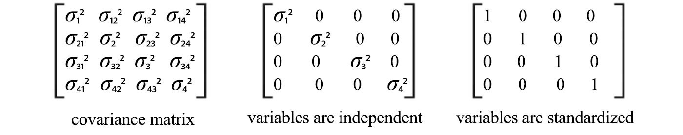

Equipped with the covariance matrix V for b, we can solve **x̂** with



In the previous equation, the least square errors are counted equally for every dimension (property). With the new equation, V⁻¹ term whitening (standardize) the data. In other words, the error in a specific dimension with a smaller variance will carry a larger weight towards the weighted least squared error. The new equation will give a better value for **x̂**. In addition, the variance of the calculated **x̂** will be reduced to



Let’s double check this equation again.



It resolves back to the previous equation if V = I. i.e. when all variables are standardized and not related, both equations are the same.

# Gram-Schmidt process

As mentioned before, we like orthogonal matrices. For a given matrix A, the columns are unlikely orthonormal. Gram-Schmidt diagonalization helps us to find an orthonormal basis that spans the same column space of A.

Let say we have a matrix A composes of columns a, b and c. How can we find orthonormal vectors q₁, q₂ and q₃ that span the same column space of A.



Such that we can factorize A into A = QR. We start with q₁’ as a. Then q₂’ equals b minus the projection of b along q₁’. Next, q₃ equals c minus the projection of c along q₁ and q₂. In short, we try to take out the projected part in the previous direction in forming orthogonal vectors.

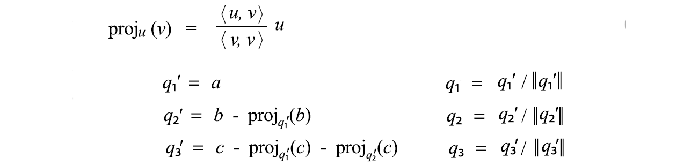

After it is done, we normalize q₁’, q₂’ and q₃’ to form unit length q₁, q₂, and q₃. We can rewrite a, b, c as



Therefore, A can be decomposed into QR with R equals



# Change of basis

Consider a vector x with its basis being the column of the matrix V.

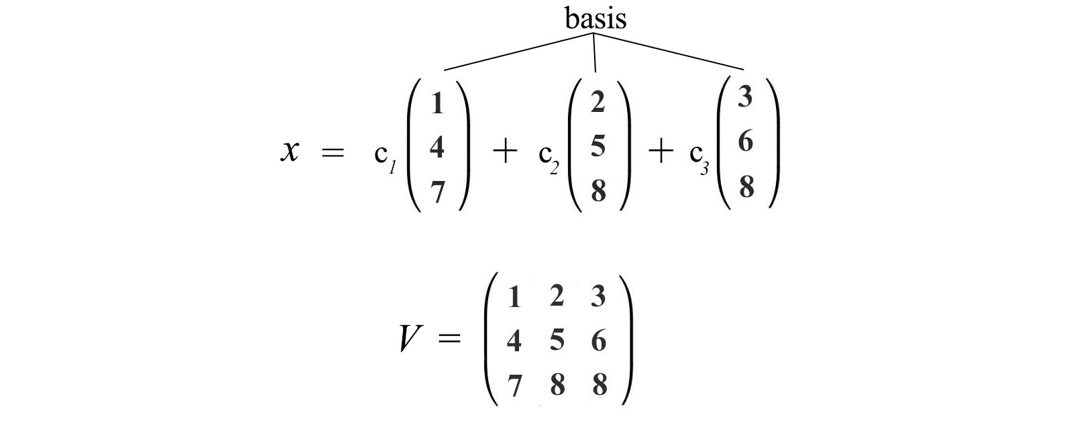

We want to transform it into a new basis, say the columns of U.



We can express the same vector in two different bases and compute the matrix needed (underline in red below) to transform the basis of a vector.

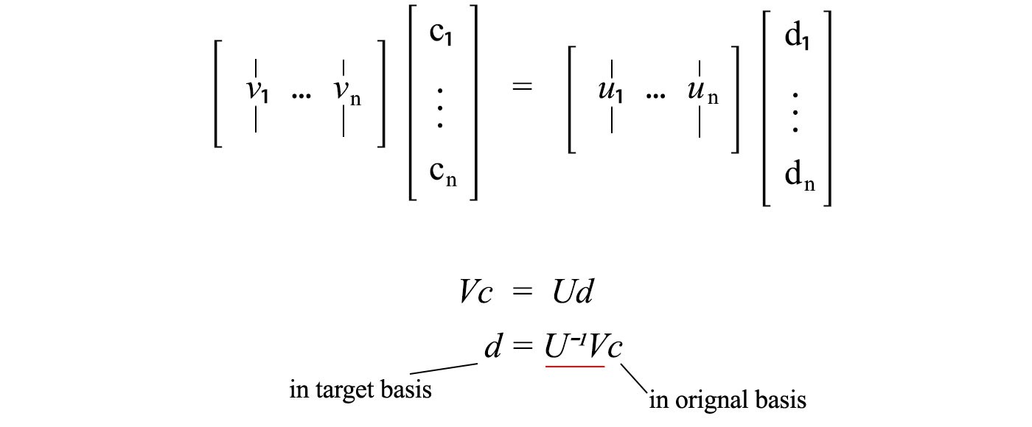

Now, let’s consider the matrix P which changes the basis for x’ into the basis for x. For y = Ax, the corresponding operation A’ in the new basis will be P⁻¹AP.

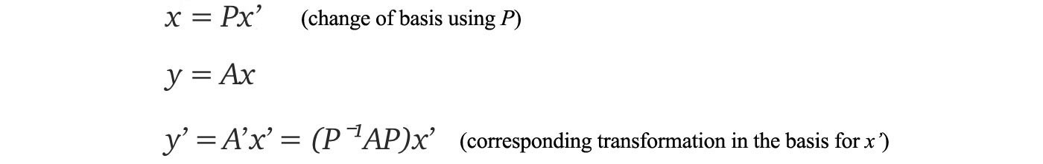

The relation between A’ and A can be written as

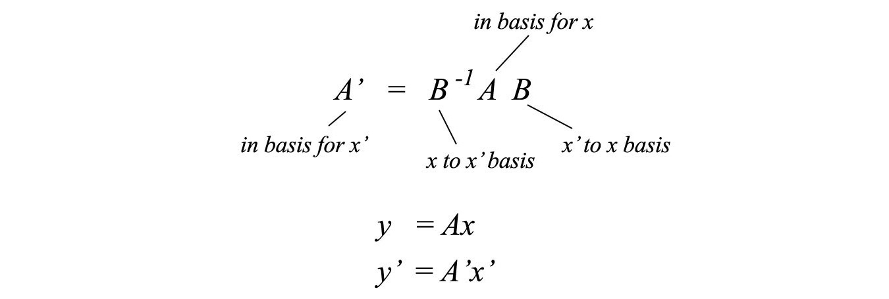

which can be further generalized as

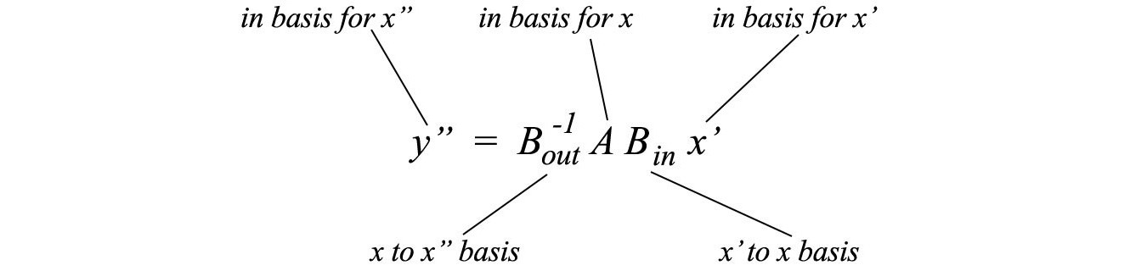

# Similar matrix

Two matrices **A** and **B** are similar (A ∼ B) if



for any invertible matrix P. Given A and B, there are many possible solutions for P. If we compare the definition of a similar matrix with the change of basis, we realize that A’ (with a change of basis) and A are similar matrices.



The law of physics should not be changed with a change of the reference frame (basis). So it is no surprise that similar matrics share some common properties.

Similar matrices

* have the same eigenvalues.
* the same determinant.
* the same rank, and
* both singular or both non-singular.

In linear algebra, if we can easily compute or guess a similar matrix that is much easier to manipulate, we can use it to compute the properties above instead.

# Choice of basis

The choice of basis is important. The Geocentric model below uses earth as the center of reference and derive the orbits of the surrounding objects accordingly. This is chaotic and hard to find the underlining physics behind it.

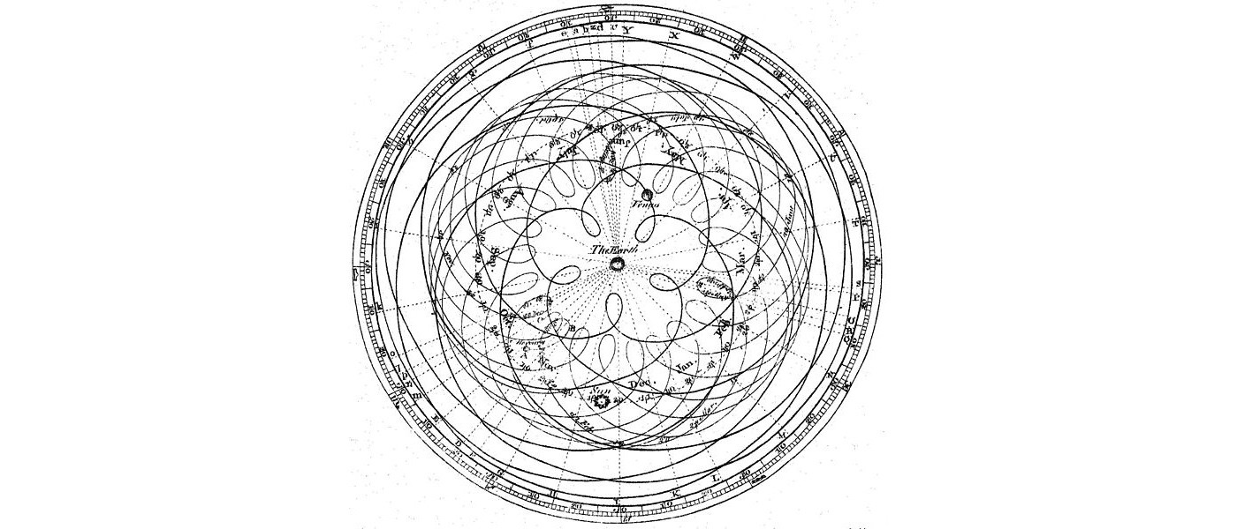

Source: Image: Encyclopaedia Britannica (1777)

As we change the model to be centered by the sun, the model becomes much simple. This helps us to discover the fundamental theory behind the observed data. The Law of Gravity makes better sense. In later articles, we will introduce eigendecomposition and SVD. If we compare these equations, we can view those methods as a change of basis.

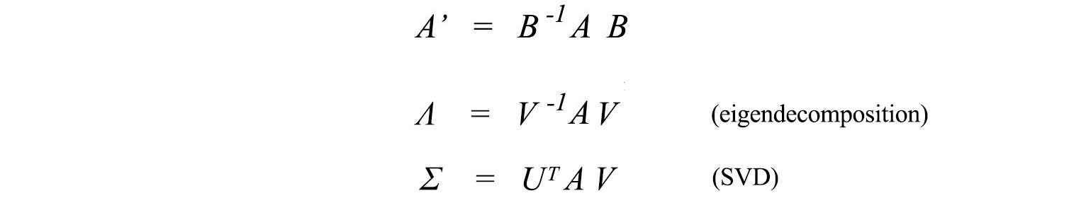

This is great news because the matrices (Λ and Σ) that are transformed into are diagonal matrices — much simple to analyze and to manipulate than A. Such simplicity helps us to discover the structures of the information.

**Jordan form**

Matrices can be transformed into the Jordan form which is a band matrix rather than a diagonal matrix.



A Jordan form matrix composes of Jordan blocks of different sizes. Each block contains one of the eigenvalues as the diagonal elements and the element on the right of the eigenvalue must be one.

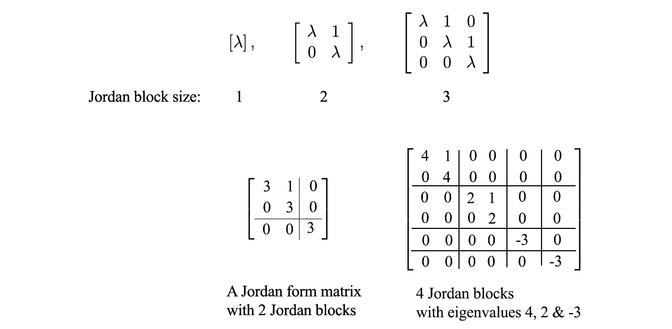

However, small changes in A create large changes in the Jordan form. Hence, it is not numerical stable in practice. Therefore, we will just let you aware of this possibility but will not elaborate further on how it can be done.

# Quadratic form equation in Matrix

A quadratic equation can be written as:



The matrix form for a quadratic equation is:



For three variables:



This representation is important because the cost function in ML, like the mean square error, is often expressed as a quadratic equation. Consider



When x equals to the eigenvector of A, f equals to its corresponding eigenvalue. If x is a unit vector, the quadratic equation f(x) = xᵀAx will have the maximum and the minimum value equals to the maximum and the minimum of the eigenvalues λ of A.

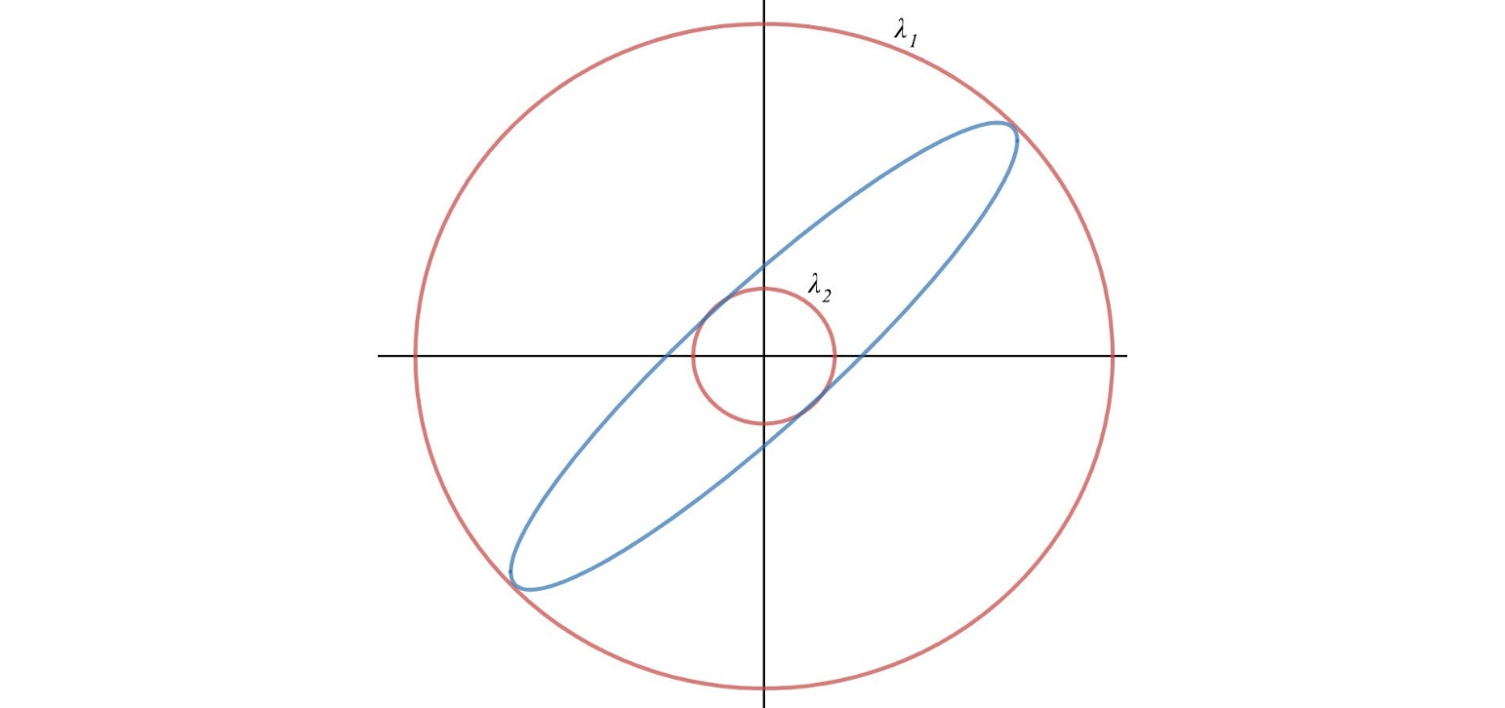

**Maximum & minimum value of a quadratic function**

The matrix A in representing the quadratic equations here is symmetrical.



The lower and upper bound of such quadratic functions equals the minimum and the maximum of the eigenvalues of A respectively.



Here is the proof for the upper bound. If A is symmetrical, A can be decomposed as A = Q Λ Qᵀ where Q composes of the eigenvectors of A.

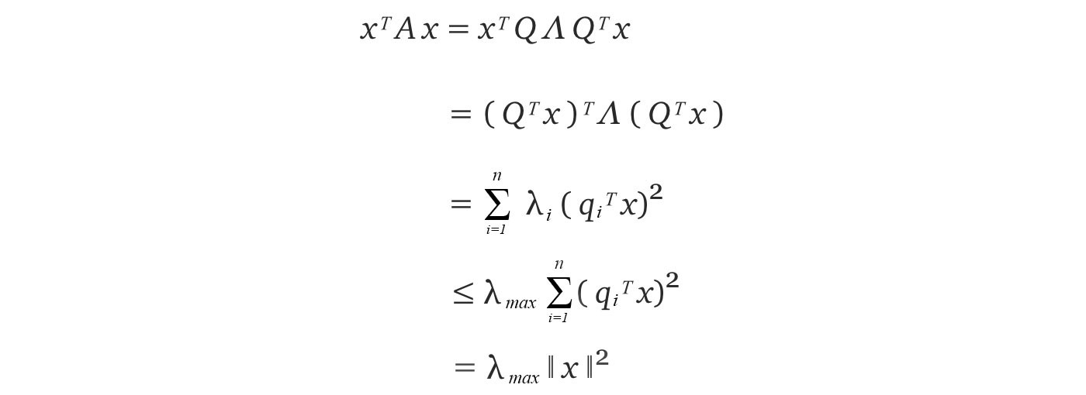

Source of the [proof](https://see.stanford.edu/materials/lsoeldsee263/15-symm.pdf)

# Determinant

The determinant of a 3 × 3 matrix is:

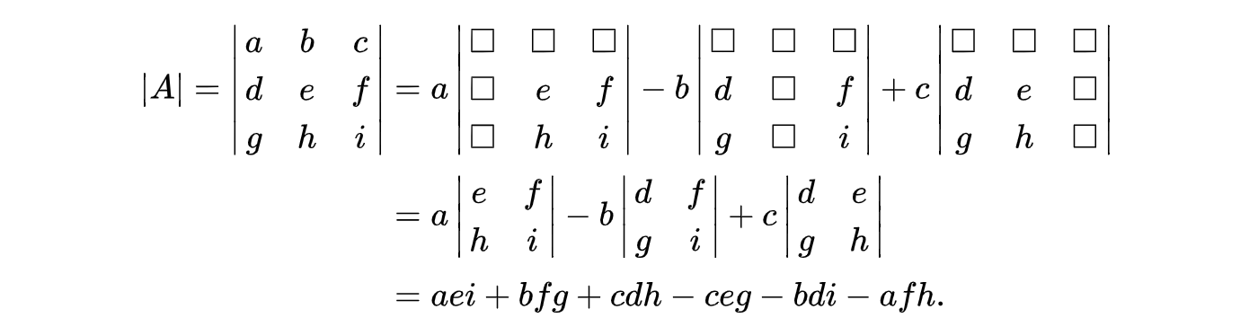

Source: Wikipedia

This definition can be extended to calculate the determinant of an n × n matrix recursively. Alternatively, it can be computed visually as:

7



**Properties**

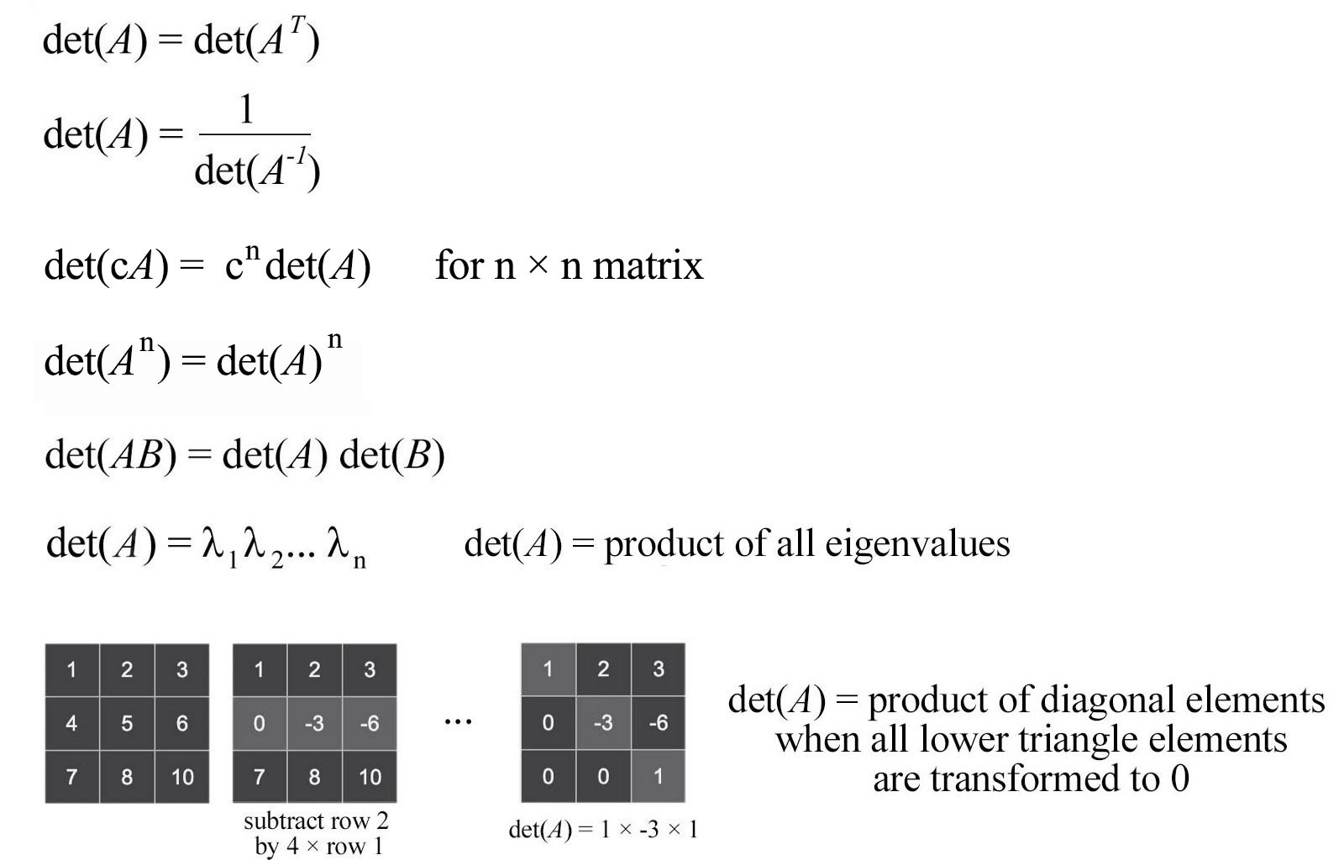

If the absolute value of the determinant for A is greater than 1, Ax expands the output space. If it is between 0 and 1, it shrinks the space. This is important in understanding the stability of the system.

# Norm

Deep learning uses norms to compute errors or to perform regularization. Here are different types of norms.

L1-norm (Manhattan distance):



L2-norm



Lp-norm



Max-norm



Frobenius norm



**Comparing L1 & L2-norm**

Comparing to L1-norm, L2-norm makes more dramatical changes to a model for large-value errors. This makes L2-norm vulnerable to outliners and less robust. In addition, L1-norm promotes sparsity in model weights. It is desirable for many machine learning problems. However, the gradient change is smoother in L2-norm around zero. Therefore, the L2-norm training is more stable with more gradual gradient changes. This makes L2-norm more popular in general.

**Matrix norm**

The norm of a matrix is the maximum growth factor of any vector **x**.



This is the same as constraining x to have a unit length.



The norm can be computed as:

* If the matrix is positive definite, the norm is the maximum eigenvalue of A.
* If the matrix is symmetric, we take the absolute value of the eigenvalues and select the largest value. (Since the norm measures length, we care more about its absolute value.)

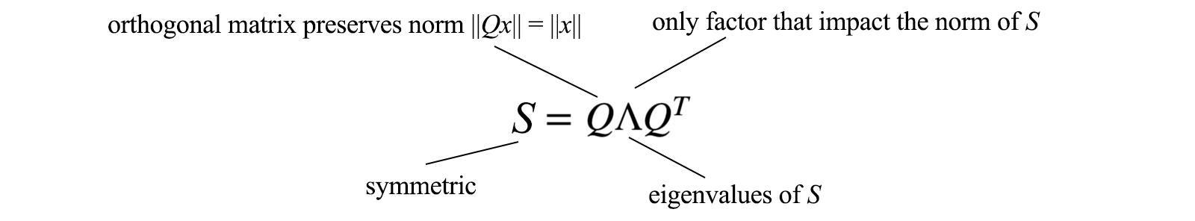

* Otherwise, it is the maximum singular value of A. i.e. the square root of the maximum eigenvalue of AᵀA.

**Rayleigh quotient**

Finding the matrix norm of A is the same as finding the maximum value of the Rayleigh quotient below.

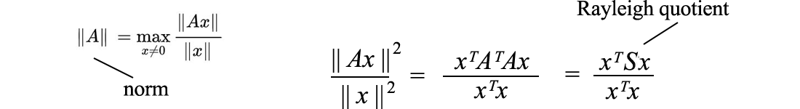

Let’s rewrite the Rayleigh quotient with the inner product.

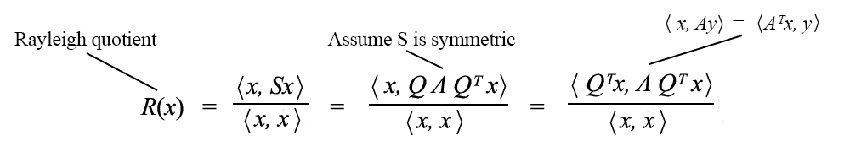

We substitute x with Qx above.

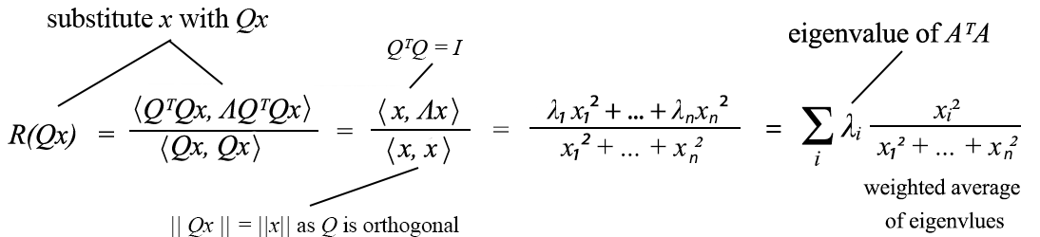

So Rayleigh quotient is the weighted average of the eigenvalues of AᵀA. Since a weighted average is smaller or equal its maximum value,



We often reshuffle λ in descending order. So λ₁ holds the largest eigenvalue. The norm of A is, therefore, the root of the largest eigenvalue of AᵀA (the singular value σ₁ of A).

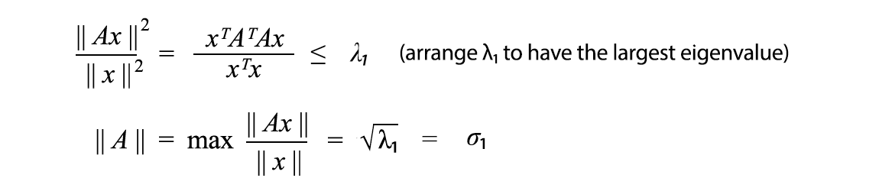

For a symmetric matrix S,



**Condition number**

In linear algebra, we use a condition number to track how sensitive the output is depending on errors in the input. The accuracy of the elimination method is reflected by the condition number



# Trace

The trace is the sum of the diagonal elements of A. It can be used to verify eigenvalues and also shows up in many proofs.





Property



[Source](https://www.math.uwaterloo.ca/~hwolkowi/matrixcookbook.pdf)

# Element-wise matrix operation

Hadamard product produces a matrix with element i, j equals the product of elements i, j of the matrix A and B.





# Reference

[Introduction to Linear Algebra by Gilbert Strang](http://math.mit.edu/~gs/linearalgebra/)

[The Matrix Cookbook by Kaare Petersen & Michael Pedersen](https://www.math.uwaterloo.ca/~hwolkowi/matrixcookbook.pdf)

[Linear Algebra by Georgi E. Shilov](https://www.amazon.com/Linear-Algebra-Dover-Books-Mathematics/dp/048663518X)

[Deep Learning by Ian Goodfellow, Yoshua Bengio, Aaron Courville](https://www.amazon.com/Deep-Learning-Adaptive-Computation-Machine/dp/0262035618/ref=asc_df_0262035618/?tag=hyprod-20&linkCode=df0&hvadid=312128454859&hvpos=1o1&hvnetw=g&hvrand=10983322122393702344&hvpone=&hvptwo=&hvqmt=&hvdev=c&hvdvcmdl=&hvlocint=&hvlocphy=9061268&hvtargid=pla-416263148149&psc=1)

[Differential Equations and Linear Algebra (MIT Open Courseware)](https://ocw.mit.edu/resources/res-18-009-learn-differential-equations-up-close-with-gilbert-strang-and-cleve-moler-fall-2015/differential-equations-and-linear-algebra/)

# Thoughts

So far, we have been focused on solving Ax=b and introducing basic concepts. Next, we will study a simple concept Av = λv which turns out to be the master key in solving many problems.

# Machine Learning — Lagrange multiplier & Dual decomposition

Optimization is a critical step in ML. In this Machine Learning series, we will take a quick look into the optimization problems and then look into two specific optimization methods, namely Lagrange multiplier and dual decomposition. These two methods are very popular in machine learning, reinforcement learning, and the graphical model.

# Optimization problem

An optimization problem is generally defined as:



which contains an objective function with optional inequality and equality constraints. The general optimization problem is [NP-hard](https://medium.com/@jonathan_hui/machine-learning-summary-proof-terms-8ca7c588905e). But many classes of **convex optimization problems** can be solved in polynomial time. When we join f(x₁) and f(x₂) to form the red line below, if f is a convex function, the red line is always above f for points between them, i.e. yᵢ ≥ f(xᵢ).

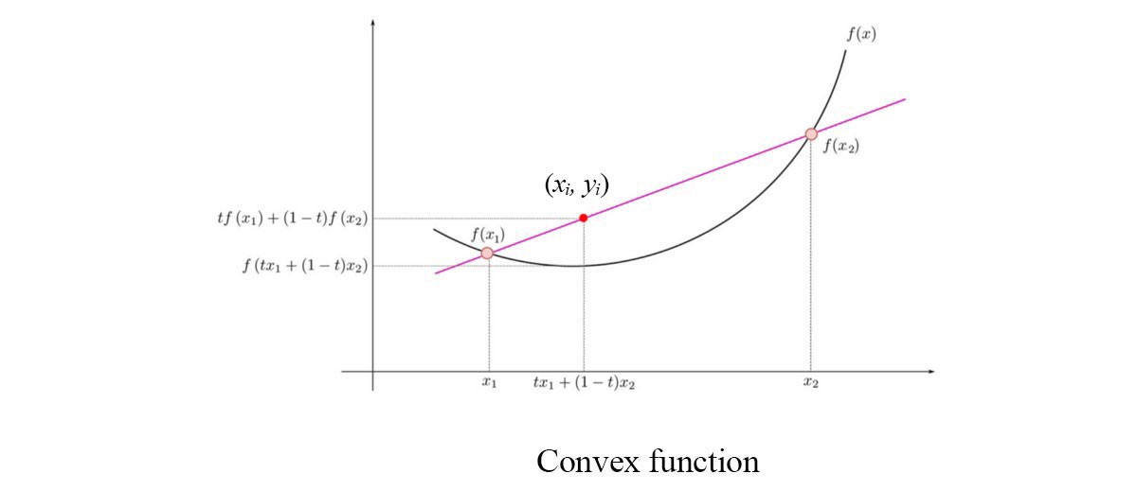

Modified from source: Wikipedia

A convex optimization problem has its objective function to be convex and its feasible set to be a convex set. A **feasible set** is the set of x that satisfy the constraints. In a **convex set**, any value between two points in the set must belong to the convex set also.



From another perspective, in a convex optimization problem, f and l are convex functions,



and the equality constraints are **affine** functions which have the general form:





As a side note, affine functions are convex. We will need that later.

In ML, the objective function for linear regression is often expressed in the least square errors. Least squares optimization problems are well studied. There are many numerical ways to solve them and they can be solved [analytically](https://medium.com/@jonathan_hui/machine-learning-summary-proof-terms-8ca7c588905e) ([normal equations](https://medium.com/@jonathan_hui/machine-learning-summary-proof-terms-8ca7c588905e)) unless certain scalability limitation is reached. They are relatively easy to solve in optimization.

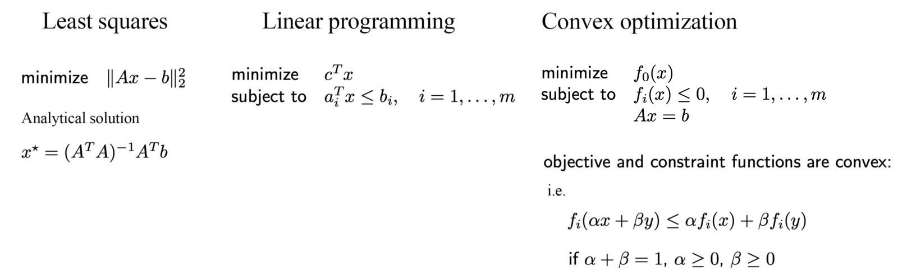

Modified from [source](https://web.stanford.edu/class/ee364a/lectures/intro.pdf)

Otherwise, if the ML problems can be expressed in a linear program, we can apply linear programming. This is also well studied. The feasible set for x in a linear program is a polyhedron.

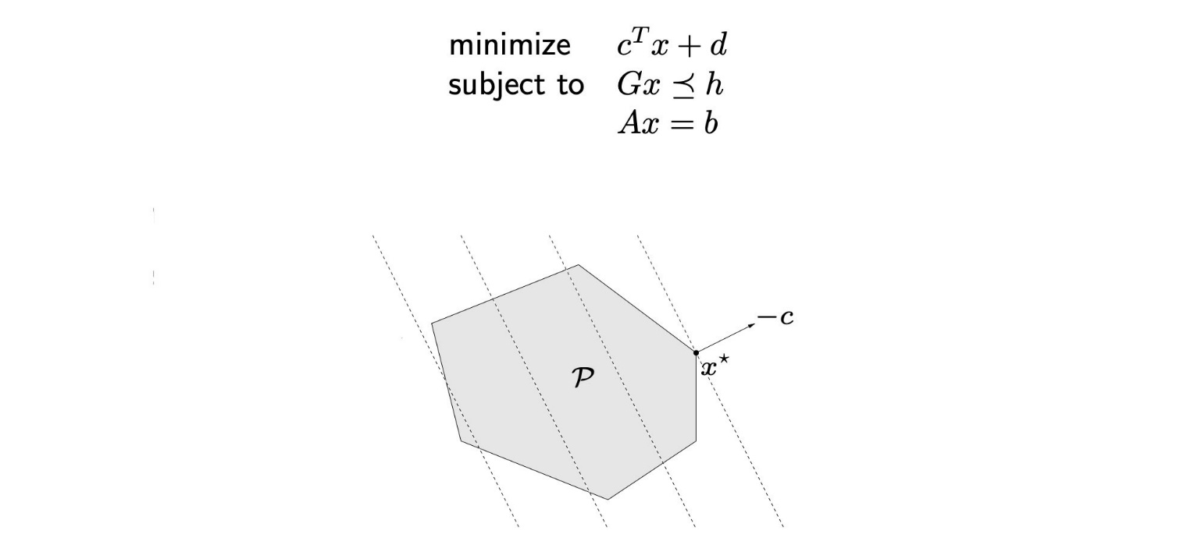

[Source](https://web.stanford.edu/~boyd/cvxbook/bv_cvxslides.pdf)

In our example above, the dotted lines are the contour plot of the objective function. The optimal x* will be one of the vertexes.

In general, if the problem is a convex optimization problem, we can solve it numerically. A function is convex if its second order derivative is positive for all x.



Modified from [source](https://web.stanford.edu/class/ee364a/lectures/intro.pdf)

*In ML, we often transform, approximate or relax our problems into one of these easier optimization models.*

# Lagrange multiplier

Let’s focus on finding a solution for a general optimization problem. Consider the cost function f=x+y with the equality constraint h: x² + y² = 25, the red circle below. (Credit: the example is adapted from [here](http://www.csc.kth.se/utbildning/kth/kurser/DD3364/Lectures/KKT.pdf).)

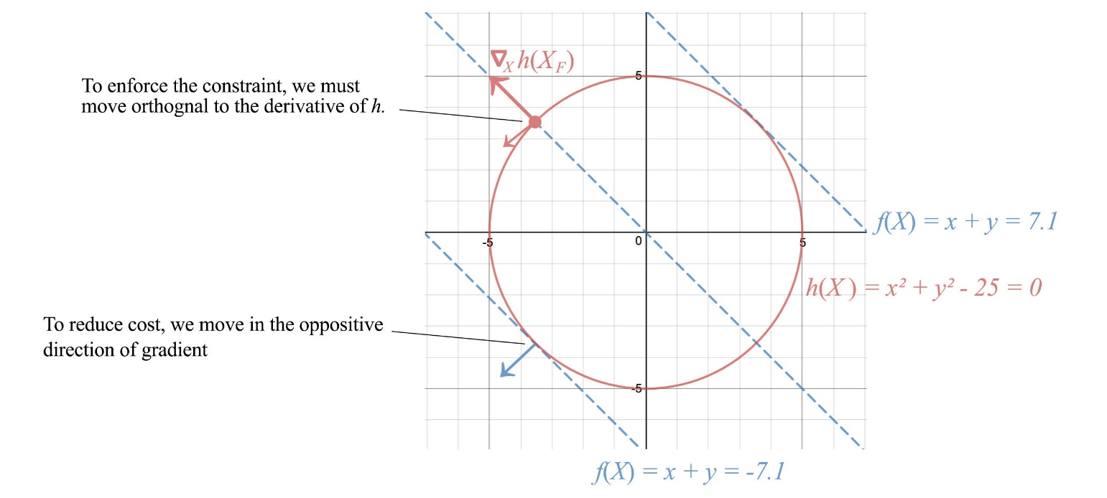

To enforce constraint, we move orthogonally to the normal of the constraint surface, i.e. perpendicular to ∇x h. And to reduce cost, we choose one of the paths along the negative gradient of f. An optimal point is reached when we cannot move further to reduce cost. This happens when ∇h aligns with the gradient of the cost function.

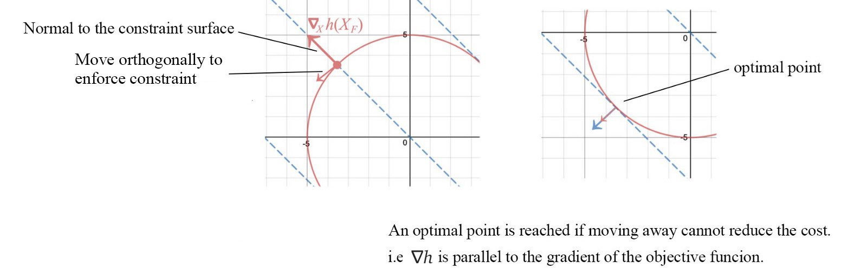

i.e.,



h(x) = 0 also implies -h(x) = 0. The sign of λ subjects to how h is defined. Therfore, λ can be positive, negative or zero.

Next, we define the **Lagrangian** as





If we take the derivative of the Lagrangian w.r.t. x and λ respectively and set them to be zero, as shown below, we enforce the optimal point described before as well as the equality constraint.

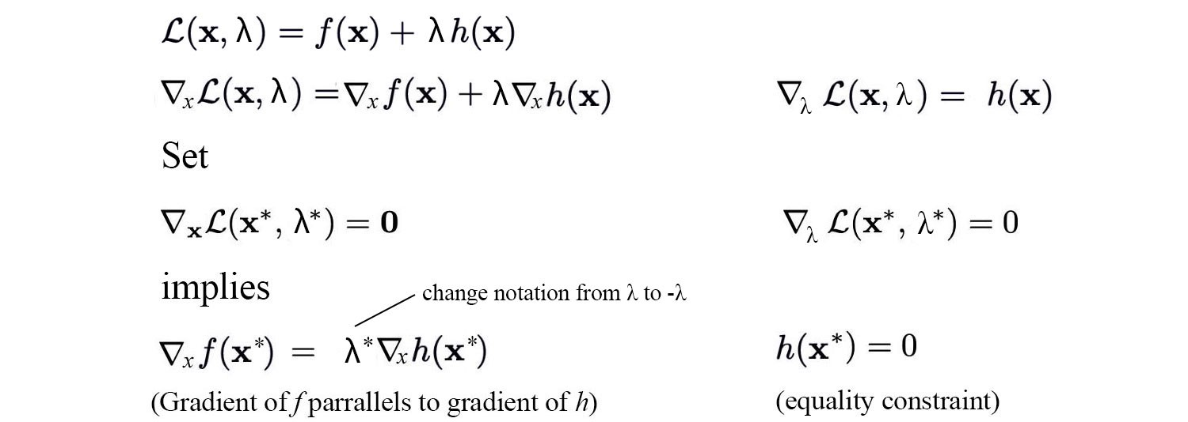

So by finding the optimal point of 𝓛 w.r.t. x and λ,we locate the optimal solution with the equality constraint enforced. We can have multiple constraints and inequality constraints in the Lagrangian also. The optimization problem will be in the form of:



and the Lagrangian is defined as:



Now the inequality constraint requires the optimal point to be in the shaded area (inclusively). The gradient of f and l will have the same direction when the solution is optimal, i.e. **αᵢ ≥ 0**.

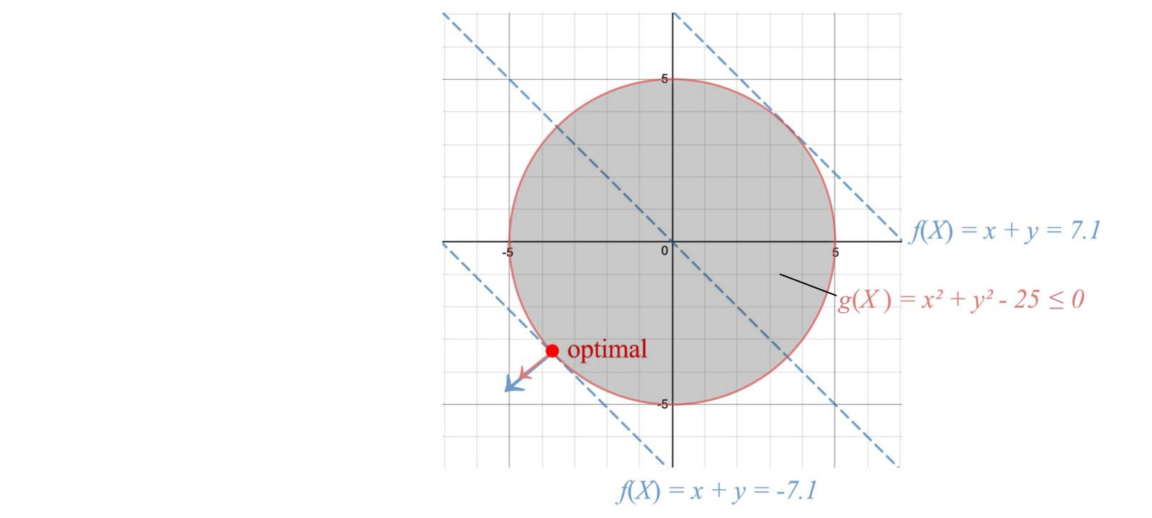

Let’s have another observation regarding the inequality constraint. The left figure below represents a cost function f with the optimal solution be the center of that circle.

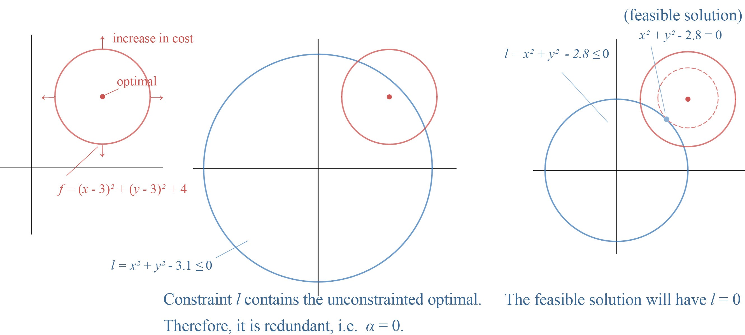

In the middle figure, we add an inequality constraint to the optimization problem. But this constraint is redundant because the unconstrained optimal already fulfill this constraint. So αᵢ can simply be zero to indicate that it is redundant.

In the right figure, the unconstrained optimal falls outside of l. We have to increase the cost (the red circle) until it touches l. The corresponding lowest cost will have the constraint l equals 0.

Therefore, αᵢ lⱼ(x) always equals 0.



**Example**

Let’s maximize f(x, y) = x + y subject to x² + y² = 32.

The Lagrangian is:



To solve the optimization, we set the derivate of 𝓛 w.r.t. x, y, and λ to zero respectively.

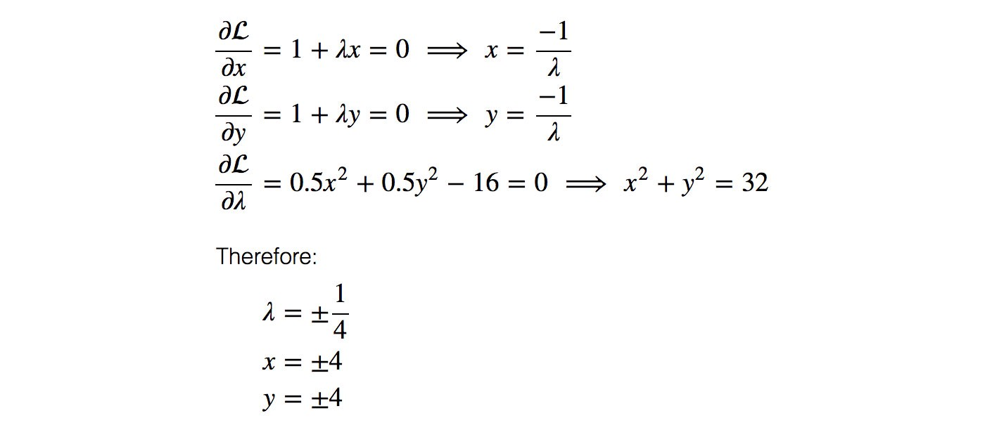

By plugin the value back to the equations,





We realize the maximum value for f is 8 with x = y = 4.

Don’t expect the solution is that simple for the general optimization problems. We build a visual model to understand the idea intuitively. But there are quite a few holes to fill.

# ****Lagrangian Duality****

In our previous discussion, we are working on a convex optimization problem. So it is time to take the convex assumption away.



Consider the following Lagrangian L. Let’s maximize L w.r.t. α.

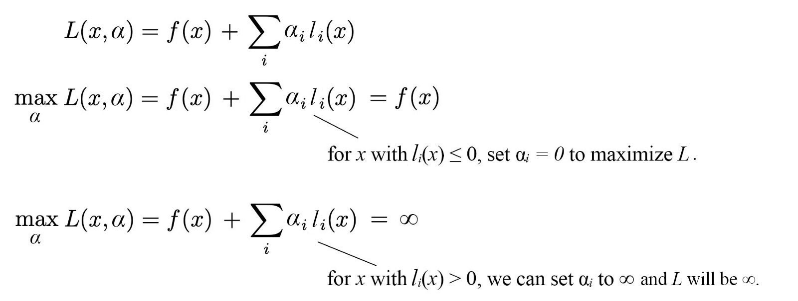

Let J(x) be



So J will be infinity if the inequality constraint lᵢ(x) ≤ 0 is violated. Otherwise, J is simply f(x). So J is a perfect cost function for our optimization problem that enforcing the inequality constraint. The original objective function becomes

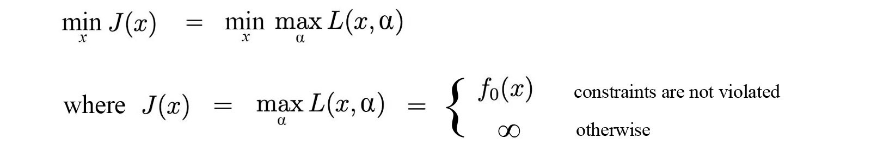

But this is very hard to solve. So let’s view it from a different perspective and discover the relationship between the following minmax solution and the maxmin solution as a possible alternative.



The minmax problem is our original problem and we call it the **primal problem**. The maxmin problem is called the **dual problem**.

Let g be





The dual problem maximizes g.





g is a convex function because it is an affine function.

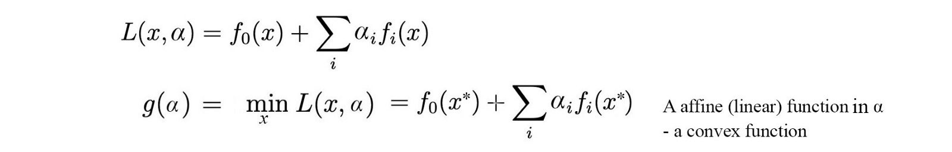

Since g is convex with a linear constraint αᵢ ≥ 0, optimize it is easy. For situations where optimizing L w.r.t. x is easy also,



finding the solution for the dual problem is easy.



However, we come to a big question. Is the primal problem has the same optimal solution as the dual problem?



The general answer is no.

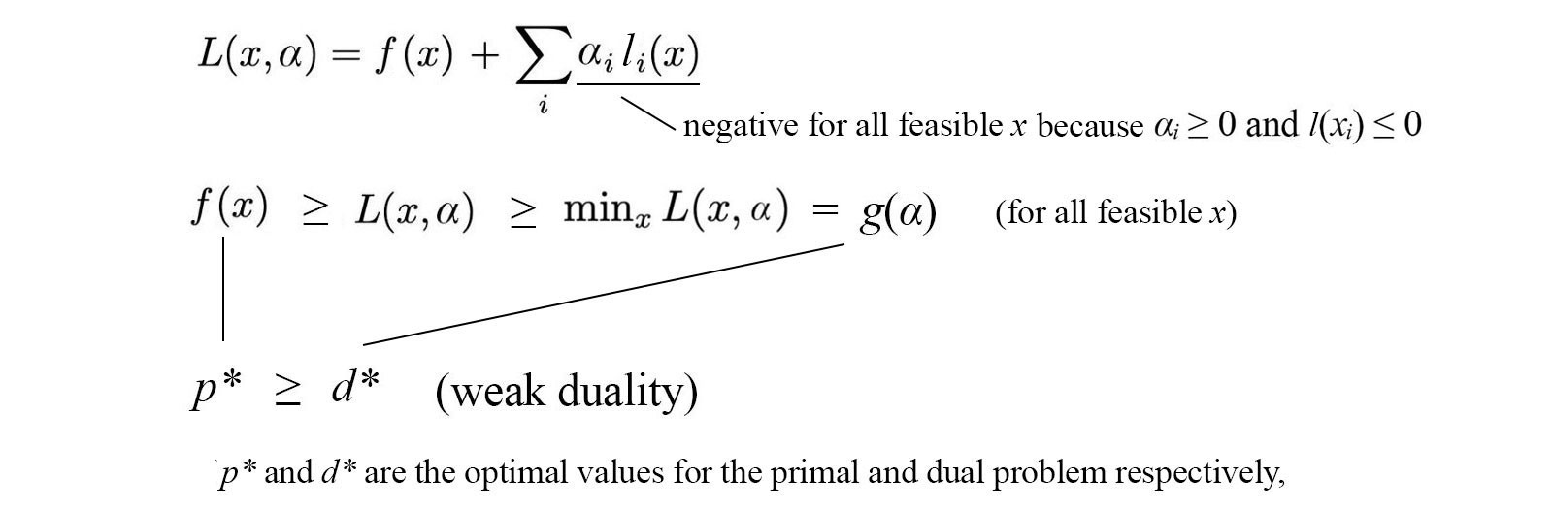

But as shown above, the dual solution d* is the lower bound for the primal solution p* in general if L is smooth. This property is called the **weak duality**. Maximizing α finds the tightest possible lower bound on p*.

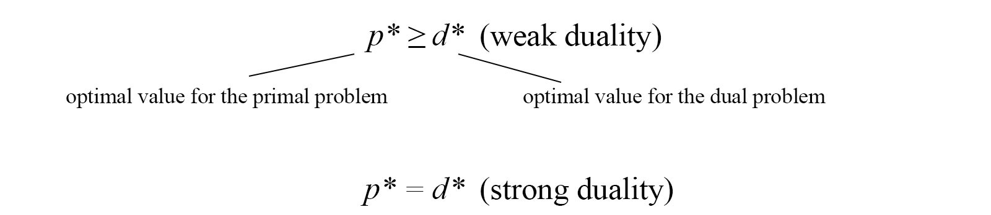

The property that p* = d* is called the **strong duality**.

**Strong duality via Slater’s condition**

Strong duality holds when the optimization problem is a convex optimization problem with a feasible x in satisfying the constraints. This is the Slater’s condition, a sufficient condition for the strong duality. There are other sufficient conditions but we will not cover here.

# ****Putting it together****

Given a **primal problem** (the original minimization problem):



We define the **Lagrangian** as



and the **Dual function** as



The associated **dual problem** will be defined as



In general, if L is smooth, the **weak duality** holds which the dual solution d* will be the lower bound for the primal solution p*, d* ≤ p*. **Strong duality** holds when d* = p*. It can be achieved through the slater’s condition (necessary condition). The dual problem provides an alternative in solving the primal problem if we can minimize L w.r.t. x easily. The rest will be simple because the result function g will be convex and easy to optimize. If the strong duality condition holds, we are done. If only the weak duality holds, we have a lower bound solution. In some situations, this may be reasonably good as an approximation solution to the primal.

If an optimization problem has a strong duality (for example, it meets the necessary condition like the Slater’s condition), then

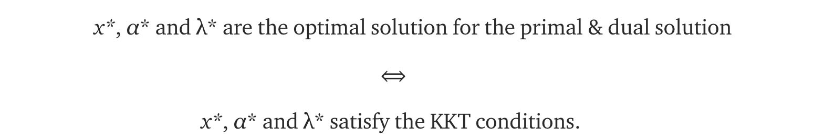

# ****KKT conditions****

Here are the KKT conditions. If it is true, x*, α* and λ* are the primal and dual solution or vice versa if strong duality holds.

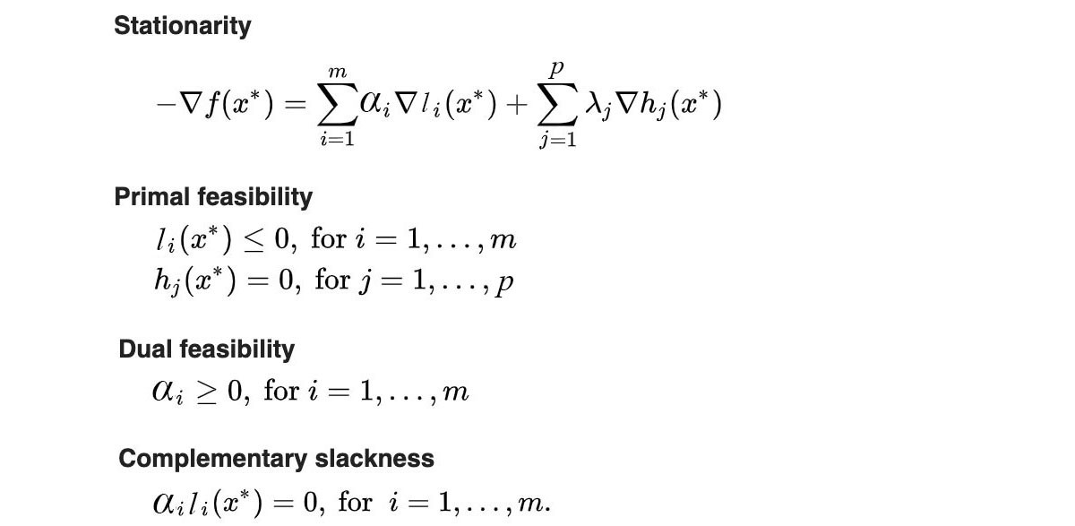

The stationarity condition is where the negative gradient of the cost function f is in the same direction or parallel to the constraint l and h respectively. The primal and the dual feasibility is the conditions required by the corresponding optimization problem. The complementary slackness is a common condition regarding whether the inequality constraints are redundant or not (we cover that already).

# Visualization of the Lagrangian multiplier

Let’s visualize our solution. We plot f(x) against l(x) below. The green space spawns all values of x. Our soluting will be one of the points in the green area. The Lagrangian is L = f(x) + α l(x).

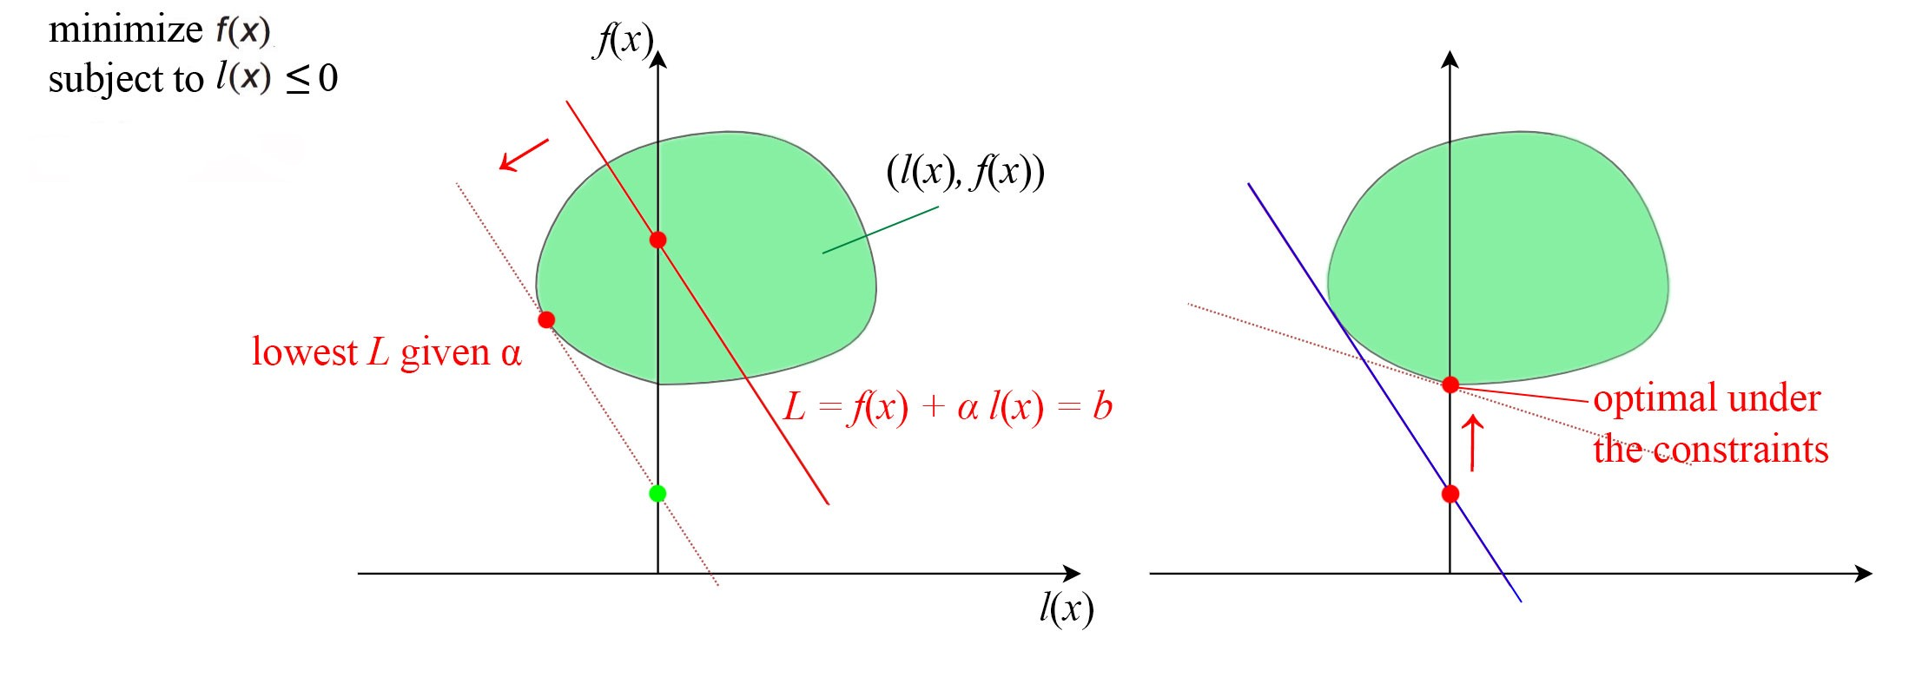

In the first step, we fix α. Given α, we can draw a red line to join points of f(x) and l(x) that have the same Lagrangian value. Since α ≥ 0, the line has a negative slope with value -α. The y-intersect (the interest on the f(x) axis) is the value of the corresponding Lagrangian value. In the first step, the dual function g(α) minimizes f(x) + α l(x) over x in the green space above. In other words, we want to have a line with the given slope -α that has the smallest y-intersection providing that it still in contact with the green zone. That is the dotted line on the left above. Since g(α) is a lower bound of p*, the green dot is a lower bound for the optimal value. Our next task is moving up from this point in finding a line with a new slope -α that will barely touch the green space. That is our second step in maximizing g(α). We often find the solution iteratively. We will demonstrate this next.

# ****Dual Gradient Descent****

We start with a random guess of λ and use any optimization method to solve the unconstrained objective.



Next, we will apply gradient ascent to update λ in order to maximize **g**. The gradient of **g** is:



i.e.





In step 1 below, we find the minimum **x** based on the current λ value, and then we take a gradient ascent step for **g** (step 2 and 3).

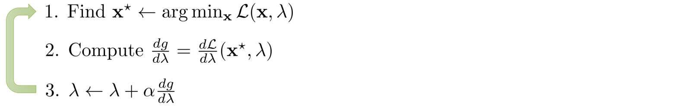

[Source](http://rail.eecs.berkeley.edu/deeprlcourse-fa17/f17docs/lecture_10_imitating_optimal_control.pdf)

We alternate between minimizing the Lagrangian 𝓛 with respect to the primal variables (x), and incrementing the Lagrange multiplier λ by its gradient. By repeating the iteration, if the problem is convex, the solution will converge.

# Decomposition

Divide-and-conquerer is the best friend of engineers. If a problem can be sub-divided, we can solve an optimization problem as multiple but smaller optimization problems.



However, the formularization above assumes the set of variables in x₁ and x₂ are not overlapping. In many problems, this is not true.





**Primal decomposition**

But, we can solve the problem in alternating steps iteratively.

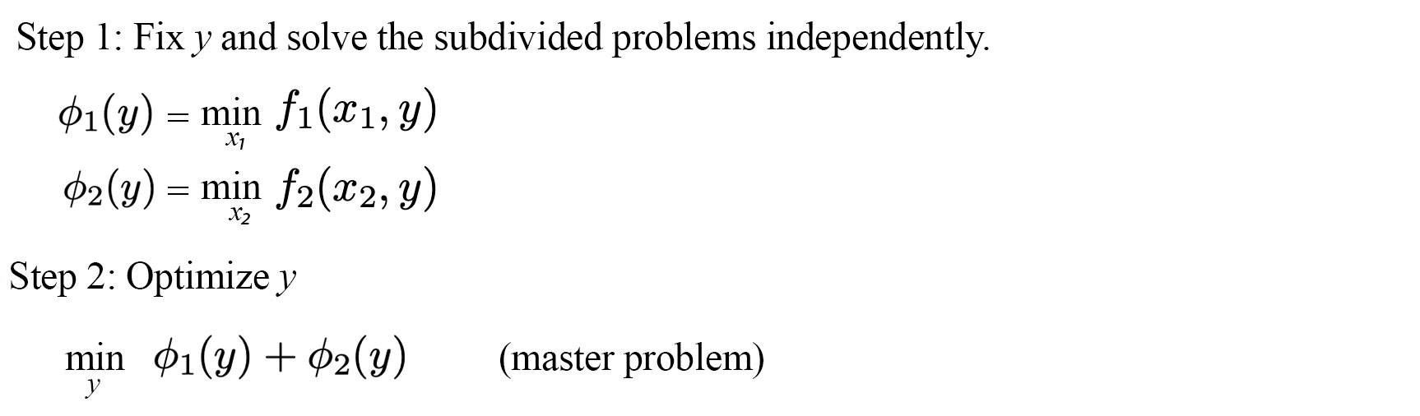

If the original problem is convex, the master problem above will also be convex. We repeat the iteration below and apply gradient descent in solving y. In step 1, we minimize f₁ and f₂ accordingly to form 𝜙₁(y) and 𝜙₂(y). We compute their gradients and update y with the gradient descent where α is the learning rate at iteration k.

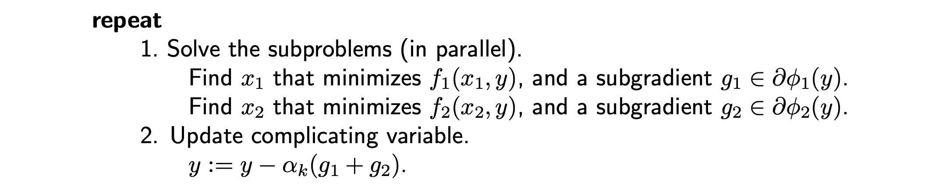

[Source](https://web.stanford.edu/class/ee364b/lectures/decomposition_slides.pdf)

This algorithm is called the primal decomposition.

**Dual decomposition**

As expected, if there is a decomposition working on the primal variables of the objective function, there should be a decomposition working on its dual equivalent. In the dual decomposition, we introduce two variables y₁ and y₂ to replace y. But we add a consensus constraint y₁ = y₂, so we are indeed solving the original problem.



The Lagrangian is





where λᵀ is the transpose of λ which is a vector holding the Lagrangian multipliers. The dual problem will be defined as:



The gradient of g₁(λ) and g₂(λ)is simply y₁* and y₂* respectively. Therefore the gradient of g(λ) equals y₂*-y₁*.

The algorithm for the dual decomposition is:



Modified from [source](https://web.stanford.edu/class/ee364b/lectures/decomposition_slides.pdf)

y below can be computed as the mean of y₁ and y₂. Or we can check which value of yᵢ in the later iterations will yield the most optimal solution.





Intuitively, we break down an objective function into smaller sub-problems. We optimize them independently. However, their solutions will not agree. So we add an equality constraint, i.e. the solutions should be the same. Once, we have the constraints added, we solve it with the Lagrangian multiplier. The idea is to find the optimal solutions for each sub-problems while trying to push the solution as close as possible (or equal) to others.

# Credits

[Lagrange Multipliers and the Karush-Kuhn-Tucker conditions](http://www.csc.kth.se/utbildning/kth/kurser/DD3364/Lectures/KKT.pdf)

[Karush-Kuhn-Tucker conditions](https://www.cs.cmu.edu/~ggordon/10725-F12/slides/16-kkt.pdf)

[Lagrangian Duality](https://www-cs.stanford.edu/people/davidknowles/lagrangian_duality.pdf)

[Duality](https://web.stanford.edu/class/ee364a/lectures/duality.pdf)

[Decomposition methods](https://web.stanford.edu/class/ee364b/lectures/decomposition_slides.pdf)

[A Tutorial on Dual Decomposition](https://www.cs.toronto.edu/~yujiali/files/talks/dd.pdf)

[Notes on decomposition methods](https://see.stanford.edu/materials/lsocoee364b/08-decomposition_notes.pdf)

# Machine Learning — Singular Value Decomposition (SVD) & Principal Component Analysis (PCA)

[](https://medium.com/@jonathan_hui?source=post_page-----1d45e885e491----------------------)

[Jonathan Hui](https://medium.com/@jonathan_hui?source=post_page-----1d45e885e491----------------------)

Follow

[Mar 7, 2019](https://medium.com/@jonathan_hui/machine-learning-singular-value-decomposition-svd-principal-component-analysis-pca-1d45e885e491?source=post_page-----1d45e885e491----------------------) · 16 min read

Photo by [Sheldon Nunes](https://unsplash.com/@sheldonnunes?utm_source=medium&utm_medium=referral)

In machine learning (ML), some of the most important linear algebra concepts are the singular value decomposition (SVD) and principal component analysis (PCA). With all the raw data collected, how can we discover structures? For example, with the interest rates of the last 6 days, can we understand its composition to spot trends?

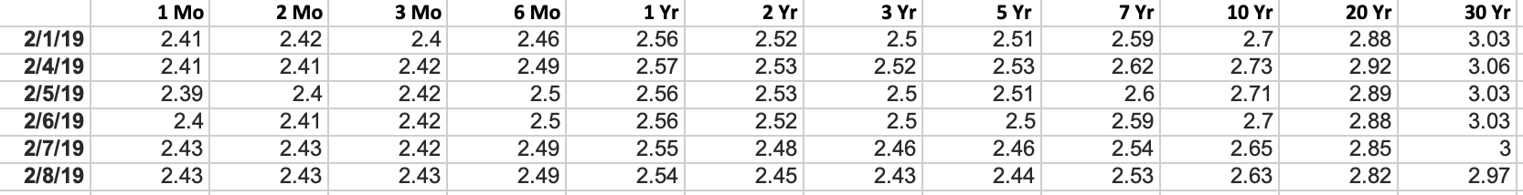

This becomes even harder for high-dimensional raw data. It is like finding a needle in a haystack. SVD allows us to extract and untangle information. In this article, we will detail SVD and PCA. We assume you have [basic](https://medium.com/@jonathan_hui/machine-learning-linear-algebra-a5b1658f0151) linear algebra knowledge including rank and [eigenvectors](https://medium.com/@jonathan_hui/machine-learning-linear-algebra-eigenvalue-and-eigenvector-f8d0493564c9). If you experience difficulties in reading this article, I will suggest refreshing those concepts first. At the end of the article, we will answer some questions in the interest rate example above. This article also contains optional sections. Feel free to skip it according to your interest level.

# Misconceptions (optional for beginners)

I realize a few common questions that non-beginners may ask. Let me address the elephant in the room first. Is PCA dimension reduction? PCA reduces dimension but it is far more than that. I like the Wiki description (but if you don’t know PCA, this is just gibberish):

*Principal component analysis (PCA) is a statistical procedure that uses an orthogonal transformation to convert a set of observations of possibly correlated variables (entities each of which takes on various numerical values) into a set of values of linearly uncorrelated variables called principal components.*

From a simplified perspective, PCA transforms data linearly into new properties that are not correlated with each other. For ML, positioning PCA as feature extraction may allow us to explore its potential better than dimension reduction.

What is the difference between SVD and PCA? SVD gives you the whole nine-yard of diagonalizing a matrix into [special matrices](https://medium.com/@jonathan_hui/machine-learning-linear-algebra-special-matrices-c750cd742dfe) that are easy to manipulate and to analyze. It lay down the foundation to untangle data into independent components. PCA skips less significant components. Obviously, we can use SVD to find PCA by truncating the less important basis vectors in the original SVD matrix.

# Matrix diagonalization

In the [article](https://medium.com/@jonathan_hui/machine-learning-linear-algebra-eigenvalue-and-eigenvector-f8d0493564c9) on eigenvalue and eigenvectors, we describe a method to decompose an n × n square matrix A into





For example,



However, this is possible only if A is a square matrix and A has n linearly independent eigenvectors. Now, it is time to develop a solution for all matrices using SVD.

# ****Singular vectors & singular values****

The matrix **AAᵀ** and **AᵀA** are very special in linear algebra. Consider any m × n matrix **A**, we can multiply it with Aᵀ to form **AAᵀ** and **AᵀA** separately. These matrices are

* symmetrical,
* square,
* at least positive semidefinite (eigenvalues are zero or positive),
* both matrices have the same positive eigenvalues, and
* both have the same rank r as A.

In addition, the covariance matrices that we often use in ML are in this form. Since they are symmetric, we can choose its eigenvectors to be orthonormal (perpendicular to each other with unit length) — this is a fundamental property for [symmetric matrices](https://medium.com/@jonathan_hui/machine-learning-linear-algebra-special-matrices-c750cd742dfe).



Let’s introduce some terms that frequently used in SVD. We name the eigenvectors for **AAᵀ** as uᵢ and **AᵀA** as vᵢ here and call these sets of eigenvectors u and v the **singular vectors** of A. Both matrices have the same positive eigenvalues. The square roots of these eigenvalues are called **singular values**.

Not too many explanations so far but let’s put everything together first and the explanations will come next. We concatenate vectors uᵢ into U and vᵢ into V to form orthogonal matrices.

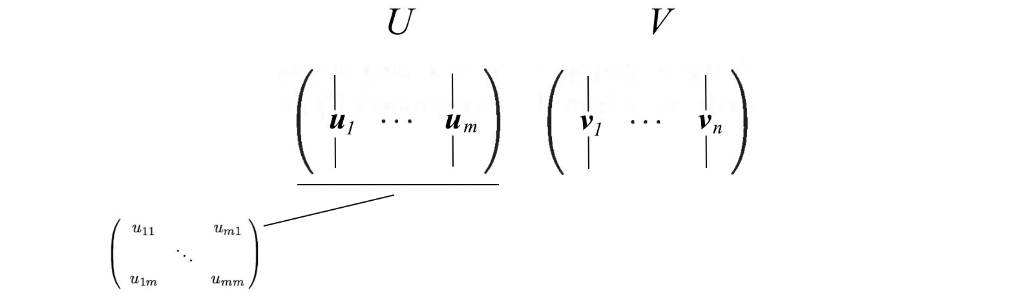

Since these vectors are orthonormal, it is easy to prove that U and V obey





# ****SVD****

Let’s start with the hard part first. SVD states that **any** matrix A can be factorized as:





where U and V are orthogonal matrices with orthonormal eigenvectors chosen from **AAᵀ** and **AᵀA** respectively. **S** is a diagonal matrix with r elements equal to the root of the positive eigenvalues of AAᵀ or Aᵀ A (both matrics have the same positive eigenvalues anyway). The diagonal elements are composed of singular values.



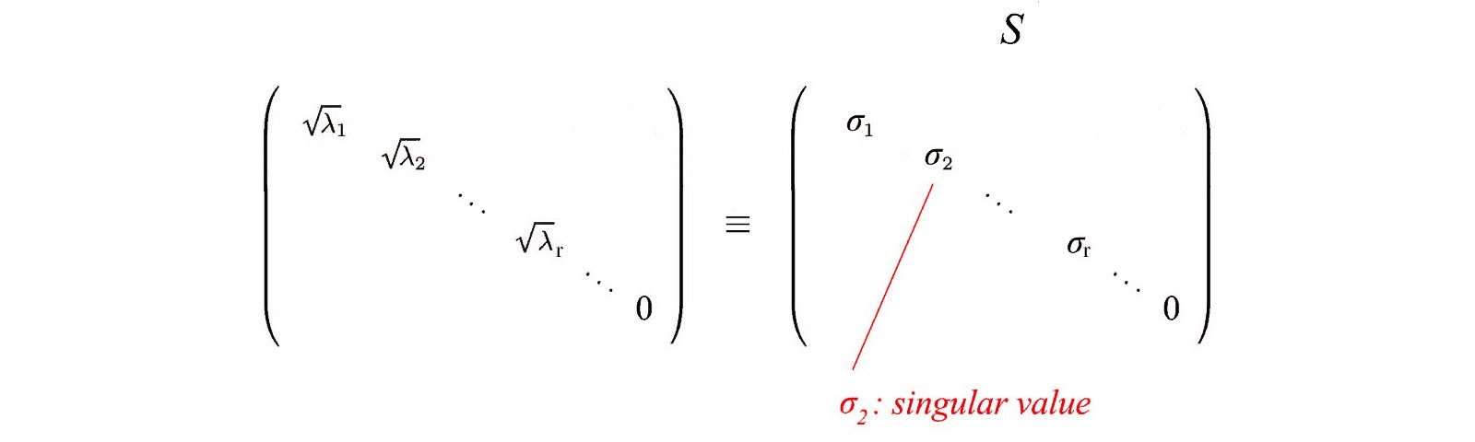

i.e. an m× n matrix can be factorized as:





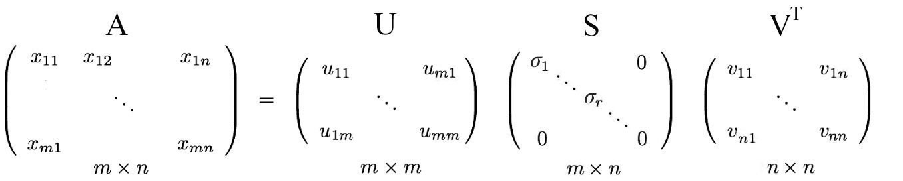

We can arrange eigenvectors in different orders to produce U and V. To standardize the solution, we order the eigenvectors such that vectors with higher eigenvalues come before those with smaller values.



Comparing to eigendecomposition, SVD works on non-square matrices. U and V are invertible for any matrix in SVD and they are orthonormal which we love it. Without proof here, we also tell you that singular values are more numerical stable than eigenvalues.

**Example** ([Source](http://www.d.umn.edu/~mhampton/m4326svd_example.pdf) of the example)

Before going too far, let’s demonstrate it with a simple example. This will make things very easy to understand.



We calculate:



These matrices are at least positive semidefinite (all eigenvalues are positive or zero). As shown, they share the same positive eigenvalues (25 and 9). The figure below also shows their corresponding eigenvectors.

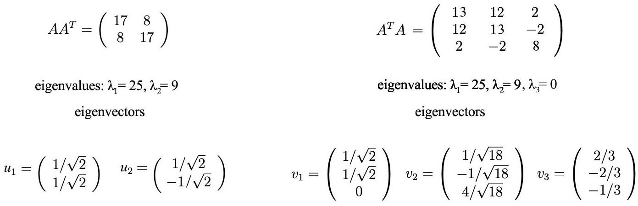

The singular values are the square root of positive eigenvalues, i.e. 5 and 3. Therefore, the SVD composition is

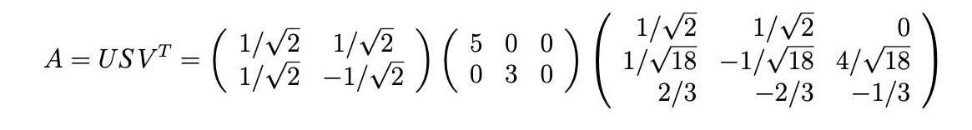

# ****Proof (optional)****

To proof SVD, we want to solve U, S, and V with:





We have 3 unknowns. Hopefully, we can solve them with the 3 equations above. The transpose of A is





Knowing





We compute AᵀA,



The last equation is equilvant to the eigenvector definition for the matrix (AᵀA). We just put all eigenvectors in a matrix.

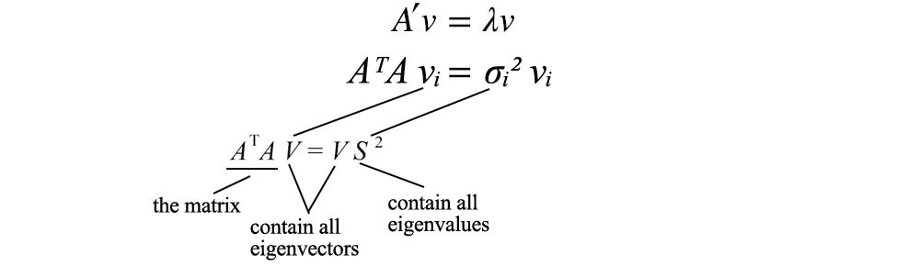

with VS² equals



V hold all the eigenvectors vᵢ of AᵀA and S hold the square roots of all eigenvalues of AᵀA. We can repeat the same process for AAᵀ and come back with a similar equation.



Now, we just solve U, V and S for





and prove the theorem.

# ****Recap****

The following is a recap of SVD.



where

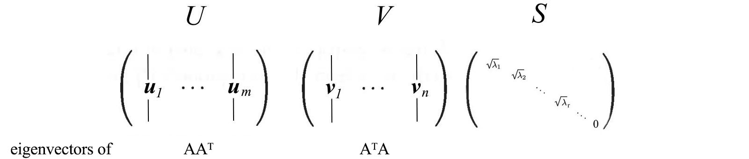

# Reformulate SVD

Since matrix V is orthogonal, VᵀV equals I. We can rewrite the SVD equation as:





This equation establishes an important relationship between uᵢ and vᵢ.

Recall



Apply AV = US,

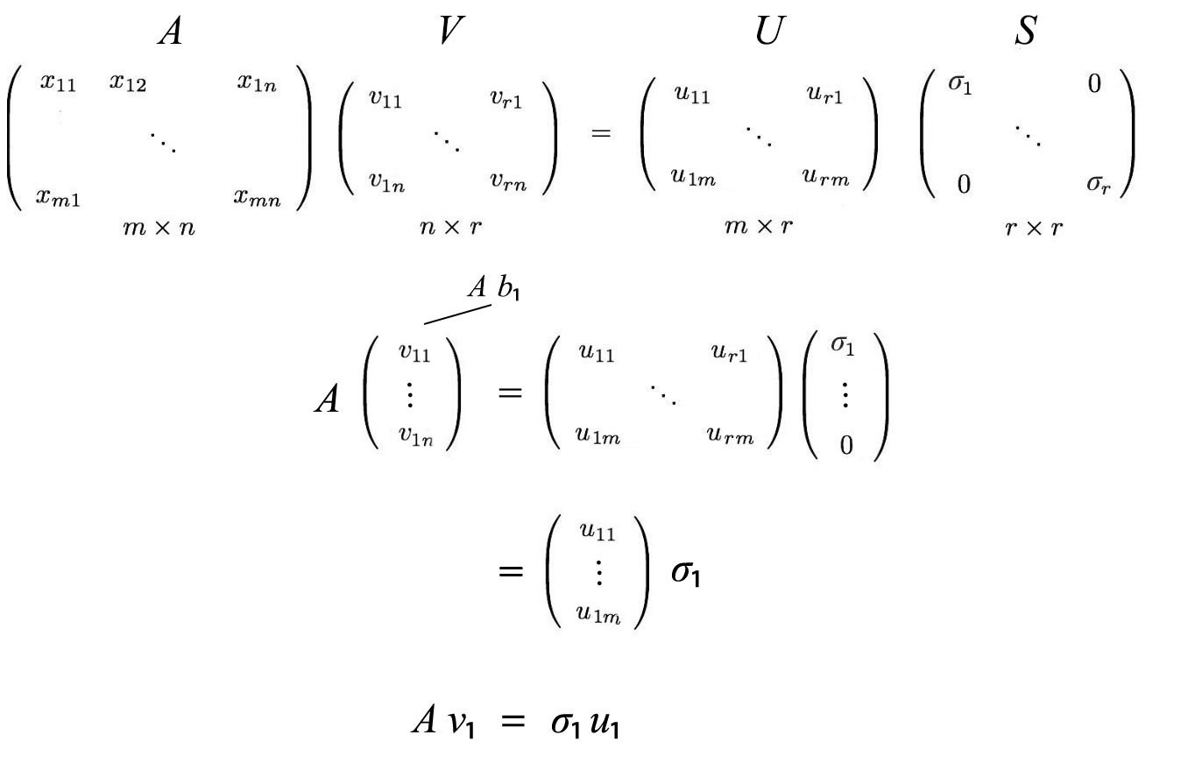

This can be generalized as



Recall,



and



The SVD decomposition can be recognized as a series of outer products of uᵢ and vᵢ.



This formularization of SVD is the key to understand the components of A. It provides an important way to break down an m × n array of entangled data into r components. Since uᵢ and vᵢ are unit vectors, we can even ignore terms (σᵢuᵢvᵢᵀ) with very small singular value σᵢ. (We will come back to this later.)

Let’s first reuse the example before and show how it works.



The matrix A above can be decomposed as

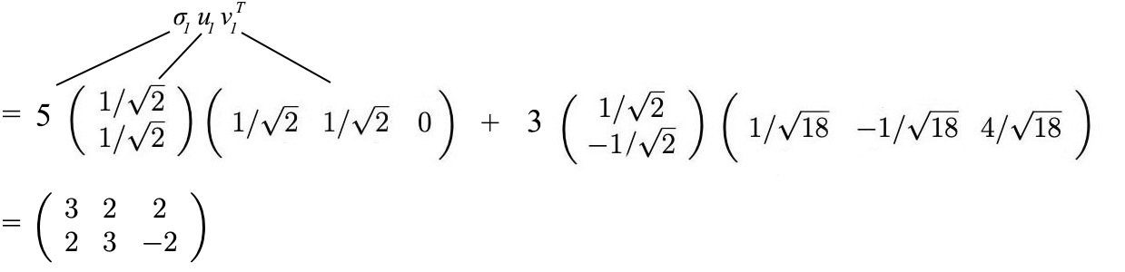

# ****Column space, row space, left nullspace and nullspace (Optional-for advanced users)****

Next, we will take a look at what U & V composed of. Let’s say A is an m × n matrix of rank r. AᵀA will be an n× n symmetric matrix. All symmetric matrices can choose n orthonormal eigenvectors vⱼ. Because of Avᵢ = σᵢuᵢ and vⱼ are orthonormal eigenvectors of AᵀA, we can calculate the value of uᵢᵀuⱼ as



It equals zero. i.e. uᵢ and uⱼ are orthogonal with each other. As shown previously, they are also eigenvectors of AAᵀ.

From Avᵢ = σuᵢ, we can recognize that uᵢ is a column vector of A.



Because A has a rank of r, we can choose these r uᵢ vectors to be orthonormal. So what are the remaining m - r orthogonal eigenvectors for AAᵀ? Since left nullspace of A is orthogonal to the column space, it is very natural to pick them as the remaining eigenvector. (The left nullsapce N(Aᵀ) is the space span by x in Aᵀx=0.) A similar argument will work for the eigenvectors for AᵀA. Therefore,

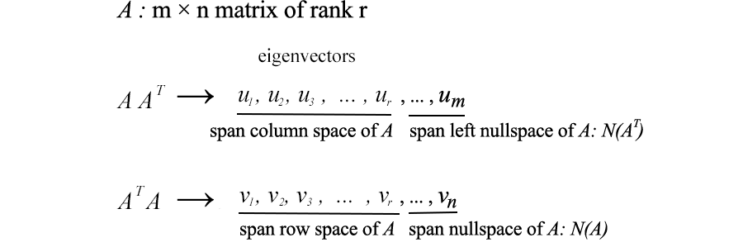

To get back to the former SVD equation from

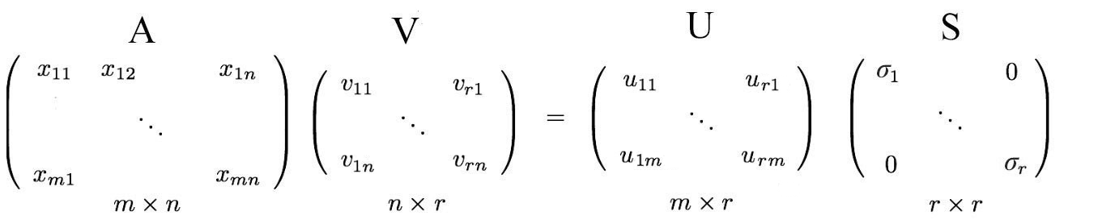

We simply put back the eigenvectors in the left nullspace and nullspace.

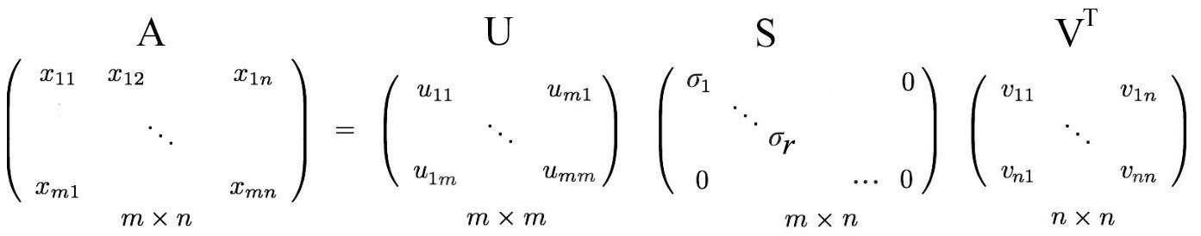

# Moore-Penrose Pseudoinverse

For a linear equation system, we can compute the inverse of a square matrix A to solve x.





But not all matrices are invertible. Also, in ML, it will be unlikely to find an exact solution with the presence of noise in data. Our objective is to find the model that best fit the data. To find the best-fit solution, we compute a pseudoinverse





which minimizes the least square error below.





And the solution for x can be estimated as,





In a linear regression problem, **x** is our linear model, **A** contains the training data and b contains the corresponding labels. We can solve x by

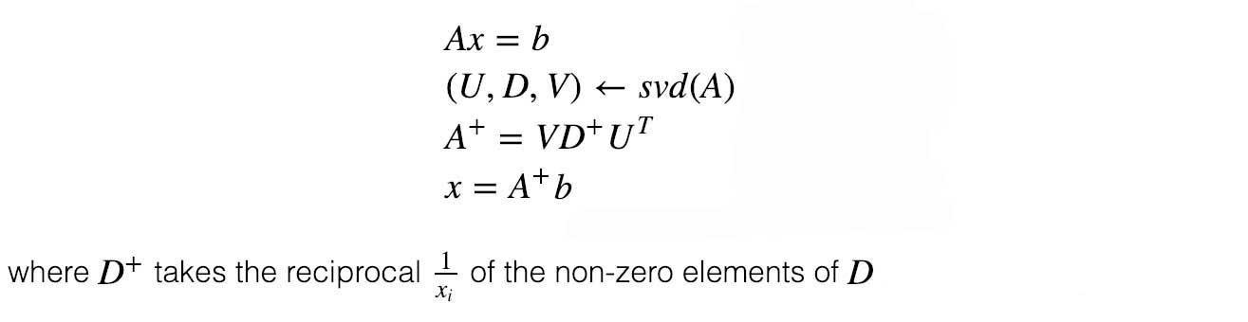



Here is an example.

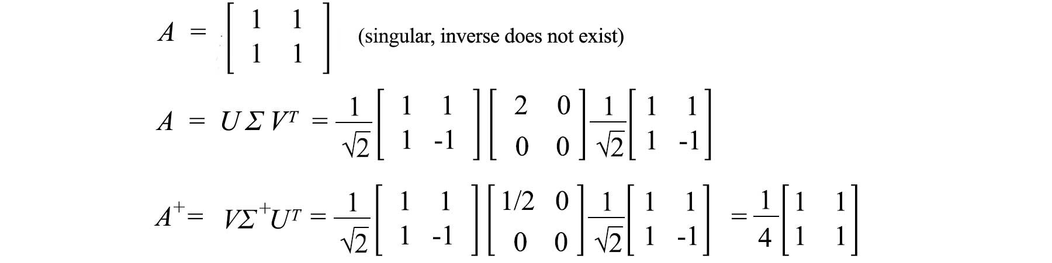

# Variance & covariance

In ML, we identify patterns and relationship. How do we identify the correlation of properties in data? Let’s start the discussion with an example. We sample the height and weight of 12 people and compute their means. We zero-center the original values by subtracting them with its mean. For example, Matrix A below holds the adjusted zero-centered height and weight.



As we plot the data points, we can recognize height and weight are positively related. But how can we quantify such a relationship?

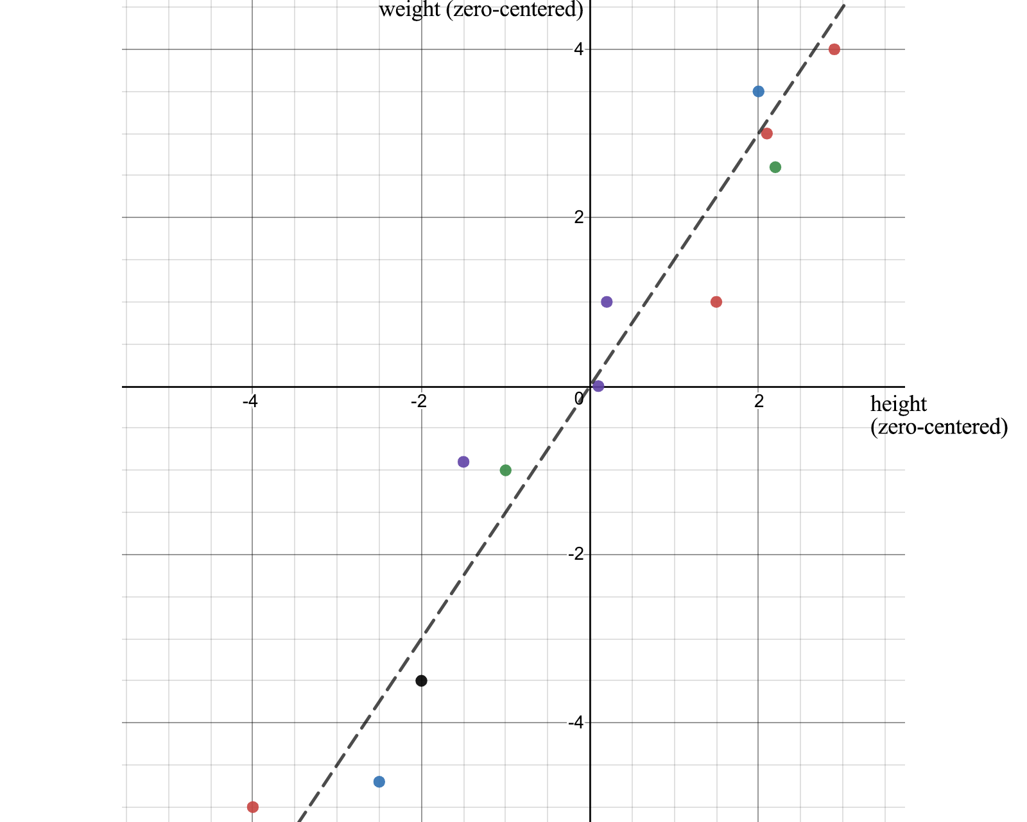

First, how does a property vary? We probably learn the variance from high school. Let’s introduce its cousin. **Sample variance** is defined as :



Note, it is divided by n-1 instead of n in the **variance**. With a limited size of the samples, the sample mean is biased and correlated with the samples. The average square distance from this mean will be smaller than that from the general population. The sample covariance S², divided by n-1, compensates for the smaller value and can be proven to be an unbiased estimate for variance σ². (The proof is not very important so I will simply provide a link for the [proof](https://en.wikipedia.org/wiki/Variance#Sample_variance) here.)

# Covariance matrices

Variance measures how a variable varies between itself while covariance is between two variables (a and b).



We can hold all these possible combinations of covariance in a matrix called the **covariance matrix** Σ.

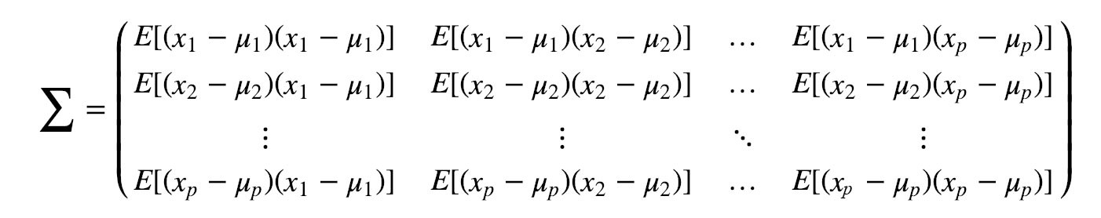

We can rewrite this in a simple matrix form.



The diagonal elements hold the variances of individual variables (like height) and the non-diagonal elements hold the covariance between two variables. Let’s compute the sample covariance now.



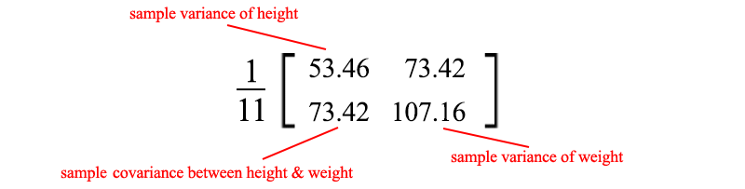

The positive sample covariance indicates weight and height are positively correlated. It will be negative if they are negatively correlated and zero if they are independent.

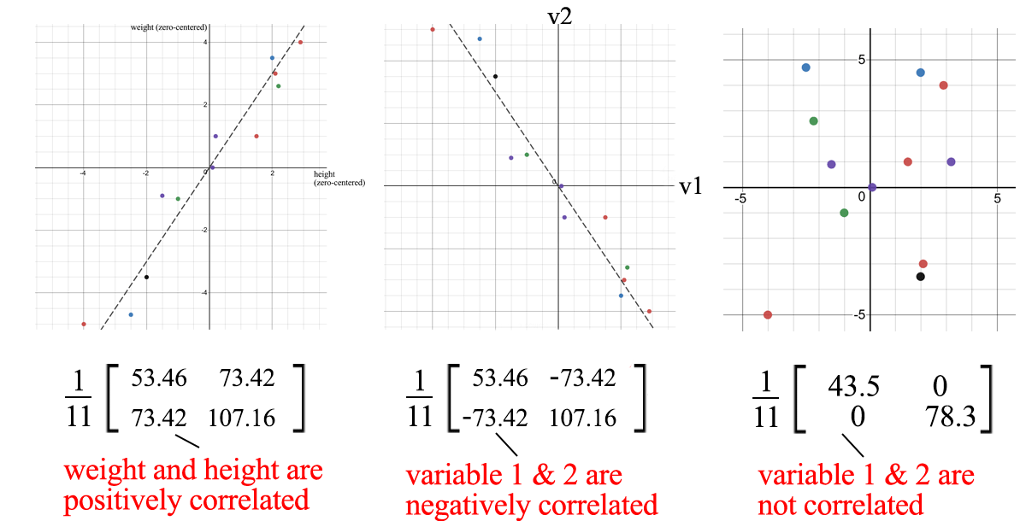

**Covariance matrix & SVD**

We can use SVD to decompose the sample covariance matrix. Since σ₂ is relatively small compared with σ₁, we can even ignore the σ₂ term. When we train an ML model, we can perform a linear regression on the weight and height to form a new property rather than treating them as two separated and correlated properties (where entangled data usually make model training harder).



u₁ has one significant importance. It is the principal component of S.

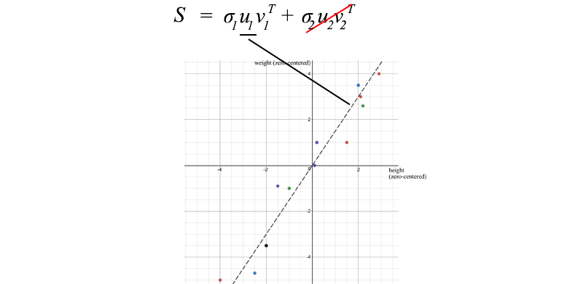

There are a few properties about a sample covariance matrix under the context of SVD:

* The total variance of the data equals the trace of the sample covariance matrix S which equals the sum of squares of S’s singular values. Equipped with this, we can calculate the ratio of variance lost if we drop smaller σᵢ terms. This reflects the amount of information lost if we eliminate them.



* The first eigenvector u₁ of S points to the most important direction of the data. In our example, it quantifies the typical ratio between weight and height.

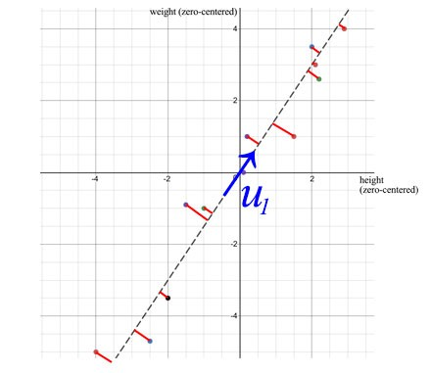

Perpendicular least squares

* The error, calculated as the sum of the perpendicular squared distance from the sample points to u₁, is the minimum when SVD is used.

**Property**

Covariance matrices are not only symmetric but they are also positive semidefinite. Because variance is positive or zero, uᵀVu below is always greater or equal zero. By the energy test, V is positive semidefinite.



Therefore,





Often, after some linear transformation A, we want to know the covariance of the transformed data. This can be calculated with the transformation matrix A and the covariance of the original data.



**Correlation matrix**

A correlation matrix is a scaled version of the covariance matrix. A correlation matrix standardizes (scale) the variables to have a standard deviation of 1.

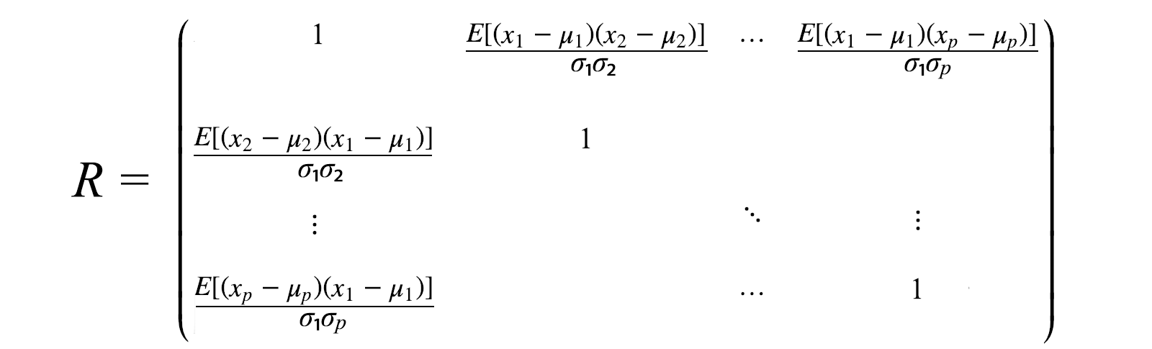

Correlation matrix will be used if variables are in scales of very different magnitudes. Bad scaling may hurt ML algorithms like gradient descent.

# ****Visualization****

So far, we have a lot of equations. Let’s visualize what SVD does and develop the insight gradually. SVD factorizes a matrix A into USVᵀ. Applying A to a vector x (Ax) can be visualized as performing a rotation (Vᵀ), a scaling (S) and another rotation (U) on x.

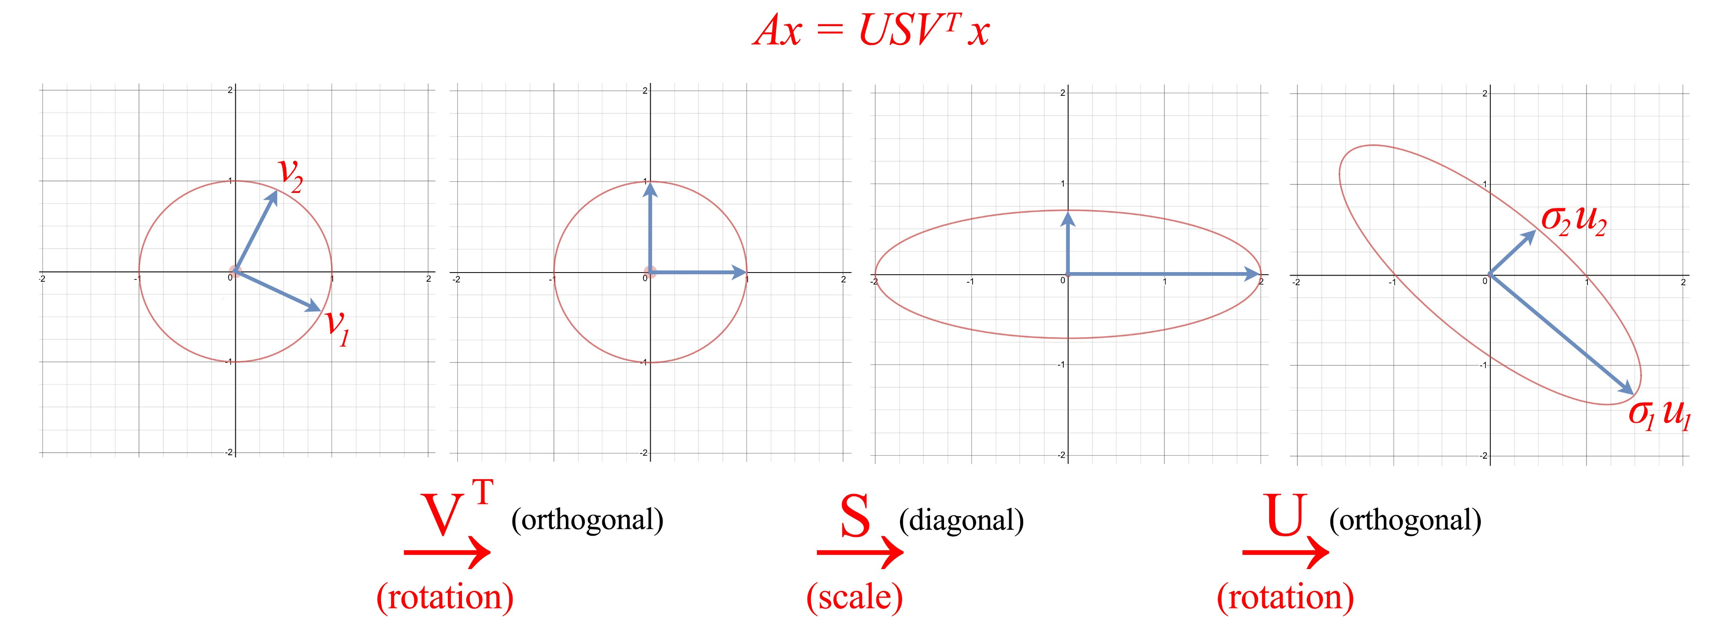

As shown above, the eigenvector vᵢ of V is transformed into:





Or in the full matrix form

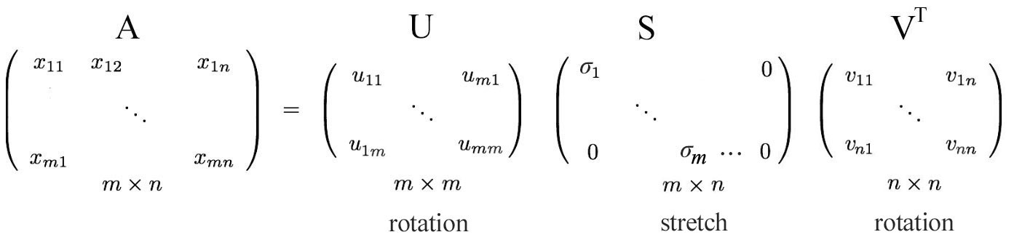

demonstrate for r = m < n

# Insight of SVD

As described before, the SVD can be formulated as



Since uᵢ and vᵢ have unit length, the most dominant factor in determining the significance of each term is the singular value σᵢ. We purposely sort σᵢ in the descending order. If the eigenvalues become too small, we can ignore the remaining terms (+ σᵢuᵢvᵢᵀ + …).

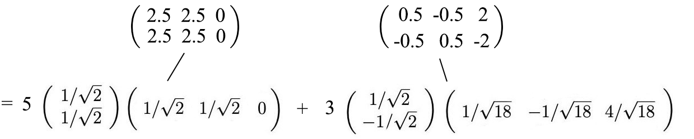

This formularization has some interesting implications. For example, we have a matrix contains the return of stock yields traded by different investors.

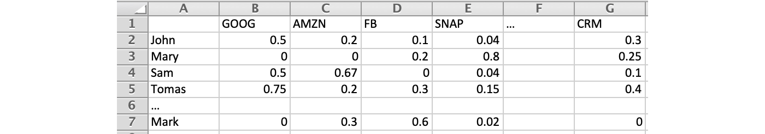

As a fund manager, what information can we get out of it? Finding patterns and structures will be the first step. Maybe, we can identify the combination of stocks and investors that have the largest yields. SVD decompose an n × n matrix into r components with the singular value σᵢ demonstrating its significant. Consider this as a way to extract entangled and related properties into fewer principal directions with no correlations.





If data is highly correlated, we should expect many σᵢ values to be small and can be ignored.

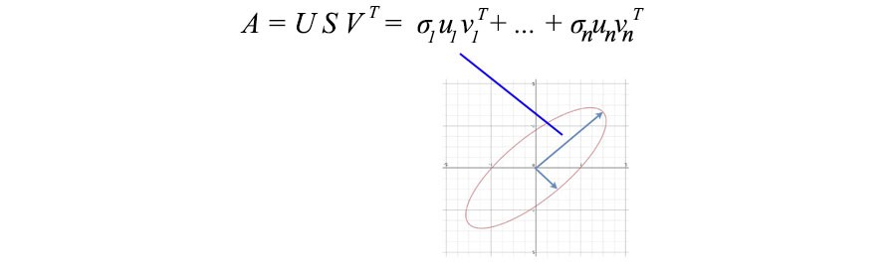

In our previous example, weight and height are highly related. If we have a matrix containing the weight and height of 1000 people, the first component in the SVD decomposition will dominate. The u₁ vector indeed demonstrates the ratio between weight and height among these 1000 people as we discussed before.

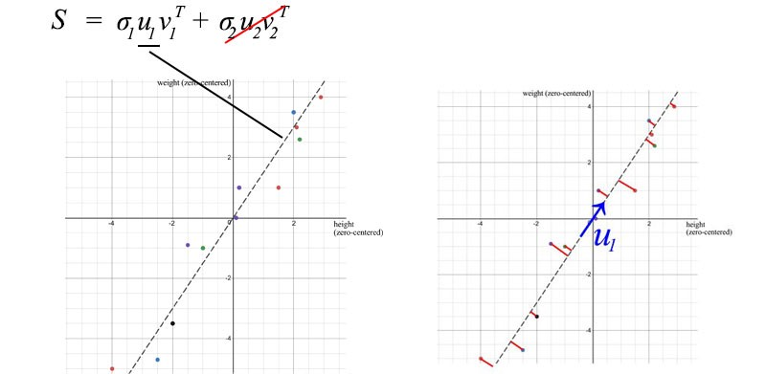

# Principal Component Analysis (PCA)

Technically, SVD extracts data in the directions with the highest variances respectively. PCA is a linear model in mapping m-dimensional input features to k-dimensional latent factors (k principal components). If we ignore the less significant terms, we remove the components that we care less but keep the principal directions with the highest variances (largest information).

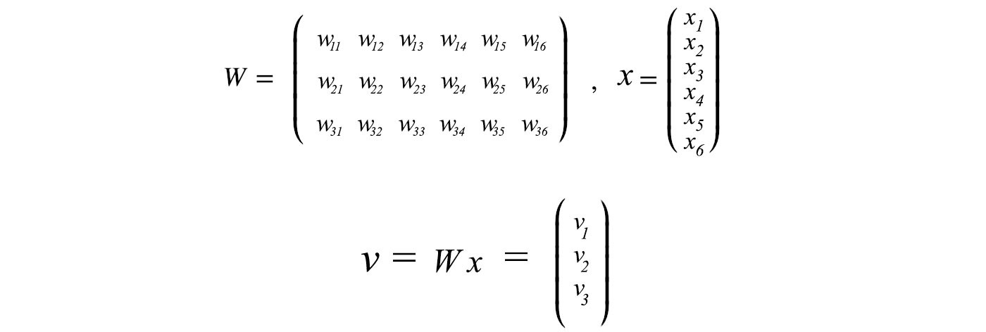

Consider the 3-dimensional data points that displayed as blue dots below. It can be approximated by a plane easily.

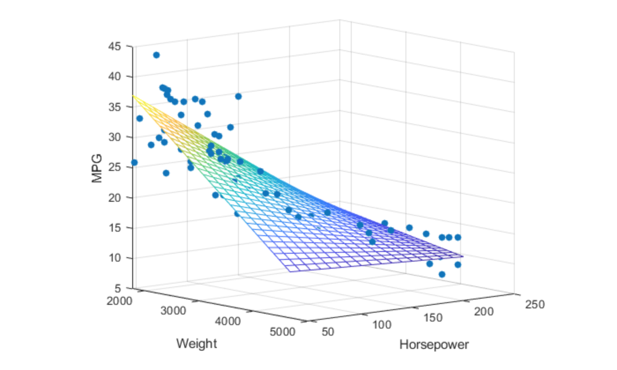

[Source](https://www.mathworks.com/help/stats/regress.html)

You may quickly realize that we can use SVD to find the matrix W. Consider the data points below that lie on a 2-D space.

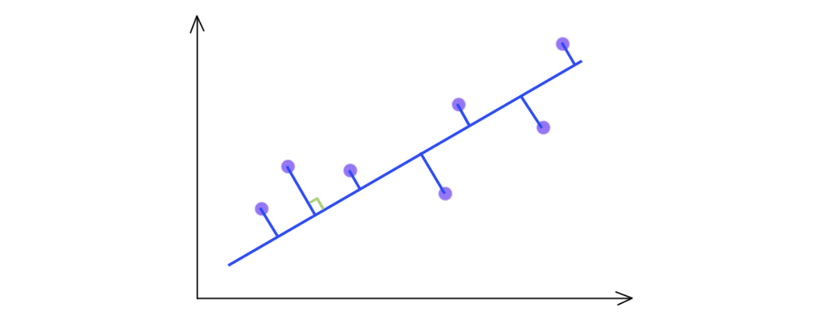

SVD selects a projection that maximizes the variance of their output. Hence, PCA will pick the blue line over the green line if it has a higher variance.

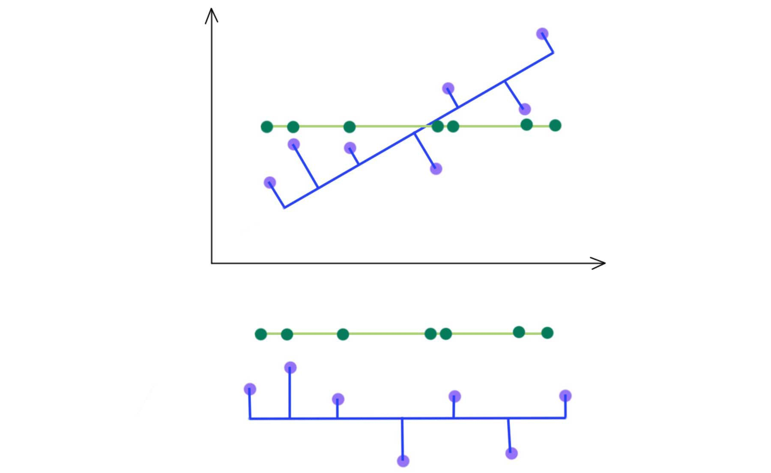

As indicated below, we keep the eigenvectors that have the top kth highest singular value.

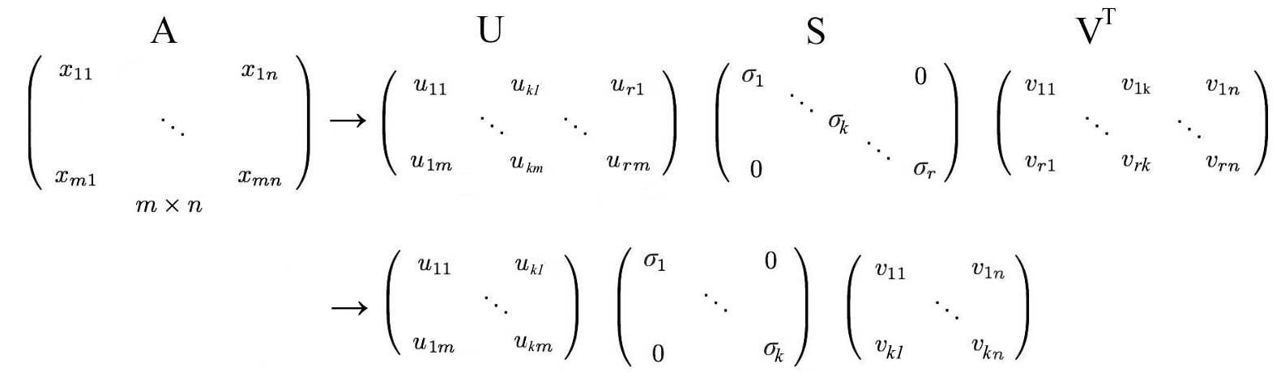

**Interest rate**

Let’s illustrate the concept deeper by retracing an example [here](http://math.mit.edu/~gs/linearalgebra/) with the interest rate data originated from the US Treasurer Department. The basis points for 9 different interest rates (from 3 months, 6 months, … to 20 years) over 6 consecutive business days are collected with A stored the difference from the previous date. **A** also has its elements subtracted by its mean over this period already. i.e. it is zero-centered (across its row).

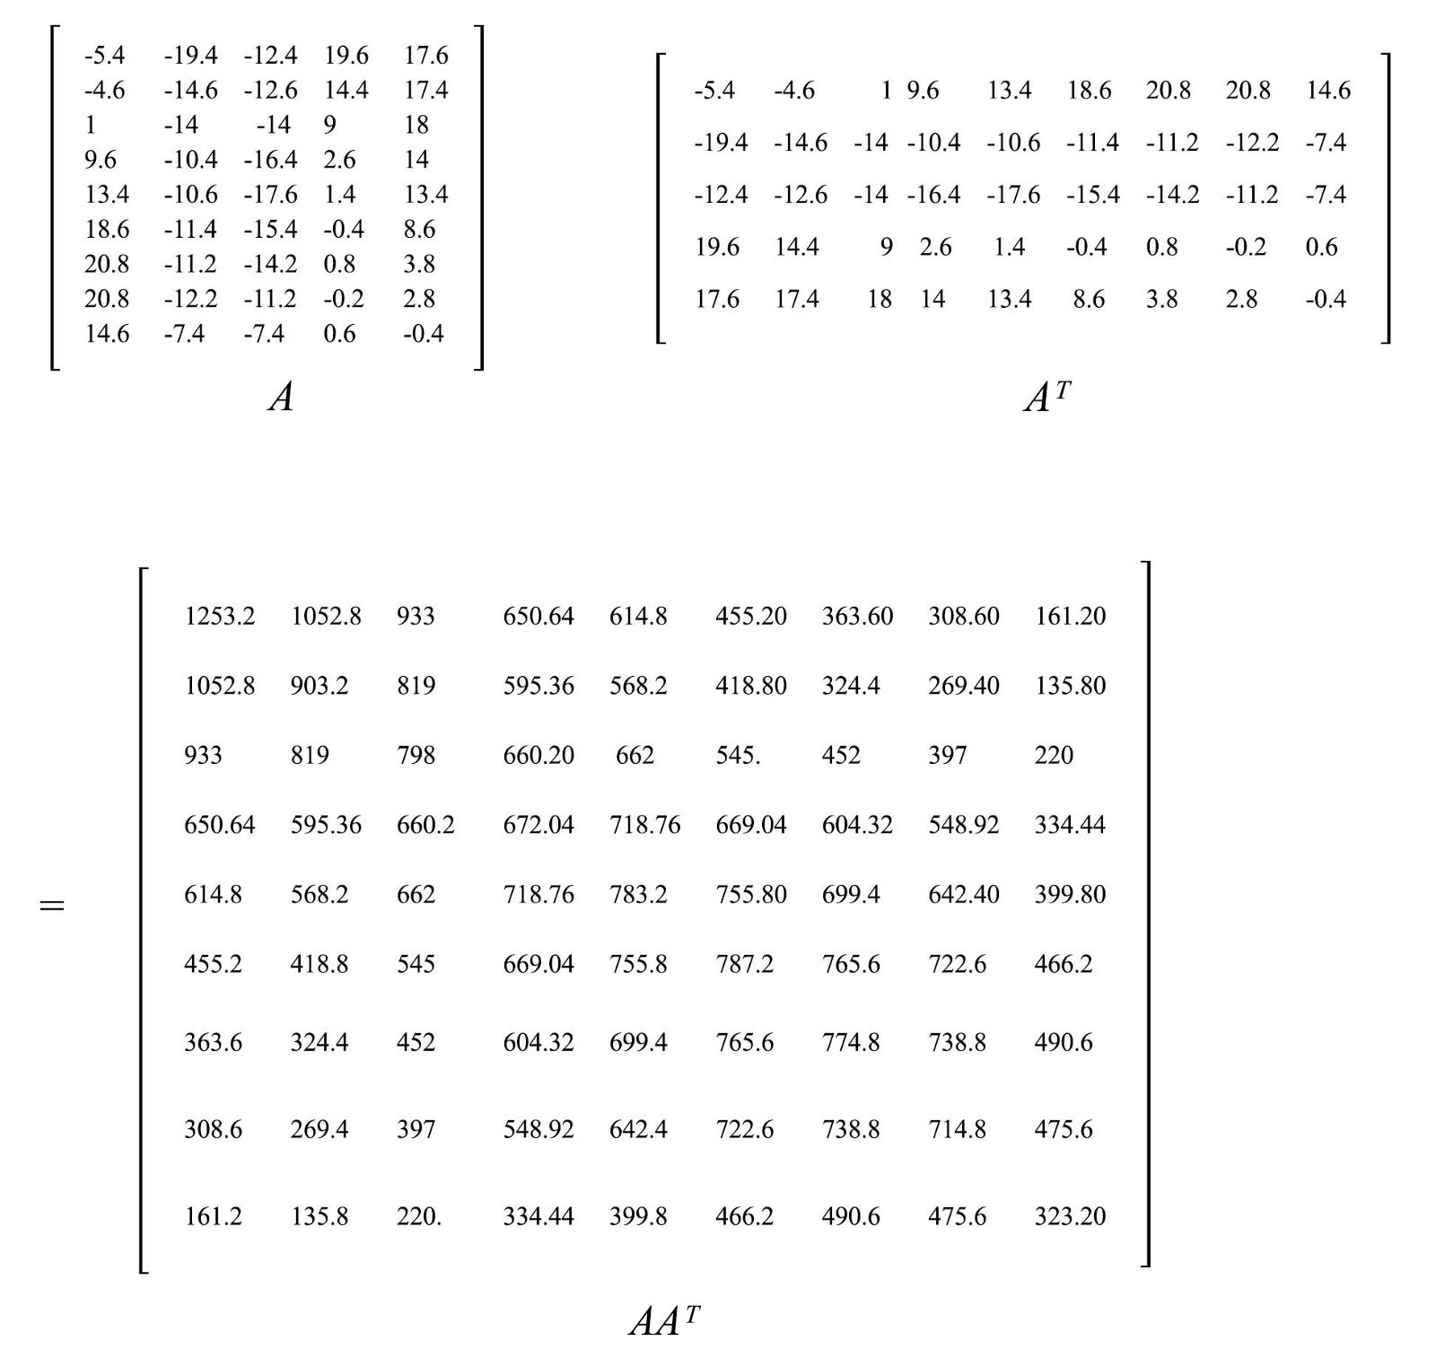

The sample covariance matrix equals S = AAᵀ/(5–1).

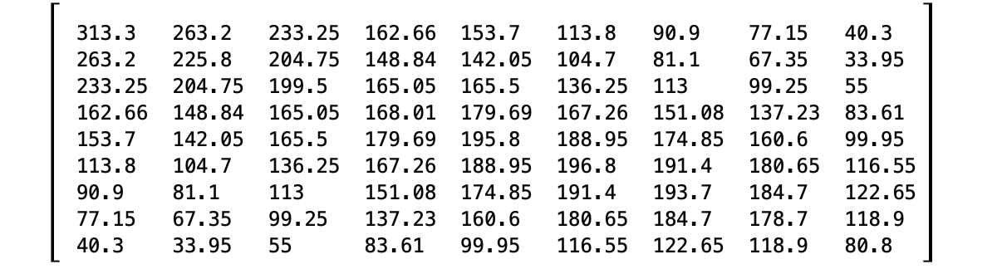

Now we have the covariance matrix S that we want to factorize. The SVD decomposition is

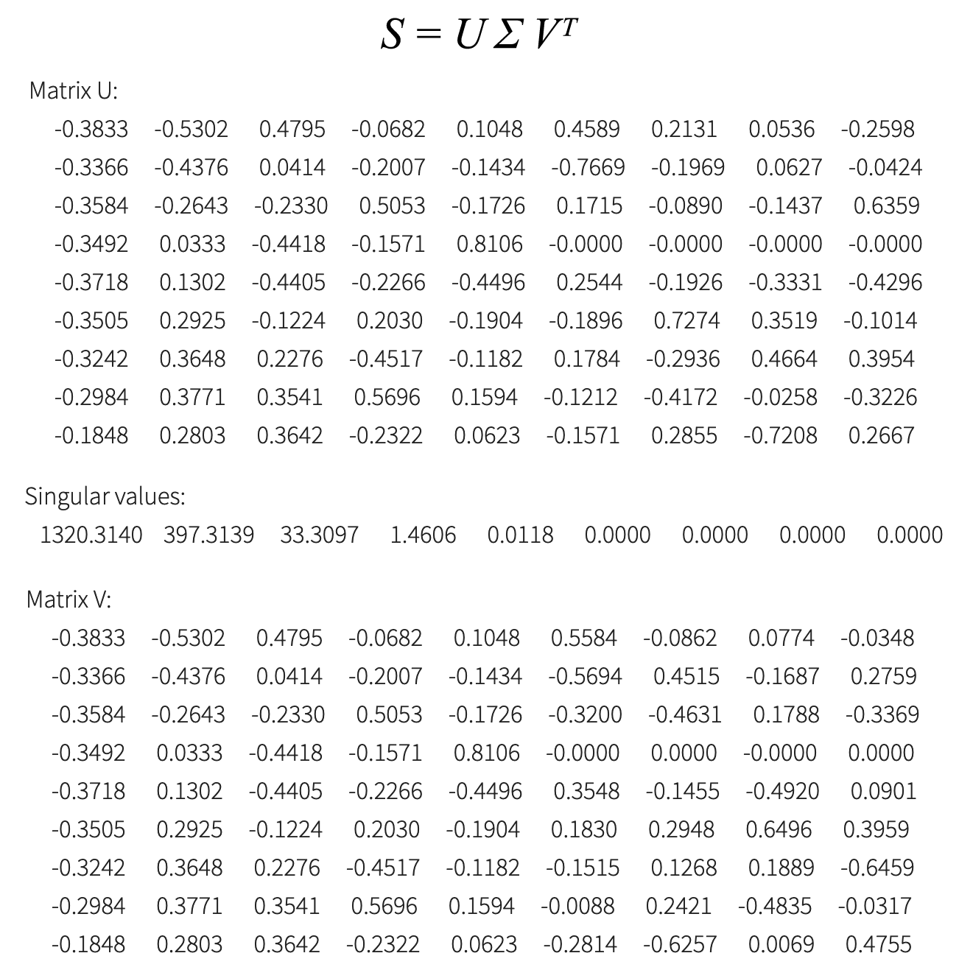

From the SVD decomposition, we realize that we can focus on the first three principal components.

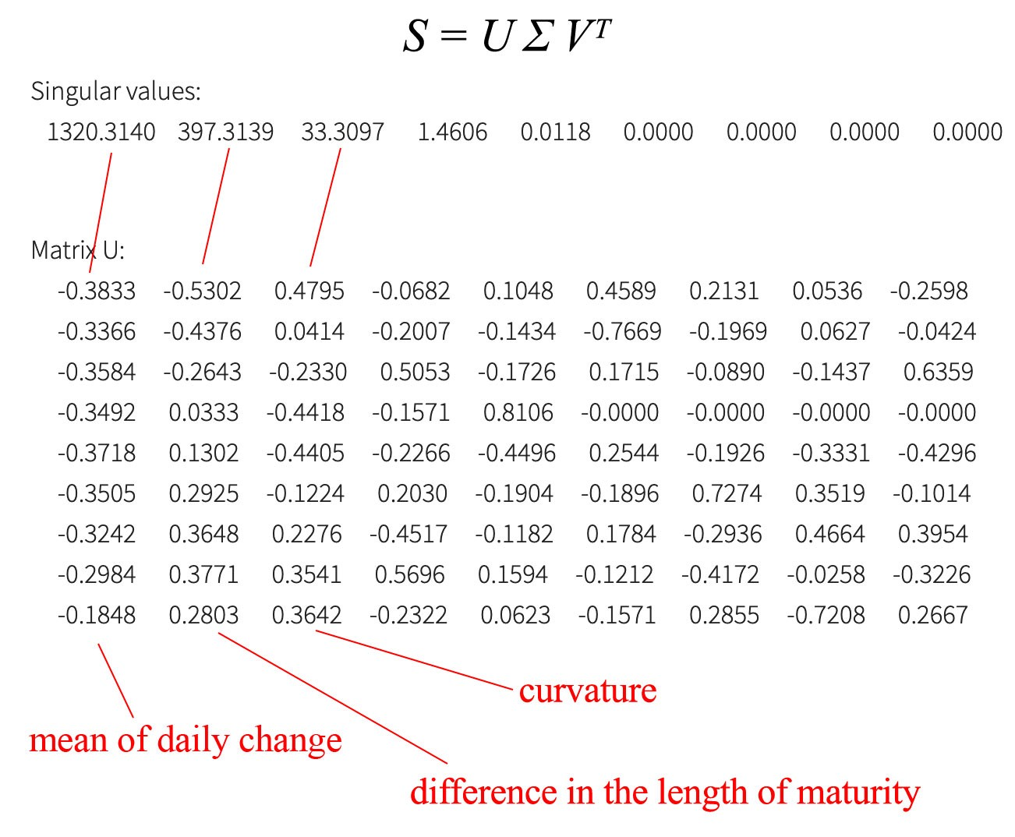

As shown, the first principal component is related to a weighted average of the daily change for all maturity lengths. The second principal component adjusts the daily change sensitive to the maturity length of the bond. (The third principal component is likely the curvature — a second-degree derivative.)

We understand the relationship between the interesting rate change and maturity well in our daily life. So the principal components reconfirm what we believe how interest rates behave. But when we are presented with unfamiliar raw data, PCA is very helpful to extract the principal components of your data to find the underneath information structure. This may answer some questions on how to find a needle in a haystack.

# Tips

Scale features before performing SVD.



Say, we want to retain 99% variance, we can choose k such that

